THE PLACE-NAMES

OF PAGLESHAM

Recorder: Paul Mardon

Essex Place-names Project (Essex Society for Archaeology & History), 2011 (e-book).

www.essex.ac.uk/history/esah/essexplacenames

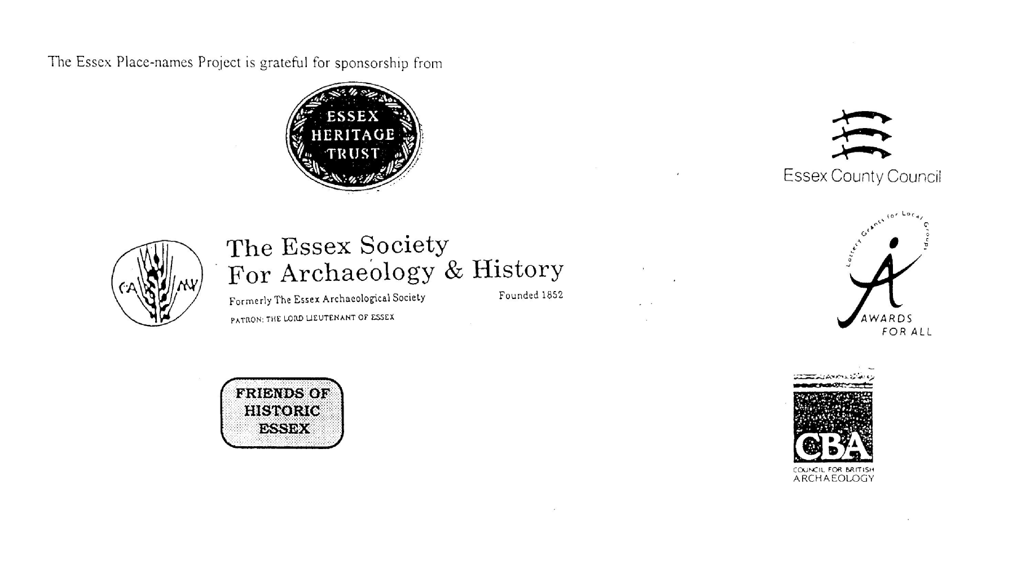

ESSEX PLACE-NAMES PROJECT.

The Essex Place-names Project is a County-wide survey to record place- and field-names from historical documents such as Tithe maps and apportionments, estate maps, sale
and auction catalogues, conveyances, terriers, deeds, rolls, inquisitions and surveys.

The second element of the Project is to investigate on-the-ground visible remains which correspond to the Place-names for actual or potential archaeological, agricultural and industrial
sites, and to record natural (topographical) and man-made features which may relate to the Place-name. This involves field-survey in rural and outside investigation in built-up areas.

It is anticipated that the Project will lead to identification of archaeological sites and lost historic buildings; it will enable analysis of indicators of early settlement, land holding, agricultural and industrial practices of the County. It will refine the more precise meaning of descriptive words and elements used by earlier settlers as they gave names appropriate to the topography of the landscape of their time.

For convenience the surveys are based on the parish, recognising that present civil parish boundaries are not necessarily identical to former ecclesiastical boundaries. Local Recorders
are supplied with templates of Record Forms to ensure consistency of recording across the County, and forward completed forms to a Central Coordinator for transfer to a county
computer database which is available to researchers on the internet at www.essex.ac.uk/history/esah/essexplacenames, and updated periodically.

This publication presents part of the information recorded from the Tithe or Estate Award and Map, and from other documents for this parish. The full record is contained on the master
database at Essex County Council (Historic Environment Section) and on the (above) website. Parish books are available from the Publications Manager, Essex Record Office, Wharf Road, Chelmsford CM2 6YT, on disc or in hard copy or may be downloaded from the website link ‘Books’ on the Home page. Please notify errors to the Project Coordinator at the Essex Record Office.

THE TITHE MAP AND APPORTIONMENT.

Since medieval times a tenth of the produce of land and stock had been paid by landholders to the church. At the Dissolution of the Monasteries, the property of many religious houses,
including the right to collect tithes, passed into lay hands. The Tithe Commutation Act which received Royal assent on 13th August 1836 abolished a rent payable in kind and
substituted rent-charges apportioned on each plot or parcel. The tithe-rent payable was assessed on the average value of wheat, barley and oats and was to fluctuate with price movements.

The commutation could be by voluntary agreement between the local owners and payers or, if agreement failed, could be compulsorily imposed by commissioners. A Valuer was to be
appointed to apportion the rent of each parcel of land and tenants could deduct that rent-charge from their rent paid to the landlord. The task fell to the Tithe Commissioners to produce a
map and an Apportionment (Award). A large-scale survey was produced for over 70% of England and Wales in the following 9 years, and about another 8% up to 1855. Most of the
parishes in Essex were surveyed. The map scales vary. The Award records ownership, tenancy and land-use, field by field and parcel by parcel (often quoting the field name) with the
ground area and rent-charge.

Land that was tithe-free tends to be less accurately mapped and contains few if any of the details recorded for those parcels subject to tithe. Rights of way and roads also tend to be
neglected. Boundaries of the tithe areas are shown as are some natural features such as streams, ponds, gardens, greens and commons. Buildings are often shown coloured red if dwellings
or grey if not. Because the Award may have been agreed only some time after the map was finished, discrepancies occur between the two. Enclosure Awards, when extant, usually date to the 18th and early 19th centuries. J.Kemble.
Reproduced by permission
of Essex County Council.

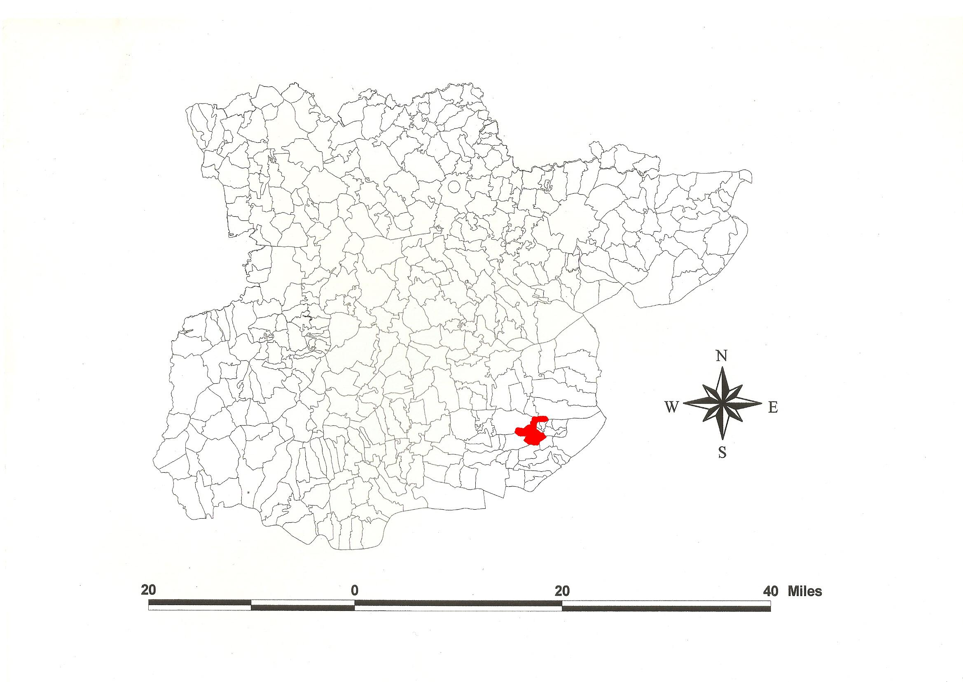
Reproduced by permission of Essex County Council.
Paglesham Parish in the County of Essex.

Paglesham Parish (in Rochford Hundred).

Paglesham Tithe Award (Essex Record Office D/CT 266a), dated 1838, shows a rent-charge of £566 and £6 for glebe payable to the Rector Rev Charles Almeric Belli. The whole parish measured 2129 acres of which 1840 acres were subject to tithes. 1200 acres were arable, 400 acres meadow and pasture, 10 acres wood, 130 acres common and waste, 18 acres glebe and 100 acres water. The Tithe Commissioners were William Blamire and J.W. Buller, the Valuer James Beadel of Witham.

The Tithe map (ERO: D/CT 266b) was surveyed at a scale of 3 chains to an inch (26.6” to a mile) by James Beadel. The map was countersigned by Roger Kynaston, Assistant Tithe Commissioner.

In 1065, Edward Confessor confirmed Paclesham to Westminster Abbey given by Ingulf (Hart, 1971). In Domesday Book, St Peters Westminster held Pachesham as a manor for 1½ hides which a thane gave to the church when he went to battle in Yorkshire with Harold [in 1066 at Stamford Bridge]. In Pachesham [East and South Halls] William de Warenne held one hide in lordship which a free man had held before 1066 (VCH, 1903). In Pachesham Theordoric Pointel held half a hide and 15 acres from Ralph Baynard which a free man had held. Gerard held Pachesham from Robert de Corbucion which a free man had held as a manor for half a hide and 30 acres. Theodoric annexed Pachesham which two free men had held for half a hide and 15 acres (Morris, 1983). Watts (2004) translates this from a O.E. personal name Pæccel’s or Pacol’s ham(m), ‘corner or settlement’, a name perhaps echoed in that of a woman Pacchild documented in Essex in 1166 (Reaney, 1935; Kemble, 2007).

There were these manors: 1. Church Hall (granted by Ingulf before 1065) was held by William de Maldon (died 1368) from the abbot of Westminster for 9 shillings per annum. In 1554 it was granted to Edward Bonner, bishop of London. 2. East Hall and South Hall were held by Ralph de Coggeshall (died 1305) of Sir Drugo de Barentyne for two marks. Sir Richard Sutton in 1373 granted part of South Hall to Robert fitz-William of Nevendon. 3. West Hall (held by Ralph Baynard in 1086) was held in 1475 by Joanne wife of Sir William Parre from the prior of Prittlewell. William Wiseman of Great Baddow held West hall from Robert earl of Warwick for 26 shillings rent. The rectory was granted in 1550 by Edward VI to Nicholas Ridley, bishop of London (Morant, 1768).

The church dedicated to St Peter has three Norman windows and a 15th century tower. Church Hall is 17th century. Finches and Maules is from the 16th century. At Eastend, the Plough and Sail Inn and Cupola House are 17th century (Pevsner, 2007).

The Hundred name was Rokesford c.1085-9, Roche(s)fort in Domesday Book. This is translated from O.E. hroca, or Hroces, “rooks’ or Hroc’s ford”, or ræcca, “hunting-dogs’ ford” (Reaney, 1935; Watts, 2004). Christy (1926) places the moot near the River Roach in the town of Rochford, perhaps on King’s Hill.

Place- and field-names from the map of Church Hall by Thomas Holmes (National Archives MAF 5/25) dated 1775, the map of Lunts Farm (ERO: T/SM 37/1) dated 1805, and the map of West Hall Farm (ERO: TS/M 38/1) dated 1828, and from other documents are shown against the Tithe names

References:
Christy M., 1926. The Essex Hundred Moots. Trans Essex Archaeological Soc., ns xviii (3), 184.
Kemble, J., 2007. Essex Place-names, Places, Streets & People. Historical Publications. p.14.
Morant P., 1768. History & Antiquities of the County of Essex, i, 311.
Morris, J., 1983. Domesday Book – Essex. Phillimore.
Pevsner, N., Bettley, J., 2007. Buildings of England – Essex. Yale.
Reaney, P., 1935. Place-names of Essex. Cambridge.
Watts, V., 2004. Dictionary of English Place-names. Cambridge.
Victoria County History of Essex, 1903. i, 476.

The Tithe Award Place-names of Paglesham - by Parcel No.

Place-name | alias | Fld no | gd rf | x | y | acr | rd | pch | Land use | Owner | Occupier | Farm | Other information
Church, Churchyard | [St Peter] | 1 | TQ | 926 | 931 | 0 | 1 | 30 |  | . | .
House & Garden |  | 2 | TQ | 926 | 931 | 0 | 3 | 33 |  | Sexton, James | Sexton,James; Wright, John; Barnes, Stephen
House & Garden |  | 3 | TQ | 925 | 931 | 0 | 1 | 18 |  | Mills, Elizabeth | Mills, Elizabeth
Brick Cottage Row | Blue House | 4 | TQ | 925 | 932 | 0 | 2 | 32 |  | Sweeting, Elizabeth | Cable, Wm; Barker, Daniel; King, Wm
Road Hooks |  | 5 | TQ | 923 | 932 | 2 | 0 | 0 | Pstre | Massu, Mary | Fisk, Thomas | Church Hall
No Name Given |  | 6 | TQ | 922 | 931 | 5 | 1 | 4 | Arble | Browning, Charles | Browning, Charles
No Name Given |  | 7 | TQ | 921 | 930 | 0 | 2 | 21 | Pstre | Browning, Charles | Browning, Charles
Friskins |  | 8 | TQ | 921 | 931 | 6 | 3 | 12 | Arble | Pechell, Sir John | Stebbing, Thomas | West Hall
Road Hooks |  | 9 | TQ | 922 | 933 | 6 | 2 | 32 | Pstre | Massu, Mary | Fisk, Thomas | Church Hall
Further Hooks |  | 10 | TQ | 920 | 933 | 14 | 0 | 17 | Pstre | Massu, Mary | Fisk, Thomas | Church Hall
Parsonage House, garden |  | 11 | TQ | 919 | 931 | 2 | 1 | 34 |  | Belli, Revd Charles | Atkinson, Rev Wm
Glebe Land |  | 12 | TQ | 918 | 930 | 3 | 3 | 13 | Arble | Belli, Revd Charles | Atkinson, Rev Wm
Glebe Land |  | 13 | TQ | 918 | 931 | 2 | 2 | 13 | Pstre | Belli, Revd Charles | Atkinson, Rev Wm
Barn Pasture |  | 14 | TQ | 917 | 931 | 7 | 2 | 2 | Pstre | Pechell, Sir John | Stebbing, Thomas | West Hall
Rush Marsh |  | 15 | TQ | 918 | 933 | 4 | 3 | 27 | Pstre | Pechell, Sir John | Stebbing, Thomas | West Hall
Gravel Pit Marsh |  | 16 | TQ | 920 | 934 | 9 | 1 | 32 | Pstre | Pechell, Sir John | Stebbing, Thomas | West Hall
Hooks | Rail Hooks, 1828, TS/M 38/1 | 17 | TQ | 918 | 934 | 11 | 2 | 5 | Arble | Pechell, Sir John | Stebbing, Thomas | West Hall
Rush Marsh |  | 18 | TQ | 917 | 933 | 2 | 2 | 27 | Pstre | Pechell, Sir John | Stebbing, Thomas | West Hall
West Hall | West Hall, 1475,Morant | 19 | TQ | 916 | 931 | 4 | 2 | 5 |  | Pechell, Sir John | Stebbing, Thomas | West Hall
Stable Field |  | 20 | TQ | 915 | 933 | 10 | 3 | 39 | Arble | Pechell, Sir John | Stebbing, Thomas | West Hall
Grove Field | Grove, 1828, TS/M 38/1 | 21 | TQ | 915 | 935 | 5 | 2 | 25 | Arble | Pechell, Sir John | Stebbing, Thomas | West Hall
Ancles Hill |  | 22 | TQ | 912 | 935 | 12 | 1 | 4 | Arble | Pechell, Sir John | Stebbing, Thomas | West Hall | Part of field is in Canewdon Parish where it is called 'Anchors Hill Field'
Middle Sixteen Acres |  | 23 | TQ | 913 | 934 | 16 | 3 | 24 | Arble | Pechell, Sir John | Stebbing, Thomas | West Hall
The Fourteen Acres |  | 24 | TQ | 910 | 935 | 10 | 3 | 2 | Arble | Pechell, Sir John | Stebbing, Thomas | West Hall | Part of field is in Canewdon Parish
The Twelve Acres |  | 25 | TQ | 909 | 931 | 12 | 0 | 26 | Arble | Pechell, Sir John | Stebbing, Thomas | West Hall
The Lower Sixteen Acres |  | 26 | TQ | 911 | 932 | 17 | 1 | 11 | Arble | Pechell, Sir John | Stebbing, Thomas | West Hall
Ozier Ground Field |  | 27 | TQ | 914 | 932 | 8 | 1 | 3 | Arble | Pechell, Sir John | Stebbing, Thomas | West Hall
Ozier Ground Field |  | 28 | TQ | 914 | 931 | 1 | 2 | 18 | Arble | Pechell, Sir John | Stebbing, Thomas | West Hall
Ozier Ground |  | 29 | TQ | 912 | 931 | 1 | 2 | 36 | Arble | Pechell, Sir John | Stebbing, Thomas | West Hall
Twelve Acres |  | 30 | TQ | 911 | 929 | 12 | 3 | 19 | Arble | Mew,Wm; Crozier,John | Mew, William | Biggins
Waste Bit |  | 31 | TQ | 911 | 927 | 0 | 1 | 3 | Pstre | Johnson, Charles | Wittingham, William
Four Acres |  | 32 | TQ | 912 | 928 | 4 | 0 | 36 | Arble | Mew,Wm; Crozier,John | Mew, William | Biggins
Upper Seven Acres |  | 33 | TQ | 914 | 928 | 7 | 0 | 20 | Arble | Mew,Wm; Crozier,John | Mew, William | Biggins
Lower Seven Acres |  | 34 | TQ | 913 | 930 | 7 | 3 | 8 | Arble | Mew,Wm; Crozier,John | Mew, William | Biggins
Hoppett |  | 35 | TQ | 915 | 931 | 0 | 3 | 6 | Arble | Pechell, Sir John | Stebbing, Thomas | West Hall
Rookery |  | 36 | TQ | 914 | 930 | 3 | 1 | 8 | Wood | Mew, Wm;Crozier,John | Mew, William | Biggins
Granary Field |  | 37 | TQ | 915 | 928 | 25 | 3 | 26 | Arble | Pechell, Sir John | Stebbing, Thomas | West Hall
Woolpacks |  | 38 | TQ | 918 | 928 | 10 | 3 | 34 | Arble | Pechell, Sir John | Stebbing, Thomas | West Hall
Glebe Land |  | 39 | TQ | 920 | 928 | 12 | 2 | 11 | Arble | Belli, Revd Charles | Atkinson, Rev Wm
Cottages & Gardens |  | 40 | TQ | 920 | 927 | 0 | 1 | 16 |  | Kersteman, Caroline | Finch, James;Fenning, Charles; Whitingham, John
No Name Given |  | 41 | TQ | 921 | 928 | 3 | 3 | 0 | Pstre | Kersteman, Caroline | Mills, Elizabeth
Cottage & Garden |  | 42 | TQ | 922 | 927 | 0 | 0 | 26 |  | Pechell, Sir John | Stebbing, Thomas | West Hall
Dovehouse Field |  | 43 | TQ | 923 | 927 | 16 | 1 | 7 | Arble | Pechell, Sir John | Stebbing, Thomas | West Hall
No Name Given |  | 44 | TQ | 922 | 929 | 2 | 3 | 15 | Arble | Browning, Charles | Browning, Charles | Finches & Maules
No Name Given |  | 45 | TQ | 923 | 929 | 6 | 0 | 17 | Arble | Browning, Charles | Browning, Charles | Finches & Maules
Finches & Maules | Malles (lane), 1422,AD iv | 46 | TQ | 923 | 930 | 0 | 3 | 2 |  | Browning, Charles | Browning, Charles | Finches & Maules | John Fynch, 1422, AD iv
No Name Given |  | 47 | TQ | 923 | 931 | 2 | 1 | 13 | Pstre | Browning, Charles | Browning, Charles | Finches & Maules
No Name Given |  | 48 | TQ | 924 | 930 | 2 | 2 | 37 | Pstre | Browning, Charles | Browning, Charles | Finches & Maules
Cottages & Gardens |  | 49 | TQ | 925 | 931 | 0 | 0 | 21 |  | Browning, Charles | Carter, John; Taylor, Wm; Taylor, Jacob
Bowl Mead |  | 50 | TQ | 925 | 928 | 21 | 2 | 0 | Pstre | Massu, Mary | Fisk, Thomas | Church Hall
Punch Bowl Land |  | 51 | TQ | 924 | 926 | 3 | 2 | 31 | Arble | Phillips, Wm; Bretnall, Robt; Fletcher, Rev Alexander | Hall, Henry |  | Owners identified as Trustees of late Lambirth, Henry
Punch Bowl Land |  | 52 | TQ | 925 | 926 | 1 | 1 | 24 | Pstre | Phillips, Wm; Bretnall, Robt; Fletcher, Rev Alexander | Hall, Henry |  | Owners identified as Trustees of late Lambirth, Henry
Punch Bowl Land |  | 53 | TQ | 926 | 926 | 1 | 1 | 21 | Pstre | Phillips, Wm; Bretnall, Robt; Fletcher, Rev Alexander | Hall, Henry |  | Owners identified as Trustees of late Lambirth, Henry
The Punch Bowl |  | 54 | TQ | 926 | 927 | 0 | 2 | 18 |  | Phillips, Wm; Bretnall, Robt; Fletcher, Rev Alexander | Hall, Henry |  | Owners identified as Trustees of late Lambirth, Henry
Further Bowl Field |  | 55 | TQ | 927 | 928 | 15 | 0 | 25 | Arble | Sparrow,LadyOlivia | Laver, William | East Hall
Cottages & Gardens |  | 56 | TQ | 927 | 930 | 0 | 2 | 32 |  | Browning, Charles | Pryke, Jeremiah; Fosdick, Thomas; English, John
Cottage, gdn, orchd |  | 57 | TQ | 927 | 929 | 1 | 0 | 24 | Ochd | Browning, Charles | Sexton, James
First Bowl Field |  | 58 | TQ | 928 | 927 | 14 | 1 | 31 | Arble | Sparrow,LadyOlivia | Laver, William | East Hall
Workhouse Field |  | 59 | TQ | 930 | 927 | 16 | 3 | 21 | Arble | Sparrow,LadyOlivia | Laver, William | East Hall
Causeway Field |  | 60 | TQ | 932 | 927 | 5 | 0 | 22 | Arble | Allen, Stephen | Rolph, James | Pound House
Crabbs Marsh |  | 61 | TQ | 933 | 927 | 4 | 2 | 4 | Arble | Allen, Stephen | Rolph, James | Pound House
Seven Acres |  | 62 | TQ | 933 | 925 | 7 | 2 | 31 | Arble | Weld, Erasmus | Stebbing, Thomas | Weldes
Two Acres |  | 63 | TQ | 931 | 926 | 2 | 0 | 0 | Arble | Weld, Erasmus | Stebbing, Thomas | Weldes
Homestall House, Garden |  | 64 | TQ | 930 | 926 | 0 | 1 | 18 |  | Weld, Erasmus | Stebbing, Thomas | Weldes
Grove |  | 65 | TQ | 931 | 925 | 3 | 3 | 15 | Wood | Sparrow,LadyOlivia | Coe, Henry | South Hall
No Name Given |  | 66 | TQ | 931 | 924 | 6 | 1 | 24 | Pstre | Sparrow,LadyOlivia | Coe, Henry | South Hall
Great Thurbans | Thurbans, tHenryVIII, AOMB | 67 | TQ | 928 | 925 | 10 | 0 | 20 | Arble | Welch, John | Sams, Jasper | Thurbans
Little Thurbans | Thurbans, tHenryVIII, AOMB | 68 | TQ | 927 | 925 | 6 | 0 | 34 | Arble | Welch, John | Sams, Jasper | Thurbans
Little West Marsh |  | 69 | TQ | 927 | 923 | 4 | 3 | 0 | Arble | Sparrow,LadyOlivia | Coe, Henry | South Hall
West Marsh Skirts |  | 70 | TQ | 924 | 921 | 14 | 1 | 18 | Pstre | Sparrow,LadyOlivia | Coe, Henry | South Hall
Stannards Marsh |  | 71 | TQ | 926 | 918 | 23 | 2 | 28 | Sltngs | Sparrow,LadyOlivia | Coe, Henry | South Hall
West Marsh |  | 72 | TQ | 927 | 921 | 21 | 0 | 24 | Arble | Sparrow,LadyOlivia | Coe, Henry | South Hall
West Marsh |  | 72a | TQ | 925 | 920 | 9 | 1 | 30 | Arble | Sparrow,LadyOlivia | Coe, Henry | South Hall
Nine Acres |  | 73 | TQ | 929 | 920 | 9 | 3 | 11 | Arble | Sparrow,LadyOlivia | Coe, Henry | South Hall
Seven Acres |  | 74 | TQ | 929 | 922 | 7 | 2 | 37 | Arble | Sparrow,LadyOlivia | Coe, Henry | South Hall
Nine Acres |  | 75 | TQ | 931 | 923 | 9 | 2 | 5 | Arble | Sparrow,LadyOlivia | Coe, Henry | South Hall
Ten Acres |  | 76 | TQ | 931 | 921 | 10 | 1 | 19 | Arble | Sparrow,LadyOlivia | Coe, Henry | South Hall
Chaseway |  | 77 | TQ | 930 | 920 | 1 | 2 | 28 |  | Sparrow,LadyOlivia | Coe, Henry | South Hall
South Hall | Southhall(e) (fee), 1374,Ct, 1422,AD iv | 78 | TQ | 932 | 923 | 1 | 2 | 3 |  | Sparrow,LadyOlivia | Coe, Henry | South Hall
Pasture |  | 79 | TQ | 932 | 924 | 3 | 1 | 28 | Pstre | Sparrow,LadyOlivia | Coe, Henry | South Hall
Grove Field |  | 80 | TQ | 934 | 923 | 4 | 1 | 28 | Pstre | Sparrow,LadyOlivia | Coe, Henry | South Hall
Cartlodge Field |  | 81 | TQ | 933 | 920 | 21 | 3 | 4 | Arble | Sparrow,LadyOlivia | Coe, Henry | South Hall
Six Acres |  | 82 | TQ | 932 | 919 | 6 | 0 | 16 | Arble | Sparrow,LadyOlivia | Coe, Henry | South Hall
Pasture |  | 83 | TQ | 930 | 920 | 2 | 2 | 24 | Pstre | Sparrow,LadyOlivia | Coe, Henry | Stannetts
Stannetts | Stanflet, 1422,AD iv; Stannet,1506,Ct | 84 | TQ | 931 | 919 | 0 | 3 | 7 |  | Sparrow,LadyOlivia | Coe, Henry | Stannetts | Adam de Stanflete, 1327,SubRoll
Three Acres |  | 85 | TQ | 931 | 918 | 3 | 3 | 15 | Arble | Sparrow,LadyOlivia | Coe, Henry | Stannetts
The Twelve Acres |  | 86 | TQ | 930 | 918 | 12 | 0 | 25 | Arble | Sparrow,LadyOlivia | Coe, Henry | South Hall
The Ten Acres |  | 87 | TQ | 929 | 916 | 8 | 2 | 33 | Arble | Sparrow,LadyOlivia | Coe, Henry | South Hall
Stannards Grove |  | 88 | TQ | 927 | 917 | 0 | 3 | 7 | Wood | Sparrow,LadyOlivia | Coe, Henry | South Hall
Saltings |  | 89 | TQ | 940 | 914 | 41 | 3 | 17 | Sltngs | Sparrow,LadyOlivia | Coe, Henry | South Hall | TQ926915 to TQ 945920
Saltings |  | 89a | TQ |  |  | 2 | 3 | 17 | Sltngs | Wiseman, James jnr | Wiseman, James jnr
Grass Marsh |  | 90 | TQ | 930 | 915 | 14 | 3 | 28 | Pstre | Sparrow,LadyOlivia | Coe, Henry | South Hall
Five Acres |  | 91 | TQ | 931 | 916 | 6 | 0 | 29 | Arble | Sparrow,LadyOlivia | Coe, Henry | Stannetts
Grass Marsh |  | 92 | TQ | 934 | 915 | 11 | 0 | 36 | Pstre | Sparrow,LadyOlivia | Coe, Henry | South Hall
Lower Twenty Acres |  | 93 | TQ | 933 | 917 | 20 | 0 | 31 | Arble | Sparrow,LadyOlivia | Coe, Henry | South Hall
Fifteen Acres |  | 94 | TQ | 936 | 921 | 16 | 3 | 5 | Arble | Sparrow,LadyOlivia | Coe, Henry | South Hall
Chaseway |  | 95 | TQ | 937 | 920 | 0 | 3 | 39 |  | Sparrow,LadyOlivia | Coe, Henry | South Hall
Eleven Acres |  | 96 | TQ | 936 | 919 | 11 | 2 | 21 | Arble | Sparrow,LadyOlivia | Coe, Henry | South Hall
The Fifteen Acres |  | 97 | TQ | 936 | 917 | 15 | 3 | 14 | Arble | Sparrow,LadyOlivia | Coe, Henry | South Hall
Grass Marsh |  | 98 | TQ | 937 | 915 | 10 | 0 | 14 | Pstre | Sparrow,LadyOlivia | Coe, Henry | South Hall
Grass Marsh |  | 99 | TQ | 937 | 914 | 8 | 1 | 26 | Pstre | Sparrow,LadyOlivia | Coe, Henry | South Hall
Pasture |  | 100 | TQ | 938 | 914 | 3 | 1 | 39 | Pstre | Sparrow,LadyOlivia | Coe, Henry | South Hall
Eleven Acres |  | 101 | TQ | 939 | 915 | 12 | 3 | 13 | Arble | Sparrow,LadyOlivia | Coe, Henry | South Hall
Decoy Piece |  | 102 | TQ | 939 | 917 | 21 | 1 | 5 | Pstre | Sparrow,LadyOlivia | Coe, Henry | South Hall
Twelve Acres |  | 103 | TQ | 939 | 920 | 12 | 3 | 16 | Arble | Sparrow,LadyOlivia | Coe, Henry | South Hall
Decoy Field |  | 104 | TQ | 939 | 921 | 19 | 0 | 1 | Arble | Sparrow,LadyOlivia | Coe, Henry | South Hall
Cottages & Gardens |  | 105 | TQ | 940 | 923 | 0 | 0 | 21 |  | Bowen, John | Sicily, Hugh; Burles, Thomas
Eight Acres | Cottage field, 1805, TS/M 37/1 | 106 | TQ | 940 | 922 | 8 | 2 | 4 | Arble | Bowen, John | Stebbing, Thomas | Lunts
Four Acres |  | 107 | TQ | 941 | 922 | 4 | 1 | 5 | Arble | Bowen, John | Stebbing, Thomas | Lunts
Orchard |  | 108 | TQ | 942 | 923 | 0 | 2 | 37 | Ochd | Wiseman, James sen | Wiseman, James sen
House & Garden |  | 109 | TQ | 942 | 923 | 0 | 2 | 28 |  | Wiseman, James sen | Wiseman, James sen
No Name Given |  | 110 | TQ | 943 | 922 | 3 | 2 | 9 | Arble | Wiseman, James jnr | Wiseman, James jnr
The Three Acres |  | 111 | TQ | 942 | 921 | 3 | 0 | 18 | Arble | Wiseman, James jnr | Wiseman, James jnr
Pigs Hoppett |  | 112 | TQ | 943 | 921 | 1 | 0 | 15 | Arble | Wiseman, James jnr | Wiseman, James jnr
Hoppett |  | 113 | TQ | 944 | 921 | 0 | 2 | 2 | Arble | Wiseman, James jnr | Wiseman, James jnr
Furze Marsh |  | 114 | TQ | 942 | 920 | 16 | 3 | 28 | Arble | Sparrow,LadyOlivia | Coe, Henry | South Hall
Eleven Acres |  | 115 | TQ | 941 | 917 | 11 | 3 | 32 | Arble | Sparrow,LadyOlivia | Coe, Henry | South Hall
Twelve Acres |  | 116 | TQ | 943 | 918 | 11 | 1 | 1 | Arble | Sparrow,LadyOlivia | Coe, Henry | South Hall
Three Acres |  | 117 | TQ | 944 | 920 | 3 | 2 | 31 | Arble | Wiseman, James jnr | Wiseman, James jnr
No Name Given |  | 118 | TQ | 946 | 921 | 4 | 3 | 8 | Arble | Wiseman, James jnr | Wiseman, James jnr
Three Acres |  | 119 | TQ | 944 | 921 | 2 | 3 | 6 | Arble | Wiseman, James jnr | Wiseman, James jnr
No Name Given |  | 120 | TQ | 944 | 920 | 2 | 0 | 37 | Pstre | Wiseman, James jnr | Wiseman, James jnr
Homestall House etc |  | 120a | TQ | 943 | 922 | 0 | 2 | 26 |  | Wiseman, James jnr | Wiseman, James jnr
Cottages & Gardens |  | 121 | TQ | 943 | 923 | 0 | 1 | 0 |  | Browning, Henry | Browning, Henry; Miller, Mary;Kemp,Wm
Cottages & Gardens |  | 122 | TQ | 943 | 923 | 0 | 1 | 3 |  | Wiseman, James snr | Wiseman, Charles; Woolfe, Lewis; Wiseman, Elijah
Cottages & Gardens |  | 123 | TQ | 944 | 923 | 0 | 1 | 19 |  | Wiseman, James jnr | Bowen, Henry; Taylor, James; Smith, Jonathan
No Name Given |  | 124 | TQ | 945 | 923 | 1 | 3 | 2 |  | Wiseman, James jnr | Wiseman, James jnr
Waterside Marsh |  | 125 | TQ | 947 | 922 | 7 | 1 | 8 |  | Wiseman, James jnr | Wiseman, James jnr
Marsh House & Garden |  | 126 | TQ | 946 | 924 | 0 | 0 | 23 |  | Wiseman, James jnr | Wiseman, James jnr
Saltpan Marsh |  | 127 | TQ | 947 | 923 | 7 | 2 | 16 | Pstre | Sparrow,LadyOlivia | Laver, William | East Hall
Pool Marsh (pt) |  | 128 | TQ | 948 | 924 | 16 | 0 | 26 | Arble | Sparrow,LadyOlivia | Laver, William | East Hall
Pool Marsh (pt) |  | 129 | TQ | 950 | 926 | 13 | 2 | 24 | Arble | Sparrow,LadyOlivia | Laver, William | East Hall
Saltings |  | 130 | TQ | 950 | 924 | 15 | 2 | 36 | Pstre | Sparrow,LadyOlivia | Laver, William | East Hall | TQ 948921 to TQ 950928
Saltings |  | 131 | TQ | 948 | 928 | 3 | 1 | 24 | Pstre | Sparrow,LadyOlivia | Laver, William | East Hall
Pool Marsh (pt) |  | 132 | TQ | 949 | 927 | 14 | 0 | 9 | Arble | Sparrow,LadyOlivia | Laver, William | East Hall
Skirts |  | 133 | TQ | 945 | 927 | 9 | 1 | 29 | Pstre | Sparrow,LadyOlivia | Laver, William | East Hall
Marsh House, gdn |  | 134 | TQ | 943 | 927 | 0 | 2 | 9 |  | Wellesley, Hon Wm | Wood, Sophia | Deans
Brownings Marsh |  | 135 | TQ | 946 | 925 | 19 | 3 | 14 | Arble | Sparrow,LadyOlivia | Laver, William | East Hall
Eight Acres |  | 136 | TQ | 944 | 925 | 8 | 2 | 29 | Arble | Wiseman, James jnr | Wiseman, James jnr
No Name Given |  | 137 | TQ | 945 | 923 | 5 | 2 | 31 | Arble | Wiseman, James jnr | Wiseman, James jnr
The Plough & Sail |  | 138 | TQ | 943 | 923 | 0 | 1 | 20 |  | Wiseman, James jnr | Fairchild, George
Barn Houses & Gardens |  | 139 | TQ | 943 | 924 | 0 | 0 | 33 |  | Wiseman, James jnr | Fletcher, George; Wolf, Wm; Snell, Wm
Trotter Row |  | 140 | TQ | 943 | 924 | 0 | 1 | 21 |  | Wiseman, James jnr | Foster, Wm; Brown, John; Taylor, Jeffrey
Six Acres |  | 141 | TQ | 943 | 925 | 5 | 3 | 4 | Arble | Wiseman, James jnr | Wiseman, James jnr
House & Garden |  | 142 | TQ | 943 | 926 | 0 | 1 | 23 |  | Browning, George | Browning, George
No Name Given |  | 143 | TQ | 942 | 926 | 1 | 3 | 16 | Pstre | Browning, George | Browning, George
Lucern Field |  | 144 | TQ | 942 | 927 | 6 | 0 | 21 | Arble | Sparrow,LadyOlivia | Laver, William | East Hall
Lunts Seven Acres | Barn field/The Croft, 1805,TS/M 37/1 | 145 | TQ | 941 | 925 | 7 | 1 | 35 | Arble | Bowen, John | Stebbing, Thomas | Lunts
Crushes Land |  | 146 | TQ | 942 | 925 | 6 | 2 | 18 | Arble | Wiseman, James jnr | Wiseman, James jnr
Lunts House, offices |  | 147 | TQ | 941 | 923 | 0 | 1 | 38 |  | Bowen, John | Stebbing, Thomas | Lunts
Pasture | Two acres, 1805, TS/M 37/1 | 148 | TQ | 940 | 923 | 2 | 0 | 20 | Pstre | Bowen, John | Stebbing, Thomas | Lunts
Five Acres | West field, 1805, TS/M 37/1 | 149 | TQ | 938 | 923 | 5 | 1 | 5 | Arble | Bowen, John | Stebbing, Thomas | Lunts
No Name Given |  | 150 | TQ | 939 | 925 | 22 | 2 | 1 | Arble | Sparrow,LadyOlivia | Laver, William | East Hall
No Name Given |  | 151 | TQ | 937 | 925 | 18 | 0 | 37 | Arble | Sparrow,LadyOlivia | Laver, William | East Hall
Nine Acres |  | 152 | TQ | 935 | 924 | 10 | 2 | 9 | Arble | Sparrow,LadyOlivia | Coe, Henry | South Hall
No Name Given |  | 153 | TQ | 935 | 926 | 7 | 0 | 36 | Arble | Sparrow,LadyOlivia | Laver, William | East Hall
No Name Given |  | 154 | TQ | 934 | 925 | 5 | 3 | 38 | Arble | Allen, Stephen | Rolph, James | Pound House
Homestall House Garden |  | 155 | TQ | 933 | 925 | 0 | 1 | 4 |  | Allen, Stephen | Rolph, James | Pound House
Orchard |  | 156 | TQ | 933 | 926 | 0 | 2 | 23 | Ochd | Allen, Stephen | Rolph, James | Pound House
No Name Given |  | 157 | TQ | 934 | 926 | 2 | 0 | 0 | Pstre | Sparrow,LadyOlivia | Laver, William | East Hall
Chaseway |  | 158 | TQ | 937 | 926 | 3 | 1 | 36 |  | Sparrow,LadyOlivia | Laver, William | East Hall
Pightle |  | 159 | TQ | 934 | 927 | 1 | 0 | 36 | Pstre | Sparrow,LadyOlivia | Laver, William | East Hall
East Hall | Esthall (fee), 1374,Ct, 1548,Pat | 160 | TQ | 935 | 927 | 1 | 2 | 38 |  | Sparrow,LadyOlivia | Laver, William | East Hall
Six Acres |  | 161 | TQ | 934 | 928 | 6 | 3 | 1 | Pstre | Sparrow,LadyOlivia | Laver, William | East Hall
Chaseway |  | 162 | TQ | 935 | 928 | 0 | 1 | 18 |  | Sparrow,LadyOlivia | Laver, William | East Hall
Cowhouse Field |  | 163 | TQ | 937 | 928 | 16 | 3 | 28 | Arble | Sparrow,LadyOlivia | Laver, William | East Hall
Eight Acres |  | 164 | TQ | 939 | 928 | 8 | 3 | 11 | Arble | Wellesley,Hon Wm | Wood, Sophia | Deans
Cottage & Garden |  | 165 | TQ | 941 | 927 | 0 | 0 | 22 |  | Wellesley,Hon Wm | Wood, Sophia | Deans
Front Pasture |  | 166 | TQ | 941 | 928 | 3 | 2 | 15 | Pstre | Wellesley,Hon Wm | Wood, Sophia | Deans
Cottage & Garden |  | 167 | TQ | 941 | 929 | 0 | 0 | 16 |  | Wellesley,Hon Wm | Wood, Sophia | Deans
Clements | North House,1875,os | 168 | TQ | 941 | 929 | 0 | 1 | 9 |  | Wellesley,Hon Wm | Wood, Sophia | Deans | Marked 'Clements' on Map; Deans Farm(pt) on Award
Garden |  | 169 | TQ | 941 | 929 | 0 | 1 | 10 |  | Wellesley,Hon Wm | Wood, Sophia | Deans
No Name Given |  | 170 | TQ | 941 | 930 | 0 | 3 | 32 | Pstre | Wellesley,Hon Wm | Wood, Sophia | Deans
Clements Marsh |  | 171 | TQ | 943 | 929 | 26 | 0 | 11 | Pstre | Wellesley,Hon Wm | Wood, Sophia | Deans
Three Acres |  | 172 | TQ | 941 | 930 | 3 | 1 | 6 | Arble | Wellesley,Hon Wm | Wood, Sophia | Deans
Nine Acres |  | 173 | TQ | 939 | 930 | 8 | 2 | 21 | Arble | Wellesley,Hon Wm | Wood, Sophia | Deans
Four Acres |  | 174 | TQ | 940 | 932 | 4 | 2 | 3 | Arble | Wellesley,Hon Wm | Wood, Sophia | Deans
Two Acres |  | 175 | TQ | 939 | 932 | 2 | 0 | 29 | Arble | Wellesley,Hon Wm | Wood, Sophia | Deans
Four Acres |  | 176 | TQ | 938 | 934 | 5 | 0 | 37 | Arble | Wellesley,Hon Wm | Wood, Sophia | Deans
Three Acres |  | 177 | TQ | 937 | 934 | 3 | 3 | 15 | Arble | Wellesley,Hon Wm | Wood, Sophia | Deans
Six Acres |  | 178 | TQ | 936 | 933 | 6 | 1 | 24 | Pstre | Sparrow,LadyOlivia | Laver, William | East Hall
Eleven Acres |  | 179 | TQ | 938 | 930 | 11 | 2 | 21 | Arble | Wellesley,Hon Wm | Wood, Sophia | Deans
Stoney Leys |  | 180 | TQ | 936 | 930 | 13 | 1 | 32 | Arble | Sparrow,LadyOlivia | Laver, William | East Hall
Eight Acres |  | 181 | TQ | 934 | 930 | 9 | 0 | 26 | Pstre | Sparrow,LadyOlivia | Laver, William | East Hall
Lower Church Field |  | 182 | TQ | 932 | 930 | 14 | 0 | 25 | Arble | Massu, Mary | Fisk, Thomas | Church Hall
Upper Church Field |  | 183 | TQ | 929 | 930 | 17 | 2 | 6 | Arble | Massu, Mary | Fisk, Thomas | Church Hall
Church Hall | Cherchehall(e) (fee), 1374,Ct, 1423,AD iv | 183a | TQ | 926 | 931 | 4 | 0 | 18 |  | Massu, Mary | Fisk, Thomas | Church Hall
Great Hooks |  | 184 | TQ | 925 | 933 | 24 | 0 | 36 | Pstre | Massu, Mary | Fisk, Thomas | Church Hall
Broom Mead |  | 185 | TQ | 924 | 936 | 7 | 2 | 26 | Pstre | Massu, Mary | Fisk, Thomas | Church Hall
Great Ware Field |  | 186 | TQ | 925 | 936 | 19 | 1 | 20 | Arble | Massu, Mary | Fisk, Thomas | Church Hall
Little Ware Field |  | 187 | TQ | 927 | 935 | 17 | 0 | 24 | Arble | Massu, Mary | Fisk, Thomas | Church Hall
Cowhouse Field |  | 188 | TQ | 929 | 934 | 18 | 1 | 19 | Arble | Massu, Mary | Fisk, Thomas | Church Hall
Eleven Acres |  | 189 | TQ | 931 | 932 | 12 | 0 | 27 | Arble | Massu, Mary | Fisk, Thomas | Church Hall
Six Acres |  | 190 | TQ | 933 | 931 | 5 | 3 | 33 | Pstre | Massu, Mary | Fisk, Thomas | Church Hall
Thistly Marsh |  | 191 | TQ | 935 | 933 | 17 | 2 | 35 | Pstre | Massu, Mary | Fisk, Thomas | Church Hall
Thistly Field |  | 192 | TQ | 934 | 934 | 21 | 0 | 13 | Arble | Massu, Mary | Fisk, Thomas | Church Hall
Wide Twenty Acres |  | 193 | TQ | 932 | 935 | 22 | 1 | 39 | Arble | Massu, Mary | Fisk, Thomas | Church Hall
Long Twenty Acres |  | 194 | TQ | 931 | 937 | 22 | 0 | 12 | Arble | Massu, Mary | Fisk, Thomas | Church Hall
Ten Acres |  | 195 | TQ | 929 | 937 | 11 | 0 | 34 | Arble | Massu, Mary | Fisk, Thomas | Church Hall
Five Acres |  | 196 | TQ | 927 | 937 | 6 | 0 | 1 | Arble | Massu, Mary | Fisk, Thomas | Church Hall
The Hobby Grove |  | 197 | TQ | 928 | 938 | 3 | 3 | 37 | Wood | Massu, Mary | Fisk, Thomas | Church Hall
Upper Grove Field |  | 198 | TQ | 930 | 938 | 9 | 0 | 4 | Arble | Massu, Mary | Fisk, Thomas | Church Hall
Lower Grove Field |  | 199 | TQ | 931 | 939 | 8 | 2 | 6 | Arble | Massu, Mary | Fisk, Thomas | Church Hall
Twenty Three Acre Marsh |  | 200 | TQ | 934 | 940 | 24 | 3 | 18 | Arble | Massu, Mary | Fisk, Thomas | Church Hall
Twelve Acres |  | 201 | TQ | 934 | 937 | 12 | 1 | 19 | Arble | Massu, Mary | Fisk, Thomas | Church Hall
Great Roundabout |  | 202 | TQ | 936 | 936 | 11 | 1 | 18 | Arble | Massu, Mary | Fisk, Thomas | Church Hall
Skirts |  | 203 | TQ | 937 | 936 | 7 | 2 | 35 | Pstre | Massu, Mary | Fisk, Thomas | Church Hall
Little Roundabout |  | 204 | TQ | 937 | 937 | 7 | 0 | 14 | Arble | Massu, Mary | Fisk, Thomas | Church Hall
Twenty Acre Marsh |  | 205 | TQ | 937 | 940 | 21 | 0 | 28 | Pstre | Massu, Mary | Fisk, Thomas | Church Hall
Saltings |  | 206 | TQ | 930 | 940 | 44 | 2 | 13 | Pstre | Massu, Mary | Fisk, Thomas | Church Hall | TQ 924937 to TQ 939938
Saltings |  | 207 | TQ | 934 | 943 | 28 | 0 | 4 |  | Scratton, John | Allen, John
Saltings |  | 208 | TQ | 938 | 943 | 17 | 3 | 28 |  | Powell, John | Witney, John | WestGrapnells
Ten Acres |  | 209 | TQ | 940 | 944 | 13 | 2 | 4 | Arble | Powell, John | Witney, John | WestGrapnells
Six Acres |  | 210 | TQ | 941 | 945 | 7 | 3 | 2 | Arble | Powell, John | Witney, John | WestGrapnells
Cottage & Garden |  | 211 | TQ | 940 | 946 | 0 | 0 | 30 |  | Powell, John | Witney, John | WestGrapnells
Four Acres |  | 212 | TQ | 940 | 945 | 4 | 2 | 26 | Arble | Powell, John | Witney, John | WestGrapnells
Four Acres |  | 213 | TQ | 939 | 945 | 2 | 2 | 32 | Pstre | Powell, John | Witney, John | WestGrapnells
Ten Acres |  | 214 | TQ | 937 | 945 | 11 | 1 | 33 | Arble | Powell, John | Witney, John | WestGrapnells
Fifteen Acres |  | 215 | TQ | 935 | 945 | 18 | 3 | 21 | Arble | Powell, John | Witney, John | WestGrapnells
Sump Marsh |  | 216 | TQ | 933 | 944 | 3 | 2 | 15 | Pstre | Scratton, John | Allen, John
Gore Marsh |  | 217 | TQ | 932 | 945 | 13 | 1 | 28 | Arble | Scratton, John | Allen, John
Seven Acres |  | 218 | TQ | 935 | 948 | 8 | 3 | 6 | Arble | Powell, John | Witney, John | WestGrapnells
Ten Acres |  | 219 | TQ | 936 | 949 | 12 | 2 | 1 | Arble | Powell, John | Witney, John | WestGrapnells
Four Acres |  | 220 | TQ | 937 | 947 | 4 | 0 | 32 | Arble | Powell, John | Witney, John | WestGrapnells
Eleven Acres |  | 221 | TQ | 937 | 950 | 11 | 2 | 17 | Arble | Powell, John | Witney, John | WestGrapnells
Saltings |  | 222 | TQ | 940 | 951 | 3 | 0 | 3 |  | Powell, John | Witney, John | WestGrapnells
Twenty Three Acres |  | 223 | TQ | 940 | 949 | 26 | 2 | 16 | Arble | Powell, John | Witney, John | WestGrapnells
West Grapnells |  | 224 | TQ | 940 | 947 | 0 | 2 | 22 |  | Powell, John | Witney, John | WestGrapnells
Fourteen Acres |  | 225 | TQ | 941 | 948 | 13 | 3 | 29 | Arble | Powell, John | Lester, Robert | EastGrapnells
East Grapnells |  | 226 | TQ | 942 | 947 | 1 | 2 | 24 |  | Powell, John | Lester, Robert | EastGrapnells
Ten Acres. Home |  | 227 | TQ | 943 | 948 | 10 | 2 | 28 | Arble | Powell, John | Lester, Robert | EastGrapnells
Eight Acres |  | 228 | TQ | 943 | 949 | 8 | 1 | 39 | Arble | Powell, John | Lester, Robert | EastGrapnells
Five Acres |  | 229 | TQ | 943 | 951 | 5 | 1 | 22 | Arble | Powell, John | Lester, Robert | EastGrapnells
Eight Acres |  | 230 | TQ | 945 | 950 | 9 | 1 | 32 | Arble | Powell, John | Lester, Robert | EastGrapnells
Ten Acres |  | 231 | TQ | 945 | 948 | 10 | 0 | 18 | Arble | Powell, John | Lester, Robert | EastGrapnells
Six Acres |  | 232 | TQ | 946 | 949 | 6 | 2 | 35 | Arble | Powell, John | Lester, Robert | EastGrapnells
Eighteen Acres (pt) |  | 233 | TQ | 947 | 948 | 10 | 2 | 23 | Arble | Powell, John | Lester, Robert | EastGrapnells
Eighteen Acres (pt) |  | 234 | TQ | 949 | 948 | 12 | 0 | 15 | Arble | Powell, John | Lester, Robert | EastGrapnells
Overland |  | 235 | TQ | 950 | 947 | 10 | 2 | 12 | Arble | Powell, John | Lester, Robert | EastGrapnells
Overland |  | 236 | TQ | 952 | 947 | 12 | 1 | 9 | Arble | Powell, John | Lester, Robert | EastGrapnells
Saltings |  | 237 | TQ | 947 | 950 | 25 | 1 | 8 | Arble | Powell, John | Lester, Robert | EastGrapnells | TQ942951 to TQ 956948

For abbreviations see Reaney, P., Place-names of Essex, Cambridge, 1935; and Kemble, J., Essex Place-names, Places, Streets & People, Historical Publications, London, 2007.

The Tithe Award Place-names of Paglesham - by Place-name.

Place-name | alias | Fld no | gd rf | x | y | acr | rd | pch | Land use | Owner | Occupier | Farm | Other information
Ancles Hill |  | 22 | TQ | 912 | 935 | 12 | 1 | 4 | Arble | Pechell, Sir John | Stebbing, Thomas | West Hall | Part of field is in Canewdon Parish where it is called 'Anchors Hill Field'
Barn Houses & Gardens |  | 139 | TQ | 943 | 924 | 0 | 0 | 33 |  | Wiseman, James jnr | Fletcher, George; Wolf, Wm; Snell, Wm
Barn Pasture |  | 14 | TQ | 917 | 931 | 7 | 2 | 2 | Pstre | Pechell, Sir John | Stebbing, Thomas | West Hall
Bowl Mead |  | 50 | TQ | 925 | 928 | 21 | 2 | 0 | Pstre | Massu, Mary | Fisk, Thomas | Church Hall
Brick Cottage Row | Blue House | 4 | TQ | 925 | 932 | 0 | 2 | 32 |  | Sweeting, Elizabeth | Cable, Wm; Barker, Daniel; King, Wm
Broom Mead |  | 185 | TQ | 924 | 936 | 7 | 2 | 26 | Pstre | Massu, Mary | Fisk, Thomas | Church Hall
Brownings Marsh |  | 135 | TQ | 946 | 925 | 19 | 3 | 14 | Arble | Sparrow,LadyOlivia | Laver, William | East Hall
Cartlodge Field |  | 81 | TQ | 933 | 920 | 21 | 3 | 4 | Arble | Sparrow,LadyOlivia | Coe, Henry | South Hall
Causeway Field |  | 60 | TQ | 932 | 927 | 5 | 0 | 22 | Arble | Allen, Stephen | Rolph, James | Pound House
Chaseway |  | 77 | TQ | 930 | 920 | 1 | 2 | 28 |  | Sparrow,LadyOlivia | Coe, Henry | South Hall
Chaseway |  | 95 | TQ | 937 | 920 | 0 | 3 | 39 |  | Sparrow,LadyOlivia | Coe, Henry | South Hall
Chaseway |  | 158 | TQ | 937 | 926 | 3 | 1 | 36 |  | Sparrow,LadyOlivia | Laver, William | East Hall
Chaseway |  | 162 | TQ | 935 | 928 | 0 | 1 | 18 |  | Sparrow,LadyOlivia | Laver, William | East Hall
Church Hall | Cherchehall(e) (fee), 1374,Ct, 1423,AD iv | 183a | TQ | 926 | 931 | 4 | 0 | 18 |  | Massu, Mary | Fisk, Thomas | Church Hall
Church, Churchyard | [St Peter] | 1 | TQ | 926 | 931 | 0 | 1 | 30 |  | . | .
Clements | North House, 1875,OS | 168 | TQ | 941 | 929 | 0 | 1 | 9 |  | Wellesley,Hon Wm | Wood, Sophia | Deans | Marked 'Clements' on Map; Deans Farm(pt) on Award
Clements Marsh |  | 171 | TQ | 943 | 929 | 26 | 0 | 11 | Pstre | Wellesley,Hon Wm | Wood, Sophia | Deans
Cottage & Garden |  | 42 | TQ | 922 | 927 | 0 | 0 | 26 |  | Pechell, Sir John | Stebbing, Thomas | West Hall
Cottage & Garden |  | 211 | TQ | 940 | 946 | 0 | 0 | 30 |  | Powell, John | Witney, John | WestGrapnells
Cottage & Garden |  | 165 | TQ | 941 | 927 | 0 | 0 | 22 |  | Wellesley,Hon Wm | Wood, Sophia | Deans
Cottage & Garden |  | 167 | TQ | 941 | 929 | 0 | 0 | 16 |  | Wellesley,Hon Wm | Wood, Sophia | Deans
Cottage, gdn, orchd |  | 57 | TQ | 927 | 929 | 1 | 0 | 24 | Ochd | Browning, Charles | Sexton, James
Cottages & Gardens |  | 105 | TQ | 940 | 923 | 0 | 0 | 21 |  | Bowen, John | Sicily, Hugh; Burles, Thomas
Cottages & Gardens |  | 49 | TQ | 925 | 931 | 0 | 0 | 21 |  | Browning, Charles | Carter, John; Taylor, Wm; Taylor, Jacob
Cottages & Gardens |  | 56 | TQ | 927 | 930 | 0 | 2 | 32 |  | Browning, Charles | Pryke, Jeremiah; Fosdick, Thomas; English, John
Cottages & Gardens |  | 121 | TQ | 943 | 923 | 0 | 1 | 0 |  | Browning, Henry | Browning, Henry; Miller, Mary;Kemp,Wm
Cottages & Gardens |  | 40 | TQ | 920 | 927 | 0 | 1 | 16 |  | Kersteman, Caroline | Finch, James;Fenning, Charles; Whitingham, John
Cottages & Gardens |  | 123 | TQ | 944 | 923 | 0 | 1 | 19 |  | Wiseman, James jnr | Bowen, Henry; Taylor, James; Smith, Jonathan
Cottages & Gardens |  | 122 | TQ | 943 | 923 | 0 | 1 | 3 |  | Wiseman, James snr | Wiseman, Charles; Woolfe, Lewis; Wiseman, Elijah
Cowhouse Field |  | 188 | TQ | 929 | 934 | 18 | 1 | 19 | Arble | Massu, Mary | Fisk, Thomas | Church Hall
Cowhouse Field |  | 163 | TQ | 937 | 928 | 16 | 3 | 28 | Arble | Sparrow,LadyOlivia | Laver, William | East Hall
Crabbs Marsh |  | 61 | TQ | 933 | 927 | 4 | 2 | 4 | Arble | Allen, Stephen | Rolph, James | Pound House
Crushes Land |  | 146 | TQ | 942 | 925 | 6 | 2 | 18 | Arble | Wiseman, James jnr | Wiseman, James jnr
Decoy Field |  | 104 | TQ | 939 | 921 | 19 | 0 | 1 | Arble | Sparrow,LadyOlivia | Coe, Henry | South Hall
Decoy Piece |  | 102 | TQ | 939 | 917 | 21 | 1 | 5 | Pstre | Sparrow,LadyOlivia | Coe, Henry | South Hall
Dovehouse Field |  | 43 | TQ | 923 | 927 | 16 | 1 | 7 | Arble | Pechell, Sir John | Stebbing, Thomas | West Hall
East Grapnells |  | 226 | TQ | 942 | 947 | 1 | 2 | 24 |  | Powell, John | Lester, Robert | EastGrapnells
East Hall | Esthall (fee), 1374,Ct, 1548,Pat | 160 | TQ | 935 | 927 | 1 | 2 | 38 |  | Sparrow,LadyOlivia | Laver, William | East Hall
Eight Acres | Cottage field, 1805, TS/M 37/1 | 106 | TQ | 940 | 922 | 8 | 2 | 4 | Arble | Bowen, John | Stebbing, Thomas | Lunts
Eight Acres |  | 228 | TQ | 943 | 949 | 8 | 1 | 39 | Arble | Powell, John | Lester, Robert | EastGrapnells
Eight Acres |  | 230 | TQ | 945 | 950 | 9 | 1 | 32 | Arble | Powell, John | Lester, Robert | EastGrapnells
Eight Acres |  | 181 | TQ | 934 | 930 | 9 | 0 | 26 | Pstre | Sparrow,LadyOlivia | Laver, William | East Hall
Eight Acres |  | 164 | TQ | 939 | 928 | 8 | 3 | 11 | Arble | Wellesley,Hon Wm | Wood, Sophia | Deans
Eight Acres |  | 136 | TQ | 944 | 925 | 8 | 2 | 29 | Arble | Wiseman, James jnr | Wiseman, James jnr
Eighteen Acres (pt) |  | 233 | TQ | 947 | 948 | 10 | 2 | 23 | Arble | Powell, John | Lester, Robert | EastGrapnells
Eighteen Acres (pt) |  | 234 | TQ | 949 | 948 | 12 | 0 | 15 | Arble | Powell, John | Lester, Robert | EastGrapnells
Eleven Acres |  | 189 | TQ | 931 | 932 | 12 | 0 | 27 | Arble | Massu, Mary | Fisk, Thomas | Church Hall
Eleven Acres |  | 221 | TQ | 937 | 950 | 11 | 2 | 17 | Arble | Powell, John | Witney, John | WestGrapnells
Eleven Acres |  | 96 | TQ | 936 | 919 | 11 | 2 | 21 | Arble | Sparrow,LadyOlivia | Coe, Henry | South Hall
Eleven Acres |  | 101 | TQ | 939 | 915 | 12 | 3 | 13 | Arble | Sparrow,LadyOlivia | Coe, Henry | South Hall
Eleven Acres |  | 115 | TQ | 941 | 917 | 11 | 3 | 32 | Arble | Sparrow,LadyOlivia | Coe, Henry | South Hall
Eleven Acres |  | 179 | TQ | 938 | 930 | 11 | 2 | 21 | Arble | Wellesley,Hon Wm | Wood, Sophia | Deans
Fifteen Acres |  | 215 | TQ | 935 | 945 | 18 | 3 | 21 | Arble | Powell, John | Witney, John | WestGrapnells
Fifteen Acres |  | 94 | TQ | 936 | 921 | 16 | 3 | 5 | Arble | Sparrow,LadyOlivia | Coe, Henry | South Hall
Finches & Maules | Malles (lane), 1422,AD iv | 46 | TQ | 923 | 930 | 0 | 3 | 2 |  | Browning, Charles | Browning, Charles | Finches & Maules | John Fynch, 1422, AD iv
First Bowl Field |  | 58 | TQ | 928 | 927 | 14 | 1 | 31 | Arble | Sparrow,LadyOlivia | Laver, William | East Hall
Five Acres | West field, 1805, TS/M 37/1 | 149 | TQ | 938 | 923 | 5 | 1 | 5 | Arble | Bowen, John | Stebbing, Thomas | Lunts
Five Acres |  | 196 | TQ | 927 | 937 | 6 | 0 | 1 | Arble | Massu, Mary | Fisk, Thomas | Church Hall
Five Acres |  | 229 | TQ | 943 | 951 | 5 | 1 | 22 | Arble | Powell, John | Lester, Robert | EastGrapnells
Five Acres |  | 91 | TQ | 931 | 916 | 6 | 0 | 29 | Arble | Sparrow,LadyOlivia | Coe, Henry | Stannetts
Four Acres |  | 107 | TQ | 941 | 922 | 4 | 1 | 5 | Arble | Bowen, John | Stebbing, Thomas | Lunts
Four Acres |  | 32 | TQ | 912 | 928 | 4 | 0 | 36 | Arble | Mew,Wm; Crozier,John | Mew, William | Biggins
Four Acres |  | 212 | TQ | 940 | 945 | 4 | 2 | 26 | Arble | Powell, John | Witney, John | WestGrapnells
Four Acres |  | 213 | TQ | 939 | 945 | 2 | 2 | 32 | Pstre | Powell, John | Witney, John | WestGrapnells
Four Acres |  | 220 | TQ | 937 | 947 | 4 | 0 | 32 | Arble | Powell, John | Witney, John | WestGrapnells
Four Acres |  | 174 | TQ | 940 | 932 | 4 | 2 | 3 | Arble | Wellesley,Hon Wm | Wood, Sophia | Deans
Four Acres |  | 176 | TQ | 938 | 934 | 5 | 0 | 37 | Arble | Wellesley,Hon Wm | Wood, Sophia | Deans
Fourteen Acres |  | 225 | TQ | 941 | 948 | 13 | 3 | 29 | Arble | Powell, John | Lester, Robert | EastGrapnells
Friskins |  | 8 | TQ | 921 | 931 | 6 | 3 | 12 | Arble | Pechell, Sir John | Stebbing, Thomas | West Hall
Front Pasture |  | 166 | TQ | 941 | 928 | 3 | 2 | 15 | Pstre | Wellesley,Hon Wm | Wood, Sophia | Deans
Further Bowl Field |  | 55 | TQ | 927 | 928 | 15 | 0 | 25 | Arble | Sparrow,LadyOlivia | Laver, William | East Hall
Further Hooks |  | 10 | TQ | 920 | 933 | 14 | 0 | 17 | Pstre | Massu, Mary | Fisk, Thomas | Church Hall
Furze Marsh |  | 114 | TQ | 942 | 920 | 16 | 3 | 28 | Arble | Sparrow,LadyOlivia | Coe, Henry | South Hall
Garden |  | 169 | TQ | 941 | 929 | 0 | 1 | 10 |  | Wellesley,Hon Wm | Wood, Sophia | Deans
Glebe Land |  | 12 | TQ | 918 | 930 | 3 | 3 | 13 | Arble | Belli, Revd Charles | Atkinson, Rev Wm
Glebe Land |  | 13 | TQ | 918 | 931 | 2 | 2 | 13 | Pstre | Belli, Revd Charles | Atkinson, Rev Wm
Glebe Land |  | 39 | TQ | 920 | 928 | 12 | 2 | 11 | Arble | Belli, Revd Charles | Atkinson, Rev Wm
Gore Marsh |  | 217 | TQ | 932 | 945 | 13 | 1 | 28 | Arble | Scratton, John | Allen, John
Granary Field |  | 37 | TQ | 915 | 928 | 25 | 3 | 26 | Arble | Pechell, Sir John | Stebbing, Thomas | West Hall
Grass Marsh |  | 90 | TQ | 930 | 915 | 14 | 3 | 28 | Pstre | Sparrow,LadyOlivia | Coe, Henry | South Hall
Grass Marsh |  | 92 | TQ | 934 | 915 | 11 | 0 | 36 | Pstre | Sparrow,LadyOlivia | Coe, Henry | South Hall
Grass Marsh |  | 98 | TQ | 937 | 915 | 10 | 0 | 14 | Pstre | Sparrow,LadyOlivia | Coe, Henry | South Hall
Grass Marsh |  | 99 | TQ | 937 | 914 | 8 | 1 | 26 | Pstre | Sparrow,LadyOlivia | Coe, Henry | South Hall
Gravel Pit Marsh |  | 16 | TQ | 920 | 934 | 9 | 1 | 32 | Pstre | Pechell, Sir John | Stebbing, Thomas | West Hall
Great Hooks |  | 184 | TQ | 925 | 933 | 24 | 0 | 36 | Pstre | Massu, Mary | Fisk, Thomas | Church Hall
Great Roundabout |  | 202 | TQ | 936 | 936 | 11 | 1 | 18 | Arble | Massu, Mary | Fisk, Thomas | Church Hall
Great Thurbans | Thurbans, tHenryVIII, AOMB | 67 | TQ | 928 | 925 | 10 | 0 | 20 | Arble | Welch, John | Sams, Jasper | Thurbans
Great Ware Field |  | 186 | TQ | 925 | 936 | 19 | 1 | 20 | Arble | Massu, Mary | Fisk, Thomas | Church Hall
Grove |  | 65 | TQ | 931 | 925 | 3 | 3 | 15 | Wood | Sparrow,LadyOlivia | Coe, Henry | South Hall
Grove Field | Grove, 1828, TS/M 38/1 | 21 | TQ | 915 | 935 | 5 | 2 | 25 | Arble | Pechell, Sir John | Stebbing, Thomas | West Hall
Grove Field |  | 80 | TQ | 934 | 923 | 4 | 1 | 28 | Pstre | Sparrow,LadyOlivia | Coe, Henry | South Hall
Homestall House etc |  | 120a | TQ | 943 | 922 | 0 | 2 | 26 |  | Wiseman, James jnr | Wiseman, James jnr
Homestall House, Garden |  | 155 | TQ | 933 | 925 | 0 | 1 | 4 |  | Allen, Stephen | Rolph, James | Pound House
Homestall House, Garden |  | 64 | TQ | 930 | 926 | 0 | 1 | 18 |  | Weld, Erasmus | Stebbing, Thomas | Weldes
Hooks | Rail Hooks, 1828, TS/M 38/1 | 17 | TQ | 918 | 934 | 11 | 2 | 5 | Arble | Pechell, Sir John | Stebbing, Thomas | West Hall
Hoppett |  | 35 | TQ | 915 | 931 | 0 | 3 | 6 | Arble | Pechell, Sir John | Stebbing, Thomas | West Hall
Hoppett |  | 113 | TQ | 944 | 921 | 0 | 2 | 2 | Arble | Wiseman, James jnr | Wiseman, James jnr
House & Garden |  | 142 | TQ | 943 | 926 | 0 | 1 | 23 |  | Browning, George | Browning, George
House & Garden |  | 3 | TQ | 925 | 931 | 0 | 1 | 18 |  | Mills, Elizabeth | Mills, Elizabeth
House & Garden |  | 2 | TQ | 926 | 931 | 0 | 3 | 33 |  | Sexton, James | Sexton,James; Wright, John; Barnes, Stephen
House & Garden |  | 109 | TQ | 942 | 923 | 0 | 2 | 28 |  | Wiseman, James snr | Wiseman, James sen
Little Roundabout |  | 204 | TQ | 937 | 937 | 7 | 0 | 14 | Arble | Massu, Mary | Fisk, Thomas | Church Hall
Little Thurbans | Thurbans, tHenryVIII, AOMB | 68 | TQ | 927 | 925 | 6 | 0 | 34 | Arble | Welch, John | Sams, Jasper | Thurbans
Little Ware Field |  | 187 | TQ | 927 | 935 | 17 | 0 | 24 | Arble | Massu, Mary | Fisk, Thomas | Church Hall
Little West Marsh |  | 69 | TQ | 927 | 923 | 4 | 3 | 0 | Arble | Sparrow,LadyOlivia | Coe, Henry | South Hall
Long Twenty Acres |  | 194 | TQ | 931 | 937 | 22 | 0 | 12 | Arble | Massu, Mary | Fisk, Thomas | Church Hall
Lower Church Field |  | 182 | TQ | 932 | 930 | 14 | 0 | 25 | Arble | Massu, Mary | Fisk, Thomas | Church Hall
Lower Grove Field |  | 199 | TQ | 931 | 939 | 8 | 2 | 6 | Arble | Massu, Mary | Fisk, Thomas | Church Hall
Lower Seven Acres |  | 34 | TQ | 913 | 930 | 7 | 3 | 8 | Arble | Mew,Wm; Crozier,John | Mew, William | Biggins
Lower Twenty Acres |  | 93 | TQ | 933 | 917 | 20 | 0 | 31 | Arble | Sparrow,LadyOlivia | Coe, Henry | South Hall
Lucern Field |  | 144 | TQ | 942 | 927 | 6 | 0 | 21 | Arble | Sparrow,LadyOlivia | Laver, William | East Hall
Lunts House, offices |  | 147 | TQ | 941 | 923 | 0 | 1 | 38 |  | Bowen, John | Stebbing, Thomas | Lunts
Lunts Seven Acres | Barn field/The Croft, 1805,TS/M 37/1 | 145 | TQ | 941 | 925 | 7 | 1 | 35 | Arble | Bowen, John | Stebbing, Thomas | Lunts
Marsh House, gdn |  | 126 | TQ | 946 | 924 | 0 | 0 | 23 |  | Wiseman, James jnr | Wiseman, James jnr
Marsh House, gdn |  | 134 | TQ | 943 | 927 | 0 | 2 | 9 |  | Wellesley, Hon Wm | Wood, Sophia | Deans
Middle Sixteen Acres |  | 23 | TQ | 913 | 934 | 16 | 3 | 24 | Arble | Pechell, Sir John | Stebbing, Thomas | West Hall
Nine Acres |  | 73 | TQ | 929 | 920 | 9 | 3 | 11 | Arble | Sparrow,LadyOlivia | Coe, Henry | South Hall
Nine Acres |  | 75 | TQ | 931 | 923 | 9 | 2 | 5 | Arble | Sparrow,LadyOlivia | Coe, Henry | South Hall
Nine Acres |  | 152 | TQ | 935 | 924 | 10 | 2 | 9 | Arble | Sparrow,LadyOlivia | Coe, Henry | South Hall
Nine Acres |  | 173 | TQ | 939 | 930 | 8 | 2 | 21 | Arble | Wellesley,Hon Wm | Wood, Sophia | Deans
No Name Given |  | 154 | TQ | 934 | 925 | 5 | 3 | 38 | Arble | Allen, Stephen | Rolph, James | Pound House
No Name Given |  | 6 | TQ | 922 | 931 | 5 | 1 | 4 | Arble | Browning, Charles | Browning, Charles
No Name Given |  | 7 | TQ | 921 | 930 | 0 | 2 | 21 | Pstre | Browning, Charles | Browning, Charles
No Name Given |  | 44 | TQ | 922 | 929 | 2 | 3 | 15 | Arble | Browning, Charles | Browning, Charles | Finches & Maules
No Name Given |  | 45 | TQ | 923 | 929 | 6 | 0 | 17 | Arble | Browning, Charles | Browning, Charles | Finches & Maules
No Name Given |  | 47 | TQ | 923 | 931 | 2 | 1 | 13 | Pstre | Browning, Charles | Browning, Charles | Finches & Maules
No Name Given |  | 48 | TQ | 924 | 930 | 2 | 2 | 37 | Pstre | Browning, Charles | Browning, Charles | Finches & Maules
No Name Given |  | 143 | TQ | 942 | 926 | 1 | 3 | 16 | Pstre | Browning, George | Browning, George
No Name Given |  | 41 | TQ | 921 | 928 | 3 | 3 | 0 | Pstre | Kersteman, Caroline | Mills, Elizabeth
No Name Given |  | 66 | TQ | 931 | 924 | 6 | 1 | 24 | Pstre | Sparrow,LadyOlivia | Coe, Henry | South Hall
No Name Given |  | 150 | TQ | 939 | 925 | 22 | 2 | 1 | Arble | Sparrow,LadyOlivia | Laver, William | East Hall
No Name Given |  | 151 | TQ | 937 | 925 | 18 | 0 | 37 | Arble | Sparrow,LadyOlivia | Laver, William | East Hall
No Name Given |  | 153 | TQ | 935 | 926 | 7 | 0 | 36 | Arble | Sparrow,LadyOlivia | Laver, William | East Hall
No Name Given |  | 157 | TQ | 934 | 926 | 2 | 0 | 0 | Pstre | Sparrow,LadyOlivia | Laver, William | East Hall
No Name Given |  | 170 | TQ | 941 | 930 | 0 | 3 | 32 | Pstre | Wellesley,Hon Wm | Wood, Sophia | Deans
No Name Given |  | 110 | TQ | 943 | 922 | 3 | 2 | 9 | Arble | Wiseman, James jnr | Wiseman, James jnr
No Name Given |  | 118 | TQ | 946 | 921 | 4 | 3 | 8 | Arble | Wiseman, James jnr | Wiseman, James jnr
No Name Given |  | 120 | TQ | 944 | 920 | 2 | 0 | 37 | Pstre | Wiseman, James jnr | Wiseman, James jnr
No Name Given |  | 124 | TQ | 945 | 923 | 1 | 3 | 2 |  | Wiseman, James jnr | Wiseman, James jnr
No Name Given |  | 137 | TQ | 945 | 923 | 5 | 2 | 31 | Arble | Wiseman, James jnr | Wiseman, James jnr
Orchard |  | 156 | TQ | 933 | 926 | 0 | 2 | 23 | Ochd | Allen, Stephen | Rolph, James | Pound House
Orchard |  | 108 | TQ | 942 | 923 | 0 | 2 | 37 | Ochd | Wiseman, James snr | Wiseman, James sen
Overland |  | 235 | TQ | 950 | 947 | 10 | 2 | 12 | Arble | Powell, John | Lester, Robert | EastGrapnells
Overland |  | 236 | TQ | 952 | 947 | 12 | 1 | 9 | Arble | Powell, John | Lester, Robert | EastGrapnells
Ozier Ground |  | 29 | TQ | 912 | 931 | 1 | 2 | 36 | Arble | Pechell, Sir John | Stebbing, Thomas | West Hall
Ozier Ground Field |  | 27 | TQ | 914 | 932 | 8 | 1 | 3 | Arble | Pechell, Sir John | Stebbing, Thomas | West Hall
Ozier Ground Field |  | 28 | TQ | 914 | 931 | 1 | 2 | 18 | Arble | Pechell, Sir John | Stebbing, Thomas | West Hall
Parsonage House, garden |  | 11 | TQ | 919 | 931 | 2 | 1 | 34 |  | Belli, Revd Charles | Atkinson, Rev Wm
Pasture | Two acres, 1805, TS/M 37/1 | 148 | TQ | 940 | 923 | 2 | 0 | 20 | Pstre | Bowen, John | Stebbing, Thomas | Lunts
Pasture |  | 79 | TQ | 932 | 924 | 3 | 1 | 28 | Pstre | Sparrow,LadyOlivia | Coe, Henry | South Hall
Pasture |  | 83 | TQ | 930 | 920 | 2 | 2 | 24 | Pstre | Sparrow,LadyOlivia | Coe, Henry | Stannetts
Pasture |  | 100 | TQ | 938 | 914 | 3 | 1 | 39 | Pstre | Sparrow,LadyOlivia | Coe, Henry | South Hall
Pightle |  | 159 | TQ | 934 | 927 | 1 | 0 | 36 | Pstre | Sparrow,LadyOlivia | Laver, William | East Hall
Pigs Hoppett |  | 112 | TQ | 943 | 921 | 1 | 0 | 15 | Arble | Wiseman, James jnr | Wiseman, James jnr
Pool Marsh (pt) |  | 128 | TQ | 948 | 924 | 16 | 0 | 26 | Arble | Sparrow,LadyOlivia | Laver, William | East Hall
Pool Marsh (pt) |  | 129 | TQ | 950 | 926 | 13 | 2 | 24 | Arble | Sparrow,LadyOlivia | Laver, William | East Hall
Pool Marsh (pt) |  | 132 | TQ | 949 | 927 | 14 | 0 | 9 | Arble | Sparrow,LadyOlivia | Laver, William | East Hall
Punch Bowl Land |  | 52 | TQ | 925 | 926 | 1 | 1 | 24 | Pstre | Phillips, Wm; Bretnall, Robt; Fletcher, Rev Alexander | Hall, Henry |  | Owners identified as Trustees of late Lambirth, Henry
Punch Bowl Land |  | 51 | TQ | 924 | 926 | 3 | 2 | 31 | Arble | Phillips, Wm; Bretnall, Robt; Fletcher, Rev Alexander | Hall, Henry |  | Owners identified as Trustees of late Lambirth, Henry
Punch Bowl Land |  | 53 | TQ | 926 | 926 | 1 | 1 | 21 | Pstre | Phillips, Wm; Bretnall, Robt; Fletcher, Rev Alexander | Hall, Henry |  | Owners identified as Trustees of late Lambirth, Henry
Road Hooks |  | 5 | TQ | 923 | 932 | 2 | 0 | 0 | Pstre | Massu, Mary | Fisk, Thomas | Church Hall
Road Hooks |  | 9 | TQ | 922 | 933 | 6 | 2 | 32 | Pstre | Massu, Mary | Fisk, Thomas | Church Hall
Rookery |  | 36 | TQ | 914 | 930 | 3 | 1 | 8 | Wood | Mew, Wm;Crozier,John | Mew, William | Biggins
Rush Marsh |  | 15 | TQ | 918 | 933 | 4 | 3 | 27 | Pstre | Pechell, Sir John | Stebbing, Thomas | West Hall
Rush Marsh |  | 18 | TQ | 917 | 933 | 2 | 2 | 27 | Pstre | Pechell, Sir John | Stebbing, Thomas | West Hall
Saltings |  | 206 | TQ | 930 | 940 | 44 | 2 | 13 | Pstre | Massu, Mary | Fisk, Thomas | Church Hall | TQ 924937 to TQ 939938
Saltings |  | 237 | TQ | 947 | 950 | 25 | 1 | 8 | Arble | Powell, John | Lester, Robert | EastGrapnells | TQ942951 to TQ 956948
Saltings |  | 208 | TQ | 938 | 943 | 17 | 3 | 28 |  | Powell, John | Witney, John | WestGrapnells
Saltings |  | 222 | TQ | 940 | 951 | 3 | 0 | 3 |  | Powell, John | Witney, John | WestGrapnells
Saltings |  | 207 | TQ | 934 | 943 | 28 | 0 | 4 |  | Scratton, John | Allen, John
Saltings |  | 89 | TQ | 940 | 914 | 41 | 3 | 17 | Sltngs | Sparrow,LadyOlivia | Coe, Henry | South Hall | TQ926915 to TQ 945920
Saltings |  | 130 | TQ | 950 | 924 | 15 | 2 | 36 | Pstre | Sparrow,LadyOlivia | Laver, William | East Hall | TQ 948921 to TQ 950928
Saltings |  | 131 | TQ | 948 | 928 | 3 | 1 | 24 | Pstre | Sparrow,LadyOlivia | Laver, William | East Hall
Saltings |  | 89a | TQ |  |  | 2 | 3 | 17 | Sltngs | Wiseman, James jnr | Wiseman, James jnr
Saltpan Marsh |  | 127 | TQ | 947 | 923 | 7 | 2 | 16 | Pstre | Sparrow,LadyOlivia | Laver, William | East Hall
Seven Acres |  | 218 | TQ | 935 | 948 | 8 | 3 | 6 | Arble | Powell, John | Witney, John | WestGrapnells
Seven Acres |  | 74 | TQ | 929 | 922 | 7 | 2 | 37 | Arble | Sparrow,LadyOlivia | Coe, Henry | South Hall
Seven Acres |  | 62 | TQ | 933 | 925 | 7 | 2 | 31 | Arble | Weld, Erasmus | Stebbing, Thomas | Weldes
Six Acres |  | 190 | TQ | 933 | 931 | 5 | 3 | 33 | Pstre | Massu, Mary | Fisk, Thomas | Church Hall
Six Acres |  | 232 | TQ | 946 | 949 | 6 | 2 | 35 | Arble | Powell, John | Lester, Robert | EastGrapnells
Six Acres |  | 210 | TQ | 941 | 945 | 7 | 3 | 2 | Arble | Powell, John | Witney, John | WestGrapnells
Six Acres |  | 82 | TQ | 932 | 919 | 6 | 0 | 16 | Arble | Sparrow,LadyOlivia | Coe, Henry | South Hall
Six Acres |  | 161 | TQ | 934 | 928 | 6 | 3 | 1 | Pstre | Sparrow,LadyOlivia | Laver, William | East Hall
Six Acres |  | 178 | TQ | 936 | 933 | 6 | 1 | 24 | Pstre | Sparrow,LadyOlivia | Laver, William | East Hall
Six Acres |  | 141 | TQ | 943 | 925 | 5 | 3 | 4 | Arble | Wiseman, James jnr | Wiseman, James jnr
Skirts |  | 203 | TQ | 937 | 936 | 7 | 2 | 35 | Pstre | Massu, Mary | Fisk, Thomas | Church Hall
Skirts |  | 133 | TQ | 945 | 927 | 9 | 1 | 29 | Pstre | Sparrow,LadyOlivia | Laver, William | East Hall
South Hall | Southhall(e) (fee), 1374,Ct, 1422,AD iv | 78 | TQ | 932 | 923 | 1 | 2 | 3 |  | Sparrow,LadyOlivia | Coe, Henry | South Hall
Stable Field |  | 20 | TQ | 915 | 933 | 10 | 3 | 39 | Arble | Pechell, Sir John | Stebbing, Thomas | West Hall
Stannards Grove |  | 88 | TQ | 927 | 917 | 0 | 3 | 7 | Wood | Sparrow,LadyOlivia | Coe, Henry | South Hall
Stannards Marsh |  | 71 | TQ | 926 | 918 | 23 | 2 | 28 | Sltngs | Sparrow,LadyOlivia | Coe, Henry | South Hall
Stannetts | Stanflet, 1422,AD iv; Stannet,1506,Ct | 84 | TQ | 931 | 919 | 0 | 3 | 7 |  | Sparrow,LadyOlivia | Coe, Henry | Stannetts | Adam de Stanflete, 1327,SubRoll
Stoney Leys |  | 180 | TQ | 936 | 930 | 13 | 1 | 32 | Arble | Sparrow,LadyOlivia | Laver, William | East Hall
Sump Marsh |  | 216 | TQ | 933 | 944 | 3 | 2 | 15 | Pstre | Scratton, John | Allen, John
Ten Acres |  | 195 | TQ | 929 | 937 | 11 | 0 | 34 | Arble | Massu, Mary | Fisk, Thomas | Church Hall
Ten Acres |  | 231 | TQ | 945 | 948 | 10 | 0 | 18 | Arble | Powell, John | Lester, Robert | EastGrapnells
Ten Acres |  | 209 | TQ | 940 | 944 | 13 | 2 | 4 | Arble | Powell, John | Witney, John | WestGrapnells
Ten Acres |  | 214 | TQ | 937 | 945 | 11 | 1 | 33 | Arble | Powell, John | Witney, John | WestGrapnells
Ten Acres |  | 219 | TQ | 936 | 949 | 12 | 2 | 1 | Arble | Powell, John | Witney, John | WestGrapnells
Ten Acres |  | 76 | TQ | 931 | 921 | 10 | 1 | 19 | Arble | Sparrow,LadyOlivia | Coe, Henry | South Hall
Ten Acres. Home |  | 227 | TQ | 943 | 948 | 10 | 2 | 28 | Arble | Powell, John | Lester, Robert | EastGrapnells
The Fifteen Acres |  | 97 | TQ | 936 | 917 | 15 | 3 | 14 | Arble | Sparrow,LadyOlivia | Coe, Henry | South Hall
The Fourteen Acres |  | 24 | TQ | 910 | 935 | 10 | 3 | 2 | Arble | Pechell, Sir John | Stebbing, Thomas | West Hall | Part of field is in Canewdon Parish
The Hobby Grove |  | 197 | TQ | 928 | 938 | 3 | 3 | 37 | Wood | Massu, Mary | Fisk, Thomas | Church Hall
The Lower Sixteen Acres |  | 26 | TQ | 911 | 932 | 17 | 1 | 11 | Arble | Pechell, Sir John | Stebbing, Thomas | West Hall
The Plough & Sail |  | 138 | TQ | 943 | 923 | 0 | 1 | 20 | inn | Wiseman, James jnr | Fairchild, George
The Punch Bowl |  | 54 | TQ | 926 | 927 | 0 | 2 | 18 |  | Phillips, Wm; Bretnall, Robt; Fletcher, Rev Alexander | Hall, Henry |  | Owners identified as Trustees of late Lambirth, Henry
The Ten Acres |  | 87 | TQ | 929 | 916 | 8 | 2 | 33 | Arble | Sparrow,LadyOlivia | Coe, Henry | South Hall
The Three Acres |  | 111 | TQ | 942 | 921 | 3 | 0 | 18 | Arble | Wiseman, James jnr | Wiseman, James jnr
The Twelve Acres |  | 25 | TQ | 909 | 931 | 12 | 0 | 26 | Arble | Pechell, Sir John | Stebbing, Thomas | West Hall
The Twelve Acres |  | 86 | TQ | 930 | 918 | 12 | 0 | 25 | Arble | Sparrow,LadyOlivia | Coe, Henry | South Hall
Thistly Field |  | 192 | TQ | 934 | 934 | 21 | 0 | 13 | Arble | Massu, Mary | Fisk, Thomas | Church Hall
Thistly Marsh |  | 191 | TQ | 935 | 933 | 17 | 2 | 35 | Pstre | Massu, Mary | Fisk, Thomas | Church Hall
Three Acres |  | 85 | TQ | 931 | 918 | 3 | 3 | 15 | Arble | Sparrow,LadyOlivia | Coe, Henry | Stannetts
Three Acres |  | 172 | TQ | 941 | 930 | 3 | 1 | 6 | Arble | Wellesley,Hon Wm | Wood, Sophia | Deans
Three Acres |  | 177 | TQ | 937 | 934 | 3 | 3 | 15 | Arble | Wellesley,Hon Wm | Wood, Sophia | Deans
Three Acres |  | 117 | TQ | 944 | 920 | 3 | 2 | 31 | Arble | Wiseman, James jnr | Wiseman, James jnr
Three Acres |  | 119 | TQ | 944 | 921 | 2 | 3 | 6 | Arble | Wiseman, James jnr | Wiseman, James jnr
Trotter Row |  | 140 | TQ | 943 | 924 | 0 | 1 | 21 |  | Wiseman, James jnr | Foster, Wm; Brown, John; Taylor, Jeffrey
Twelve Acres |  | 201 | TQ | 934 | 937 | 12 | 1 | 19 | Arble | Massu, Mary | Fisk, Thomas | Church Hall
Twelve Acres |  | 30 | TQ | 911 | 929 | 12 | 3 | 19 | Arble | Mew,Wm; Crozier,John | Mew, William | Biggins
Twelve Acres |  | 103 | TQ | 939 | 920 | 12 | 3 | 16 | Arble | Sparrow,LadyOlivia | Coe, Henry | South Hall
Twelve Acres |  | 116 | TQ | 943 | 918 | 11 | 1 | 1 | Arble | Sparrow,LadyOlivia | Coe, Henry | South Hall
Twenty Acre Marsh |  | 205 | TQ | 937 | 940 | 21 | 0 | 28 | Pstre | Massu, Mary | Fisk, Thomas | Church Hall
Twenty Three Acre Marsh |  | 200 | TQ | 934 | 940 | 24 | 3 | 18 | Arble | Massu, Mary | Fisk, Thomas | Church Hall
Twenty Three Acres |  | 223 | TQ | 940 | 949 | 26 | 2 | 16 | Arble | Powell, John | Witney, John | WestGrapnells
Two Acres |  | 63 | TQ | 931 | 926 | 2 | 0 | 0 | Arble | Weld, Erasmus | Stebbing, Thomas | Weldes
Two Acres |  | 175 | TQ | 939 | 932 | 2 | 0 | 29 | Arble | Wellesley,Hon Wm | Wood, Sophia | Deans
Upper Church Field |  | 183 | TQ | 929 | 930 | 17 | 2 | 6 | Arble | Massu, Mary | Fisk, Thomas | Church Hall
Upper Grove Field |  | 198 | TQ | 930 | 938 | 9 | 0 | 4 | Arble | Massu, Mary | Fisk, Thomas | Church Hall
Upper Seven Acres |  | 33 | TQ | 914 | 928 | 7 | 0 | 20 | Arble | Mew,Wm; Crozier,John | Mew, William | Biggins
Waste Bit |  | 31 | TQ | 911 | 927 | 0 | 1 | 3 | Pstre | Johnson, Charles | Wittingham, William
Waterside Marsh |  | 125 | TQ | 947 | 922 | 7 | 1 | 8 |  | Wiseman, James jnr | Wiseman, James jnr
West Grapnells |  | 224 | TQ | 940 | 947 | 0 | 2 | 22 |  | Powell, John | Witney, John | WestGrapnells
West Hall | West Hall, 1475,Morant | 19 | TQ | 916 | 931 | 4 | 2 | 5 |  | Pechell, Sir John | Stebbing, Thomas | West Hall
West Marsh |  | 72 | TQ | 927 | 921 | 21 | 0 | 24 | Arble | Sparrow,LadyOlivia | Coe, Henry | South Hall
West Marsh |  | 72a | TQ | 925 | 920 | 9 | 1 | 30 | Arble | Sparrow,LadyOlivia | Coe, Henry | South Hall
West Marsh Skirts |  | 70 | TQ | 924 | 921 | 14 | 1 | 18 | Pstre | Sparrow,LadyOlivia | Coe, Henry | South Hall
Wide Twenty Acres |  | 193 | TQ | 932 | 935 | 22 | 1 | 39 | Arble | Massu, Mary | Fisk, Thomas | Church Hall
Woolpacks |  | 38 | TQ | 918 | 928 | 10 | 3 | 34 | Arble | Pechell, Sir John | Stebbing, Thomas | West Hall
Workhouse Field |  | 59 | TQ | 930 | 927 | 16 | 3 | 21 | Arble | Sparrow,LadyOlivia | Laver, William | East Hall

Map of Church Hall, Paglesham, 1775 (National Archive MAF 5/25).

Furzey Hooks |  |  | TQ | 921 | 932 | 23 | 2 | 15 |  | [Butler, James] |  | Church Hall | Equates to Tithe fields 5 & 9
Little Meade |  |  | TQ | 924 | 930 | 1 | 3 | 26 |  | [Butler, James] |  | Church Hall | Equates to part of Tithe field 50
Middle Meade |  |  | TQ | 925 | 930 | 4 | 3 | 10 |  | [Butler, James] |  | Church Hall | Equates to part of Tithe field 50
Great Meade |  |  | TQ | 925 | 928 | 10 | 2 | 6 |  | [Butler, James] |  | Church Hall | Equates to part of Tithe field 50
Meade Spring |  |  | TQ | 924 | 928 | 1 | 0 | 19 |  | [Butler, James] |  | Church Hall | Equates to part of Tithe field 50
Further Church Field |  |  | TQ | 932 | 930 | 13 | 0 | 7 |  | [Butler, James] |  | Church Hall | Equates to Tithe field 182
Hither Church Field |  |  | TQ | 929 | 930 | 18 | 0 | 10 |  | [Butler, James] |  | Church Hall | Equates to Tithe field 183
Rale Hooks |  |  | TQ | 924 | 933 | 14 | 3 | 28 |  | [Butler, James] |  | Church Hall | Equates to part of Tithe field 184
Little Hooks |  |  | TQ | 926 | 932 | 3 | 0 | 10 |  | [Butler, James] |  | Church Hall | Equates to part of Tithe field 184
Further Ware Field |  |  | TQ | 925 | 936 | 26 | 2 | 35 |  | [Butler, James] |  | Church Hall | Equates to Tithe fields 185 & 186
Hither Ware Field |  |  | TQ | 926 | 935 | 17 | 3 | 35 |  | [Butler, James] |  | Church Hall | Equates to Tithe field 187
Eighteen Acres |  |  | TQ | 929 | 934 | 19 | 2 | 12 |  | [Butler, James] |  | Church Hall | Equates to Tithe field 188
Hither Eight Acres |  |  | TQ | 931 | 932 | 9 | 3 | 13 |  | [Butler, James] |  | Church Hall | Equates to Tithe field 189
Further Eight Acres |  |  | TQ | 933 | 931 | 8 | 0 | 9 |  | [Butler, James] |  | Church Hall | Equates to Tithe field 190
Thisely Marsh |  |  | TQ | 935 | 933 | 26 | 1 | 11 |  | [Butler, James] |  | Church Hall | Equates to part of Tithe fields 191
West Field |  |  | TQ | 933 | 934 | 31 | 1 | 15 |  | [Butler, James] |  | Church Hall | Equates to part of Tithe nos 192,193
Twenty Acres |  |  | TQ | 932 | 935 | 24 | 0 | 35 |  | [Butler, James] |  | Church Hall | Equates to part of Tithe nos 193,194
Tenn Acres |  |  | TQ | 930 | 935 | 12 | 2 | 1 |  | [Butler, James] |  | Church Hall | Equates to part of Tithe field 194
Hofeli Field |  |  | TQ | 928 | 937 | 16 | 1 | 19 |  | [Butler, James] |  | Church Hall | Equates to part of Tithe nos 195,196
Hofeli Grove & Coney Croft |  |  | TQ | 930 | 938 | 14 | 3 | 17 |  | [Butler, James] |  | Church Hall | Equates to part of Tithe nos 197,198
Hither Nine Acres |  |  | TQ | 931 | 938 | 11 | 3 | 10 |  | [Butler, James] |  | Church Hall | Equates to part of Tithe nos 194,201
Further Nine Acres |  |  | TQ | 932 | 938 | 9 | 2 | 4 |  | [Butler, James] |  | Church Hall | Equates to part of Tithe nos 201,202

For abbreviations see Reaney, P., Place-names of Essex, Cambridge, 1935; and Kemble, J., Essex Place-names, Places, Streets & People, Historical Publications, London, 2007.

Paglesham.

Map 1

Map 3

Map 2



6 inches = 1 mile.

O.S. c.1875

Sheets 70, 71

Tithe parcel nos. superimposed

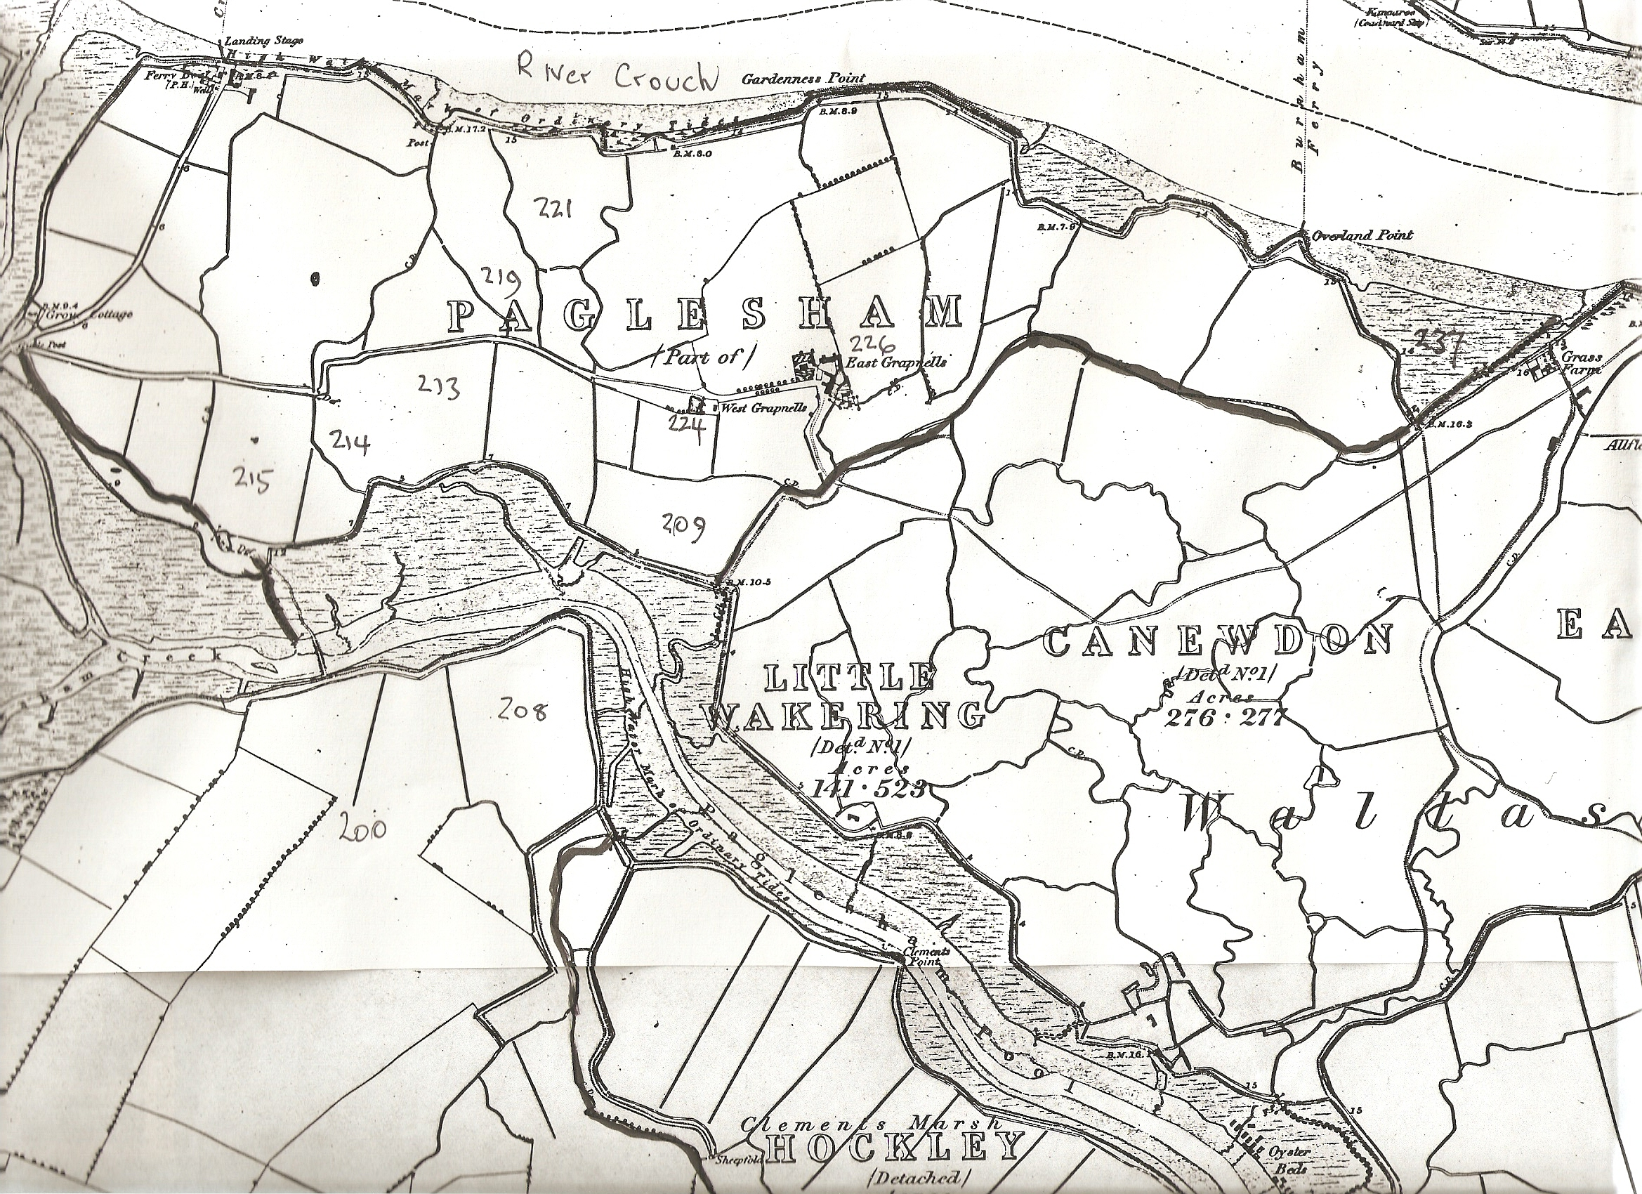
Map 1.
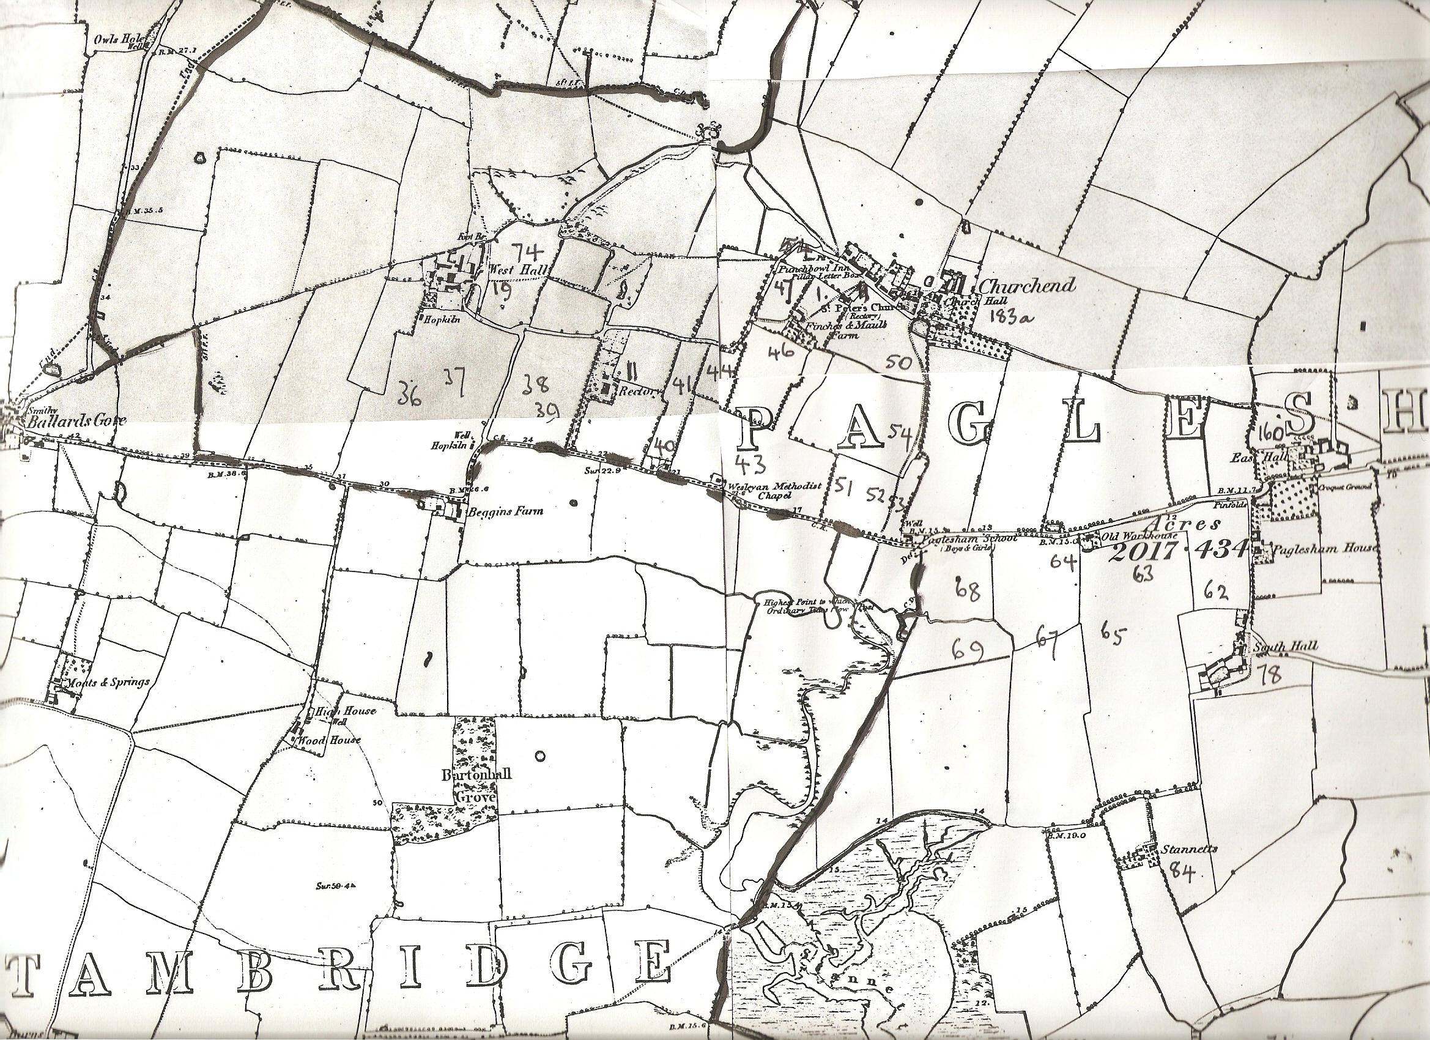
Map 2.
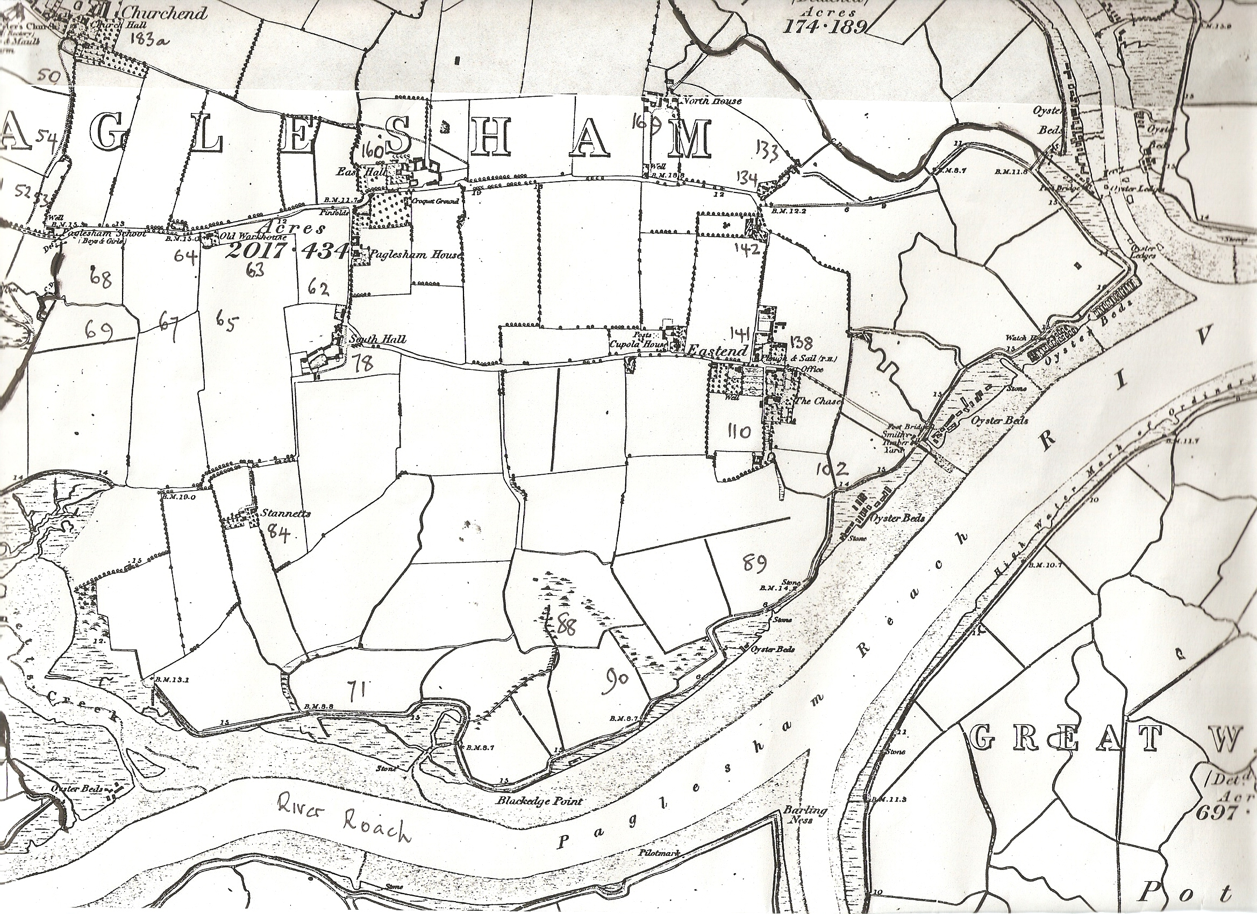
Map 3.

