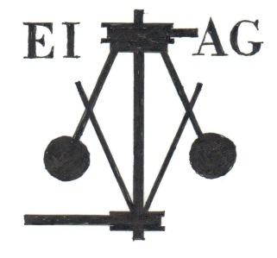
Essex Industrial Archaeology Group

NEWSLETTER

Number 1 October 2014

Welcome …

… to the first Newsletter for the Essex Industrial Archaeology Group (EIAG). We plan to produce one every couple of months or so initially, bringing Members up-to-date with events arranged by the Group and by the Essex Society for Archaeology and History, our parent Society, reports of visits, news from industrial sites and groups around the County, new publications, and events in neighbouring Counties.

Next Event

Saturday 1st November 2014, 10:30 a.m.
1st Anniversary Meeting

At Abbey Barn, St Marks College, Audley End, CB11 4JD.
Cost £7.00 including refreshments.
(£10.00 for non-members)

EIAG meeting followed by a talk by Prof. Marilyn Palmer on
‘The Use of Technology in Country Houses.’

This first anniversary meeting will start with a short time of EIAG business and hopefully a short talk about the historic St Marks College. The main item will be a talk by Professor Marilyn Palmer on Country House Technology with particular reference to Audley End House. After a short break when people will be able to buy lunch at the House if they wish, there will be an opportunity to visit the House (at extra cost of the usual admission fee unless you are an English Heritage member) to view the features mentioned by Marilyn, who will be on hand to point out and explain the features. Please Contact Dr Graham Gould to book and pay for this event. Email: drgegould@aol.com. Tel: 0208 556 1423.
Other up-coming events

Making Waves: How Marconi’s wireless legacy takes us ever further into space
When: 29 October 2014 @ 7:30 pm – 9:00 pm
Where: Anglia Ruskin University - Business School, Bishop Hall Lane, Chelmsford, Essex CM1 1SH UK
Cost: Free
Prof. Francesco Parasce Marconi, grandson of Guglielmo Marconi, the founder of the world’s very first wireless factory to Chelmsford, will talk about his grandfather, the Marconi family and how Guglielmo’s discoveries and inventions continue to play an important role in modern communications both here on Earth and far out into space. This brilliance and dedication however, had its personal costs in family and politics, Francesco will share his personal insight into an amazingly driven and visionary individual who had such a profound influence on creating the modern ‘connected’ world.
Please, ensure you book online at http://www.changingchelmsford.org/ai1ec_event/space-final-frontier-marconis-creative-legacy-wireless-technology-pushes-us-ever-onwards/?instance_id=915 or by calling 01245 684723.

Latest Visit

On Thursday 9th October 14 EIAG members visited the British Postal Museum & Archive store in Loughton. We had a guided tour of just some of the hundreds of items stored here. We concentrated on the road vehicles used to deliver the post from an 18th century mail coach through the various motorised vehicles up to an all-terrain vehicle. We were then guided through the development of the various designs for telephone boxes and post boxes, including some very unusual and rare examples of post boxes. We finally had some free time to look around other items including pneumatic tube railcars and Mail Rail vehicles. It was a very enjoyable and interesting visit which is highly recommended.

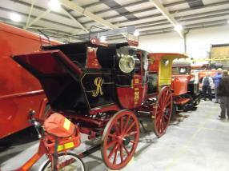
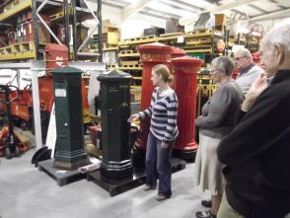
New Publication

On 30th August 2014 a new book was published titled, ‘THE WORKS A History of Rippers Joinery Manufacturers of Castle and Sible Hedingham’ by Pam and Adrian Corder-Birch. The book is about Rippers Limited, a joinery company which was started by three brothers in the 1890s that grew into a major employer in north Essex. It includes the hardship of the early days and gives an insight into how the company expanded, the products they made and the buildings where Ripper woodwork was used. A variety of wooden products were manufactured to help the war effort in the Boer, First and Second World Wars. It shows how the Colne Valley and Halstead Railway played an important part in Rippers development, the industrial buildings within the factory and the housing which they built for their workers. There is a history of the Ripper family and numerous references to employees. The book includes George Evans and Sons Limited later Evans Bellhouse Limited and William Kay (Bolton) Limited, two northern companies which they acquired. There is a particular emphasis upon buildings in Essex for which Rippers supplied the joinery including the Empire Theatre at Southend, Ilford Town Hall, County Hall and the Shire Hall at Chelmsford. Joinery was also supplied for many Essex Hospitals and Nurses Homes including Billericay, Colchester, Halstead and Romford. One speciality was ecclesiastical furnishings and carving which can be found in churches at Castle and Sible Hedingham, Maldon and Becontree. Joinery was also supplied for housing estates in Brightlingsea, Chelmsford, Feering and Harlow New Town. The book is A4 and contains 224 pages, over 250 illustrations, some being in colour and costs £14.95. It is available from Braintree District Museum, Colne Valley Railway and Sible Hedingham Parish Council Office or by post (plus £2.85 for postage and packing) from the authors at: Rustlings, Howe Drive, Halstead, Essex. CO9 2QL (email: corder-birch@lineone.net).

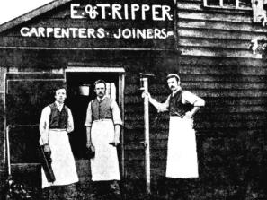
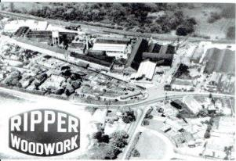

Left: The three brothers who founded Rippers, which was taken outside their first workshop in Castle Hedingham during the 1880s.
Right: An aerial view of The Works during the 1950s.

Help needed with Oral History Project in Halstead

The Halstead 21st Century Group has identified the 16 World War II air raid shelters in the town as a highly significant part of the town’s, and the county’s, heritage. The shelters, 15 of which are underground, were built by Courtaulds for their employees at the adjacent textile mill which was weaving silk for parachutes during the war. Not only are they campaigning for these shelters to be preserved, opened up to the public and interpreted, rather than have the land on which they are situated developed, but they are also about to embark on an oral history project to record the memories of former Courtauld employees from the town who used the shelters during the war. The Society would welcome more people to help with this project, especially people to undertake the oral history interviews. So if you or anyone you know has experience of oral history, or would be willing to undertake training in oral history, and has a few hours to spare each month then do get with the Group at info@halstead21stcentury.org.uk

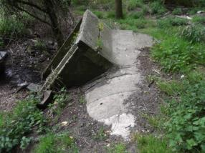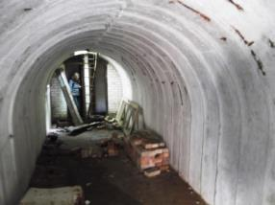

Left: External view of entrance to shelter Right: Internal view to escape ladder and toilet cubicles
Upminster Windmill

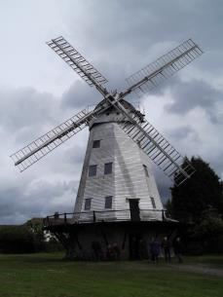
One of London’s handful of surviving windmills is to be saved, thanks to a grant of £1.4 million from the Heritage Lottery Fund (HLF). The Upminster windmill was built in 1803 and remained in use as a family- owned business grinding corn until the 1930’s. The Grade ll* listed mill is one of only six surviving with sails in Greater London, and is one of the most complete examples of a smock mill remaining in the country. The name refers to the sloping sides of the structure that gives the building the appearance of a countryman’s smock. The building is currently on English Heritage’s At Risk register and the HLF grant will enable Havering Council, which owns the site, working with Upminster Windmill Preservation Trust to restore the mill and bring the milling machinery back to full working order.
Although situated in the midst of a built-up area the five storey octagonal mill still sits in a one hectare open field setting. Archaeological research has identified 14 ancillary buildings that were associated with the mill during its more than 130 years of active life. As such, it gives a clear indication of the area’s industrial heritage during the Georgian and Victorian eras.

The restoration project will also create an education and training centre in a separate building that will allow public access for the first time to a wide range of historical documents. The centre will be able to host school visits, public workshops and training sessions in traditional skills associated with milling. CCTV installed in the mill will permit visitors who cannot access the upper floors of the structure to view the restored machinery in action. Volunteer researchers will record residents’ memories about local history and the project will create two apprenticeships in tourism and visitor attraction skills.
At present the mill is only able to open at limited times for guided tours about 30 days a year. Once the work is complete and the education and training centre is open visitor days are expected to increase fourfold

Pound End Mill, Braintree

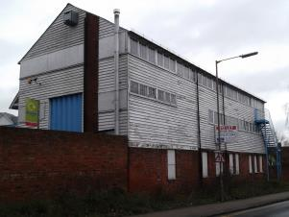
Pound End Mill, South Street, Braintree was built by Courtaulds in 1818 for their expanding silk weaving business, but it was sold to Daniel Walters in 1822 as Courtaulds acquired a water-powered mill in Bocking. It has a red-brick ground floor, the other two storeys being timber-farmed and weather-boarded, all under a slate roof. It is Listed Grade II and in the Conservation Area. Most recently it has been used for commercial purposes but has lain empty for some years. It is owned by Tesco, being on the site of their Braintree supermarket, but has not been maintained for years. Following representations by members of the Braintree & Bocking Civic Society and a local Councillor, Tesco have recently carried out remedial work to the exterior woodwork and paint which will hopefully keep this important building in good condition until a new use can be found for it.

First Wireless Factory in the World

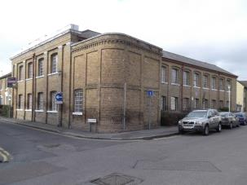
Marconi’s Hall Street, Chelmsford, wireless factory is currently the subject of development proposals. Originally built by John Hall as a silk warehouse in 1861, it was bought be Courtaulds to be used as a silk weaving mill between 1865 and 1894. Marconi used the building as his first wireless factory from 1899 to 1912 when Marconi’s New Street factory was opened. Now empty it is proposed to convert it into flats with possibly some commercial use of parts of the building. Considering the national, even international, significance of the building it would be a shame if it were all privately owned and not accessible by and interpreted for the public to learn from and enjoy. Alternative proposals being put together by former Marconi employees are for it to be a community resource to include a Marconi Heritage Centre and spaces for the local community and local organisations to use. The planning applications can be viewed at:
http://publicaccess.chelmsford.gov.uk/online-applications/applicationDetails.do?activeTab=summary&keyVal=NA8N4XBR0AS00

and
http://publicaccess.chelmsford.gov.uk/online-applications/applicationDetails.do?activeTab=summary&keyVal=NA8O18BR0AS00

Please do consider making comments on this development to the Planning Department and object to yet more flats which will deny public access to this historic building, but support its use as a Heritage Centre and community resource.

Essex Society for Archaeology & History

Some notices from the ESAH Hon. Deputy Librarian:

- The Society has begun digitising its back catalogue of Transactions. These will be made available to those who sign up / subscribe for free. Notification will sent out to members when each item is produced.
- The Society has its own blog - http://www.esah160.blogspot.co.uk/ - and twitter account, so members are encouraged to follow us.
- A project is beginning to improve the ESAH website.
- Finally, the Society has a book stall. The latest list of items for sale is on www.blackmorehistory.co.uk/esah.html

If you have any comments on the Newsletter generally or the items in it, or wish to make a contribution to the next Newsletter, please contact Tony Crosby at tcrosby.iah@outlook.com.

