Essex Industrial Archaeology Group
(Incorporating The Essex Mills Group)

NEWSLETTER

Number 48 April 2023

Welcome to this edition of the Essex Industrial Archaeology Group’s (EIAG) Newsletter

In this edition we have a detailed report on the ERO Conference on Railways of Essex and East Anglia written by Adrian Corder-Birch. Also an excellent article outlining the development of Upminster Windmill which was provided for us by Paul Sainsbury. There is news on three industrial heritage sites in various stages of conservation (or not!).

Please note the details of the EERIAC conference on 10th June in Chelmsford and book your place soon! It promises to be a very informative day with talks on the industries of the city and a personal view on one in particular – Marconi’s. There will also be a chance to view artefacts from the city’s industrial past in the museum and visit some of the sites in the Moulsham area.

If you have any comments on the Newsletter generally or specific items in it, or wish to make a contribution to the next Newsletter, please contact us via our email address - essexiag@gmail.com.

Contributions for the Newsletter should be sent by the end of the month prior to publication (i.e. by end of March, June, September and December), please. Please submit text as a Word document and photos as separate files such as jpgs.

Programme of EIAG events 2023

East of England Region Industrial Archaeology Conference
Saturday 10th June, 10:00 – 4:00 at Chelmsford Museum.

See Poster below for details of the day’s programme and booking

EIAG Annual Meeting
Saturday 11th November, 2:00 pm.
Further details TBC

Report of Essex Record Office Conference, 1st April 2023

Playing to the whistle: the railways of Essex and East Anglia

Over sixty people attended the railway conference and were welcomed by Martin Astell, Essex Record Office Manager – during which he read the poem, ‘The Age of the Train’, by Martin Newell.

First speaker: Jonathan Denby, Greater Anglia Head of Corporate Affairs – Transforming the railway: meeting the challenges of the post-pandemic world – from the Greater Anglia perspective. Jonathan Denby outlined his career in railways in which he has held a number of senior roles, latterly with Greater Anglia, which serves: London, Essex, Suffolk, Norfolk, Hertfordshire and Cambridgeshire and is now owned by Transport UK Group. Greater Anglia manages 134 stations and operates over 1200 trains a day, which are the best regional trains in the UK. There has been a recent £1.4 billion investment for 191 new trains resulting in more seats, increased comfort, better accessibility and safety. The new trains were described in detail, but the Marks Tey to Sudbury branch, which has no overhead lines, will still operate in diesel. The performance and feedback was very good. Other developments are in progress, but the pre-pandemic commuter service to London, is not yet up to former levels and Greater Anglia are looking to recover and win customers back. Delegates expressed concern about the use of ticket machines and online booking and prefer the retention of ticket office staff. Mr. Denby explained that stations have a button to press if help is required for tickets.

Second speaker: Jayne Sumner, Essex County Council Rail Engagement Manager – Essex and South Suffolk Community Rail Partnership, which was established in 1998 being one of 73 Community Rail Partnerships in the UK. The Annual Activity Plan includes promotional events and material, line guides, walk booklets, history boards, art work, defibrillators, benches (including talking benches), water dispensers and many more facilities. Rail safety and infrastructure improvements continue with efforts to try and get people to use trains, particularly the branch lines.

Third speaker: Dr. Colin Runeckles, Ilford Historical Society – The Impact of the Eastern Counties Railway on the village of Ilford in the late 1830s. Around 1835 two lines were proposed through Ilford, but in 1836 the present line was approved. Details were given of the acquisition of land from land owners and the demolition of 66 houses for the railway and station. With meticulous research the location of these houses has been found and upon demolition many of the materials were re-used. Some old roads were stopped up and some new roads were constructed. The line through Ilford opened on 18th June 1839.

Fourth speaker: Graham Rowland – The Holden F5 Locomotive Trust – Building a steam locomotive for the 21st century. The history of the F5 locomotive was outlined, which was used throughout East Anglia by GER and many passed to LNER in 1923. Of particular interest were some locomotives used on coastal lines during the Second World War, which had additional armour and were camouflaged. Unfortunately steam ended quickly in the Eastern Region. Details were given of the early Steam Railway Preservation Societies such as the Talyllyn Railway Preservation Society founded in 1950, being the first narrow gauge railway saved and the Bluebell line, which was the first standard gauge railway saved in 1959. From 1968, 213 locomotives were saved from Woodham Brothers scrap yard in Wales, thanks to Dai Woodham. A detailed history of 71000 Duke of Gloucester was given which returned to steam in 1986; 6023 King Edward II, which moved under its own power in 2011 and 60163 Tornado established in 1990 and moved under its own steam in 2008. Sadly, none of the F5 class survived into preservation and therefore ‘The Holden F5 Steam Locomotive Trust’ was formed to recreate it. Detailed drawings, now stored in the ERO were vital to manufacture the components. A workshop at Ovington, Essex was used from 2003 for the manufacture of buffer beams, footplate supports, smoke box, chimney and bunker. The bunker was completed and other parts made by Hunwicks of Halstead in 2010. Other castings were made in a variety of foundries and workshops. Good progress is continuing and to see ‘GER 789’ in steam is eagerly awaited. This presentation ended with a short film of the Epping Ongar Railway, which was one of many railways where F5s operated.

Fifth speaker: Nigel Bowdidge, Vice President of the Great Eastern Railway Society, gave a talk titled – All Things, Great Eastern. He gave a brief history of GER from 1862 to 1922, when it was incorporated into LNER during the 1923 grouping. GER nearly had a monopoly in East Anglia, with a few exceptions including the London, Tilbury and Southend Railway, the Colne Valley and Halstead Railway, the Mid Suffolk Light Railway and the Southwold Railway. The history of the Eastern Counties Railway was also outlined. It reached Colchester in 1843 and Norwich in 1849. The main lines were followed by the construction of branches and cross-country lines, which were lightly built and followed river valleys, such as the Colne, Crouch and Waveney valleys. The GER came into being in 1862 and its main constituents included the Eastern Counties Railway, Eastern Union Railway, East Anglian Railway and Norfolk Railway. The GER operated main line, suburban and extensive cross-country, branch lines, coastal and continental services. Within the area, which was mainly covered by GER, the Wisbech and Upwell Tramway, was formed in 1883. Following the Light Railways Act 1896, the Benwick Goods Railway was established in 1897; the Kelvedon and Tollesbury Light Railway in 1904 and the Elsenham and Thaxted Light Railway in 1913. Information was also given about locomotives including the Claud Hamilton, E4 and J15 together with the extensive Stratford Works and coal traffic.

Sixth speaker: Lyn Brooks, Archivist, Great Eastern Railway Society – Highlights of the GERS Historical Collection. Following the formation of GERS the speaker was appointed as archivist and started with some twenty odd documents. Over the years this has extended to a massive archive of thousands of records, which are now held in the ERO. These include photographs, plans, drawings, timetables, scrapbook’s, legal agreements, signalling diagrams, rolling stock records, accidents reports, weekly operating instructions, Bradshaw’s guides and many other documents. This well illustrated talk included photographs of the Decapod, an experimental Class A55 locomotive used by GER from 1903. Mr. Brooks and other speakers emphasised the huge value of the GER collection held by the ERO for researchers.

The next speaker was specially introduced by Neil Wiffen, MA, an, Archivist at Essex Record Office.

Seventh speaker: Malcolm Root, FGRA, professional transport artist – Painting the past in colour. As the last speaker, he commenced with thanking the ERO for organising the conference, which was warmly supported by delegates. His interests in both art and railways followed a parallel path from an early age and began with seeing an illustration of Thomas the Tank Engine, when he desired to become a railway and transport artist. An early influence was the picture, ‘Evening Star’, by Terence Cuneo. Malcolm explained the process of two of his paintings starting with the locomotive, Princess Elizabeth, crossing a bridge at Low Borrowbridge, which he painted for the late Queen’s Platinum Jubilee last year. He showed various preliminary sketches and explained about perspective and vanishing points. The background, colours, vegetation, buildings, groups of figures and reflections are all important. He usually starts painting the background at the top of the canvas. Many of his paintings have since been converted into jigsaws, calendars, cards, plates and even appear on four Grenada postage stamps. Ten of Malcolm’s paintings, including five of Essex railways, were on display in the Walker Room at the ERO and were admired by delegates for their accuracy.

Conclusion: Martin Astell summed up the day and what he had learnt about railways in Essex. He was delighted to learn that the railway records, which were held and preserved in the ERO, were being well used and the drawings go right down to nuts and bolts. He thanked all the speakers and also thanked Neil Wiffen for putting the day together.

This was an excellent conference, with good speakers who all showed brilliant illustrations. The day passed by all too quickly and a second railway conference in the future will be very welcome.

Adrian Corder-Birch
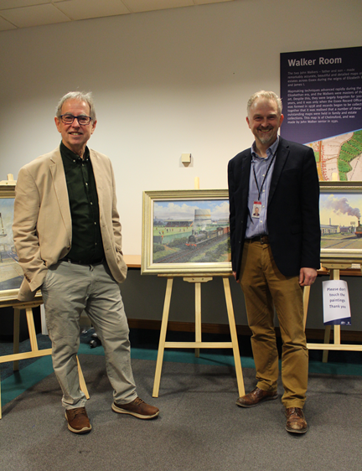

Left: Malcolm Root, F.G.R.A., (Professional Transport Artist) and Martin Astell (Essex Record Office Manager)

(Photograph by Neil Wiffen)

Below: A few of Malcolm Root’s paintings displayed at the Essex Record Office

(Photograph by Edward Harris)

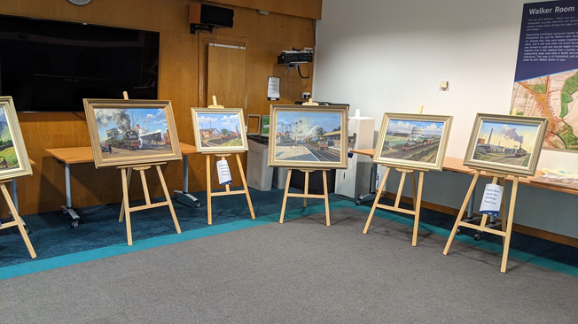
The Evolution of Upminster Windmill
The Beginning
- Upminster Windmill was established by James Nokes.
- James Nokes was a farmer from Stifford.
- He moved to Upminster in 1793 and became a Tenant Farmer at Hunts Farm in Corbets Tye Road.
- James Nokes was a devout non-conformist and one of three people who guaranteed the money for the building of the Old Chapel on Upminster Hill (Circa1800).
- In 1801 James's younger brother William took over the tenancy of Bridge House Farm.

Land Acquisition
- By November 7th, 1803, James had acquired, from his brother William, the land belonging to Bridge Farm, north of Upminster Hill.
- It was on this land, on the highest point (which was 200 feet above sea level), that James had Upminster Windmill built.
- James also had 2 Tenements built on the eastern side of the land at Station Road, one of which became the bakery.
- By September 16, 1805, the land had been registered as mill land, and by December 9, 1805, Upminster Windmill was up and running.
- These dates are confirmed from the land rateable values.
Buildings
When the Windmill was constructed, it would not have been a lone building, it would have required a granary and a meal room.
The archaeology of the two granaries and meal room, show that these three buildings appear to have been built around the same time as the Windmill.
It appears the meal room was the first to be built and attached to the windmill, with the two granaries attached to the meal room.
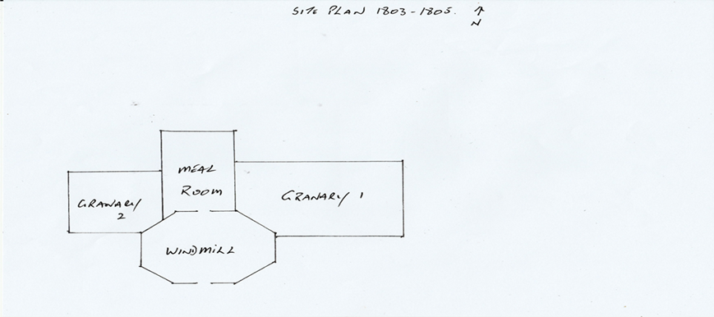

Addition of a Steam Mill
- As there was a great need for flour, due to the French Revolutionary War, a Steam Mill was added to Upminster Windmill during 1811.
- This was early for steam driven engines in windmills.
- Thurrock Windmill, also run by the Nokes family had steam around the same time.
- The steam mill was up and running by June 12, 1812.
- This was confirmed by the increase in the rateable value of the mill land.
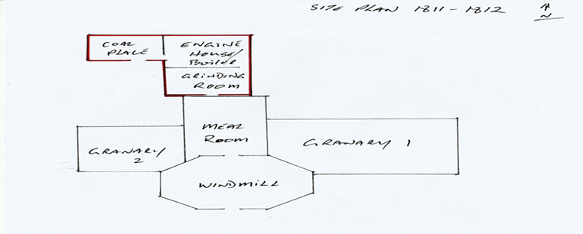
- The Steam Mill consisted of three buildings, built to resemble one large building, and a tall chimney. The first building, butted up to the meal room, was the grinding room. This contained the grain storage, two sets of stones and the mechanisms to turn the stones. The next building contained the steam engine, flywheel, and boiler. The last building contained the coal required to stoke the boiler.

The following document is a transcript of the agent’s log from 1818. It lays out all the buildings and machinery on the windmill site and the sums insured for.
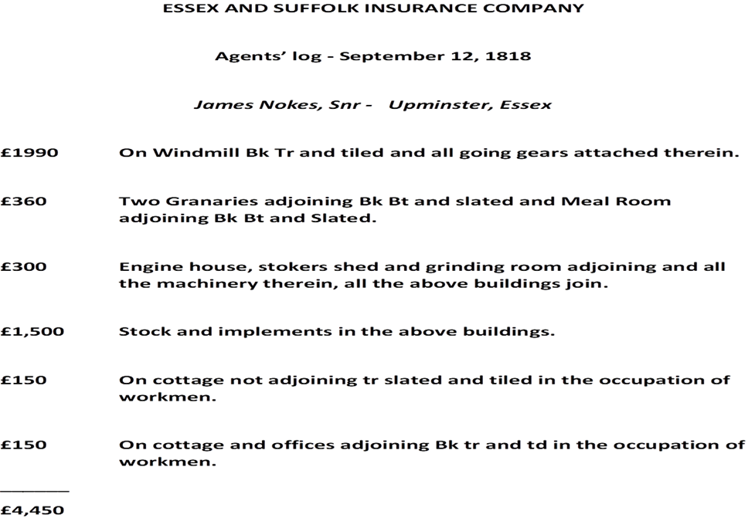
We know what the site looked like in 1849, from an auction catalogue and plan, when the site was put up for auction. According to the auction catalogue there was a “substantial mill house built about 10 years prior”, which puts it around 1839.The rateable values for 1840 indicates there was a house included with the mill. The 1841 census shows the mill house and mill cottage, as does the 1841 tithe map.
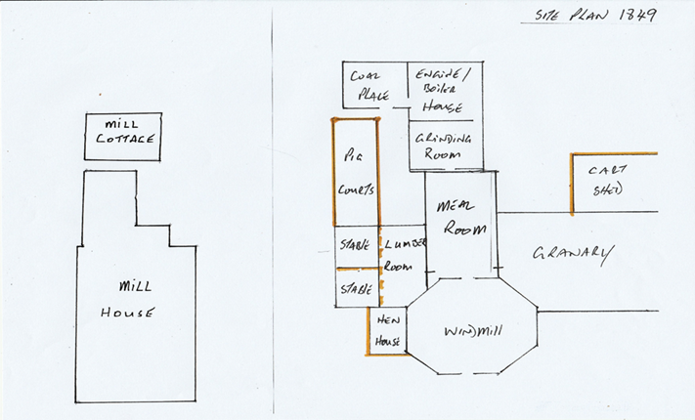
According to the 1896 map, more changes were made to the windmill site.
A new 2 storey stable block had been built against the northern boundary. This block consisted of stalls for 3 horses, a cart shed, what we think was a forge and a lean-to with a brick lined pit. The first floor was a hayloft and horse food store.
There was also another cart/utility shed on the eastern boundary.
The pig sty appears to have been moved and upgraded.
The mill cottage had been rebuilt, nearer to the steam mill and new stables.
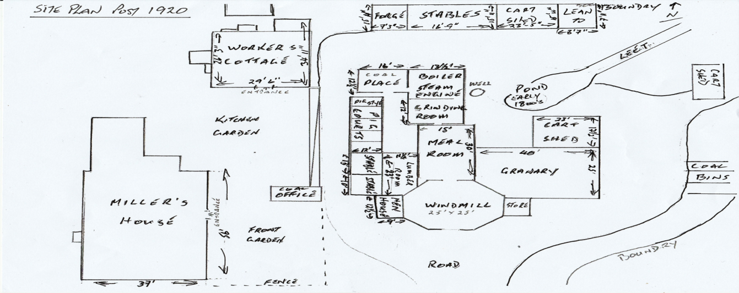
According to the Lloyd George doomsday map of 1911, further additions had been made to the site. These occurred between 1897 and 1911.
A coal office was added opposite the hen house.
Several wooden coal bins were added on the eastern boundary.
There was a transient room on the eastern side of the windmill on the same alignment as the hen house. This appeared on some maps and not on others. This is shown on the 1911 and 1920 maps, and we know it was used initially to weigh the bags of coal before delivery. At a later date it was used as a storeroom for paint.
The 1920 map shows no further additions; therefore, this was the last expansion of the site.
One item that has never been shown on any map or any database, that is the well……a well-kept secret.
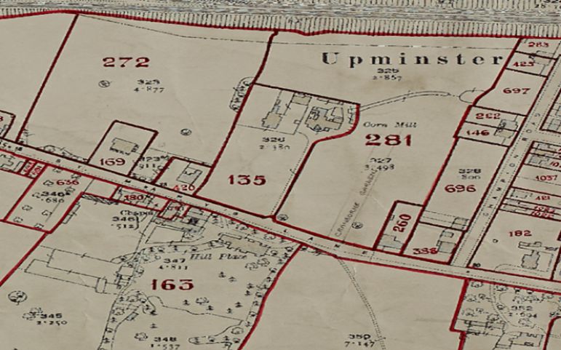
Upminster Windmill ran a coal business in the early 1900s, and due to the lack of corn was producing mainly animal feed and dog biscuits.
The windmill ceased working in 1934, although the coal business continued from Upminster Station into the 1950s.
Lloyd George Doomsday map 1911
Ridley’s Brewery, Hartford End

Following on from the feature on the Wethersfield Brewery in edition no.47 of the newsletter, I have also recently re-visited the former Ridley’s Brewery at Hartford End. Previous visits were in July 2002 when undertaking the ECC Comparative Survey of Essex Breweries, and December 2004 when undertaking the ECC Comparative Survey of Industrial Housing, at which times it was still in operation.

Thomas Dixon Ridley inherited the Hartford End water mill from his father and following his marriage into the Wells brewing family, built his own brewery downstream from the mill on the River Chelmer in 1842. Thomas continued to expand the business and following his death in 1882 it remained in the family, becoming a limited company in 1906. The company also built four cottages on the site in Mill Lane for the staff of the brewery. In 2005 Ridley's was bought by Greene King for £45.6 million, and they then closed the Hartford End brewery ending over 160 years of independent operation by the one family. The brewery survey report recommended that the brewery buildings be Listed Grade II, while the housing survey recommended some protection for the cottages. These were not implemented.

Since closure the site has been re-developed for housing, although some of the brewery buildings (top photo) and the four workers’ cottages (bottom photo) have been retained, although adapted to their new use.

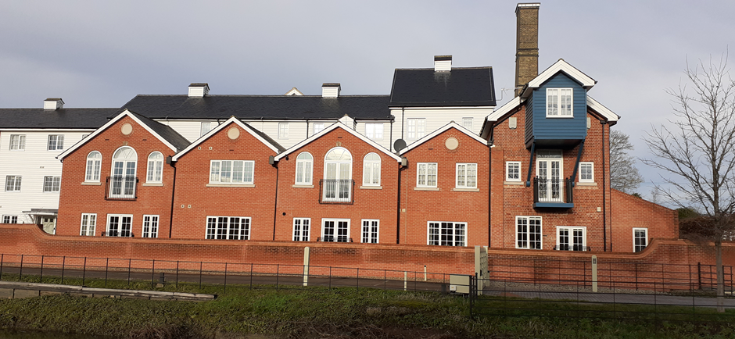

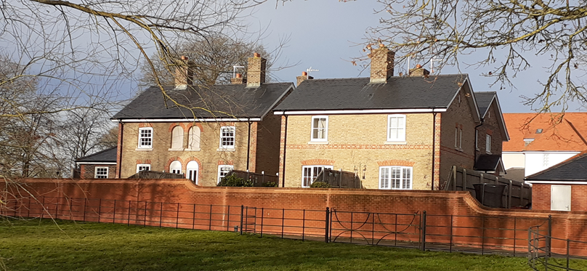
Text and photos – Tony Crosby
Woodfield Cottages, Heybridge

Woodfield Cottages in Heybridge were built in 1873 by the industrialist E H Bentall as homes for his employees. The 41 single-storey cottages are a pioneering example of mass concrete construction.
Although the cottages were Grade II listed in 1971, several have been altered in ways that detract from their traditional character, and some are in poor repair.
The cottages have been designated as a conservation area, and the potential for a Conservation Area Partnership Agreement between Historic England and Maldon District Council is being explored.
Success would make grant funding available to cottage owners for historically sensitive repair and restoration work.

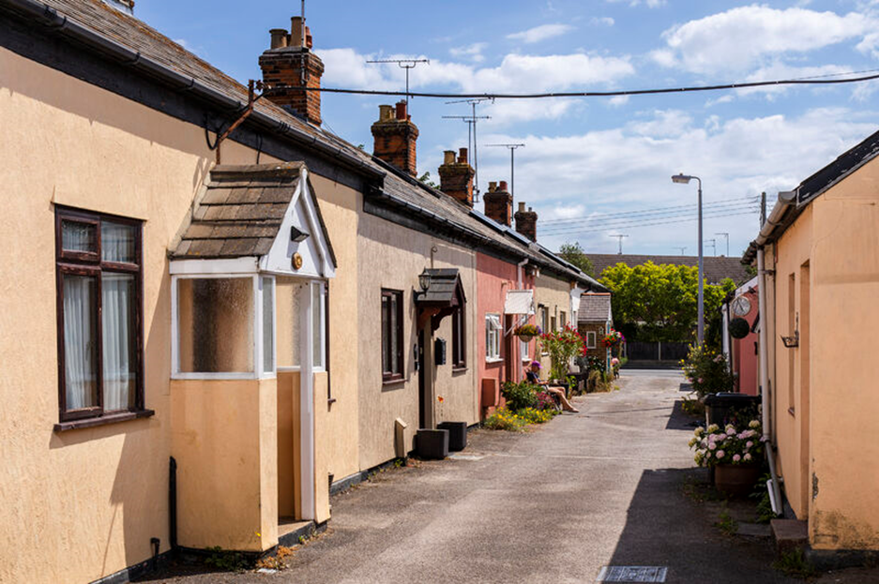

Photo – Historic England

Felsted Station

The former Bishop’s Stortford, Dunmow and Braintree branch line was opened in 1869 as part of the second phase of railway construction in Essex – filling the gaps between the main lines built during the railway mania phase. Four new stations were built on the branch at Takeley, Dunmow (now demolished), Felsted and Rayne, along with four halts. All four stations were built in the Great Eastern Railway corporate ‘Italianate’ style.
Principally a freight line, one of the agricultural industries served was the British Sugar Corporation’s sugar beet processing factory at Felsted, built in 1926. Passenger services were always a secondary function and in 1952 passenger services ceased, while freight services continued until the final total closure of the branch in 1972. The Essex part of the former line was acquired by Essex County Council, being designated a Country Park in the early 1990s – the Flitch Way.

Dunmow Station was demolished in the early 1970s; Rayne Station is the Flitch Way Visitor Centre, café and museum and is Listed Grade II; Takeley Station is a private residence.

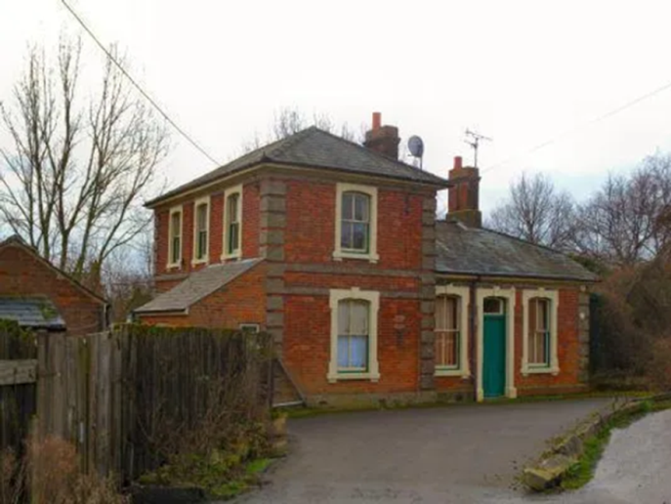
Felsted Station was sold for conversion to a private residence and saw some restoration and extension. The photo on the top left shows it in about 2013 in its original form.

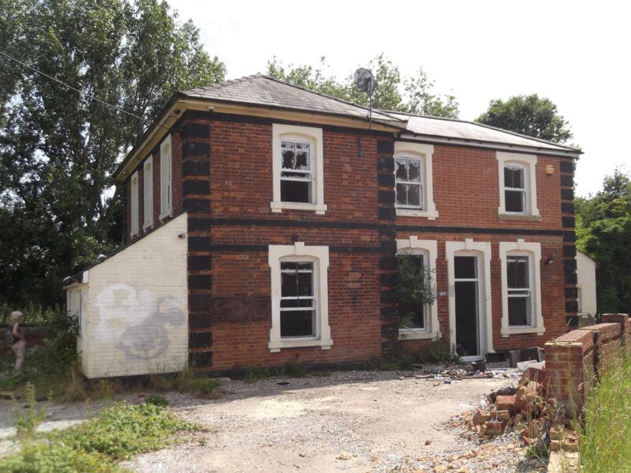
However, it is now vacant, derelict and greatly vandalised, the surrounding ground being used as a dumping area for building materials and other rubbish. Planning permission has now been granted for the demolition of the station as part of the development of the site for housing.

Photo right taken in 2022 showing how it had been restored and extended.

Tony Crosby

