Essex Industrial Archaeology Group
(Incorporating The Essex Mills Group)

NEWSLETTER

Number 49 July 2023

Welcome to this edition of the Essex Industrial Archaeology Group’s (EIAG) Newsletter

In this edition we have reports from two recent events and notice of forth-coming events into the autumn. There is excellent news of the re-opening of Upminster Windmill and more excellent news, this time of grant funding for the restoration of ‘Jumbo’, the iconic water tower in Colchester. Elphin Watkin has provided a very informative article of the history of the Harwich Harbour Lights. Finally there is notice of a new book from the pen (or should that be keyboard?!) of Adrian Corder-Birch.

If you have any comments on the Newsletter generally or specific items in it, or wish to make a contribution to the next Newsletter, please contact us via our email address - essexiag@gmail.com.

Contributions for the Newsletter should be sent by the end of the month prior to publication (i.e. by end of March, June, September and December), please. Please submit text as a Word document and photos as separate files such as jpgs.

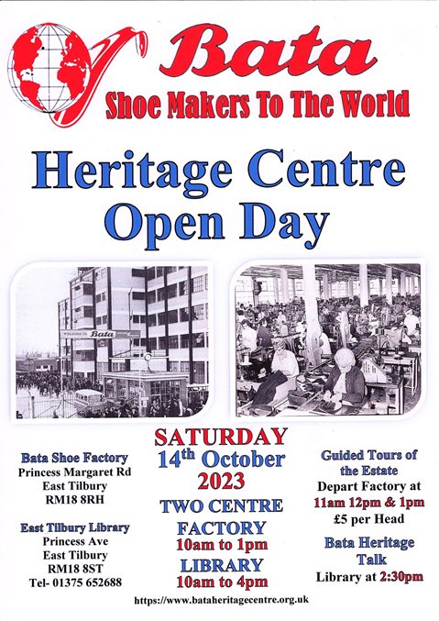

Programme of EIAG events 2023

Tuesday 15th August, 10:30 am. Beeleigh Mill, Maldon, CM9 6LL. Tour of the Mill. Cost £10.There have been water mills on this site since 1066. Steam power has been used since 1845 when the surviving Wentworth beam engine and elephant boiler were installed. Limited parking. Please book with the Excursions Secretary.

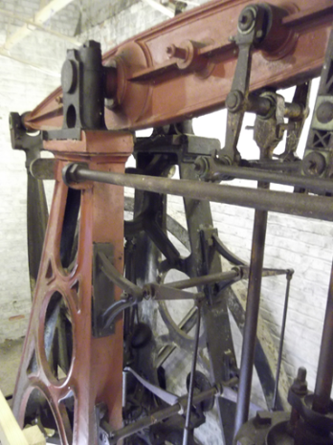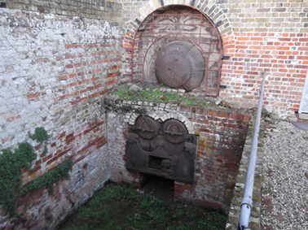

EIAG Annual Meeting at Chelmsford Museum, Saturday 11th November, 2:00 pm. Free for members, £2 for non-members.

As well as the usual business of the Annual Meeting we have the pleasure of welcoming our guest speaker Peter Wynn who will be giving a talk on
The Christy family of Broomfield: the rise and fall of their engineering businesses
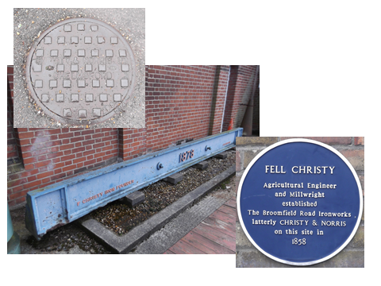

New Publication

A Centenary History of the Courtauld Homes of Rest 1923-2023
By Adrian Corder-Birch

This book is a history of Almshouses in Halstead and District with an emphasis upon the Courtauld Homes of Rest in Halstead, which is celebrating its centenary. In 1923 Samuel Augustine Courtauld built twenty almshouses on the site of the former Halstead Workhouse. The concise history of the Workhouse, its demolition and the Halstead Board of Guardians has therefore been included. A biography of the founder and his other generous benefactions are outlined. The wonderful architecture, the construction of the homes and one hundred year history has been detailed together with the gardens, grounds, allotments, spinney and meadow. The personalities comprising the trustees, chairmen and clerks, are the subject of brief biographies. Importantly, the residents who occupy the homes and the contractors who maintain them have not been forgotten.

The book also includes a short history of other almshouses in the surrounding villages, particularly at Castle Hedingham, Earls Colne, Great Yeldham and Sible Hedingham. The history of the former almshouses in Castle Hedingham has been traced back to the seventeenth century, but only the picturesque Webster Almshouses at Sible Hedingham still survive.

Also included is brief information about the association of Samuel Augustine Courtauld and other members of the family to Samuel Courtauld & Co, later Courtaulds Limited, textile manufacturers, and details of industrial housing in Halstead built by members of the family and the company.

The book is available from the author at: Rustlings, Howe Drive, Halstead CO9 2QL price £15 plus £2.50 postage and packing – cheques payable to: Adrian Corder-Birch.

Balkerne Tower Trust – ‘Jumbo’

The following excellent news has been gleaned from the Balkerne tower Trust (BTT) annual report:

“In July [2022] it was announced by North Essex Heritage (NEH) that the architects Purcell, with HQ in London but an office in Colchester, had won the competitive tender to lead the restoration of Jumbo. During August, a team of volunteers carried out a comprehensive clean of the inside of the tower. In September, for the first time, Jumbo was opened to the public as part of Heritage Open Days. The available 120 places on guided tours were booked very quickly. In February [2023], after much preparation by NEH, a Stage 1 (development phase) application for a Heritage Enterprise Grant (including a letter of support from BTT) was submitted to the National Lottery Heritage Fund (NLHF). In early July it was announced that the NLHF has awarded £250,000 towards the development phase, a landmark achievement. Funding will be also be needed from other bodies and if forthcoming, a stage 2 (delivery phase) grant application to the HLF will be made in 2024.”

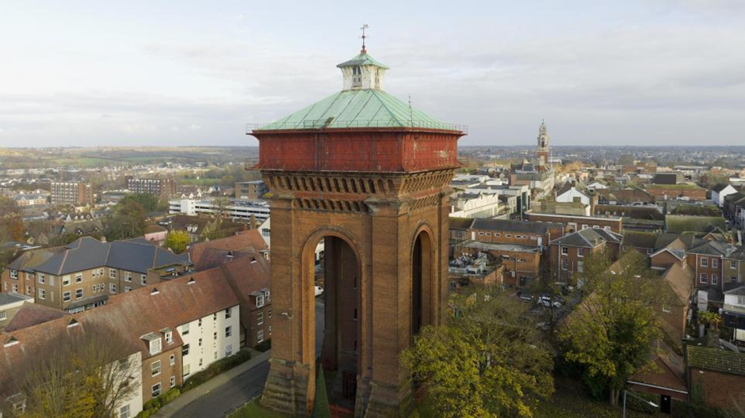
Photo credit: North Essex Heritage

The Windmills of Ashdon

The Saffron Walden Historical Journal, Spring 2023, edition no. 45, includes a fascinating article by Gillian Brooker entitled The Windmills of Ashdon. Following a brief hsitory of windmills in England and a description of the three types of windmill, Gillian then outlines the histories of the windmills of Ashdon – Church End Mill, Nuts Green Mill, Radwinter Road Tower Mill and Bragg’s Mill, a post mill. The latter is the surviving windmill in the village, built in 1757 and restored in the early 2000s. The article continues outlining Bragg’s Mill’s 20th century history and concludes with a details of the recent restoration. The article is illustrated by ten figures including historic views of the mill. A recent photo of Bragg’s mill can be found in the EIAG newsletter of September 2021, no. 42.

In the same edition of the Saffron Walden Historical Journal is an article by Malcolm White entitled Saffron Walden Borough Council: the provision of public services 1835-1974. The article covers such public services as law enforcement, housing, highways and public health.

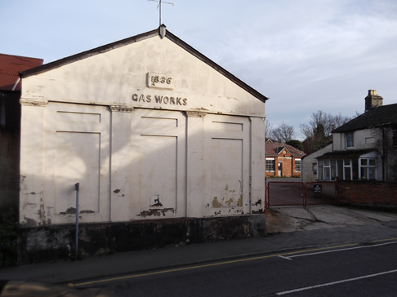
In the section on local utilities the author covers the gas works, public water supply and sewage. The article is illustrated with twelve images and a timeline of the various services. One of the images is of the gas works on Thaxted Road as it was in 1836 – the photo (left) is of one of the surviving buildings.

Text and photo: Tony Crosby
HARWICH HARBOUR LEAD-IN LIGHTS
Elphin Watkin
Harwich has been a major harbour and ship building and repair centre developed over hundreds of years. By the 17th century a packet service commenced to the continent soon increased to a daily service which still exists. Trinity House started by Henry VIII in the early 1500’s has its main operational base at Harwich.
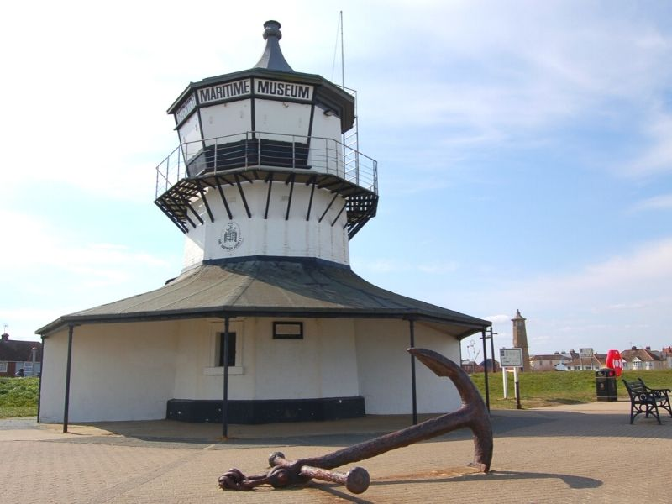
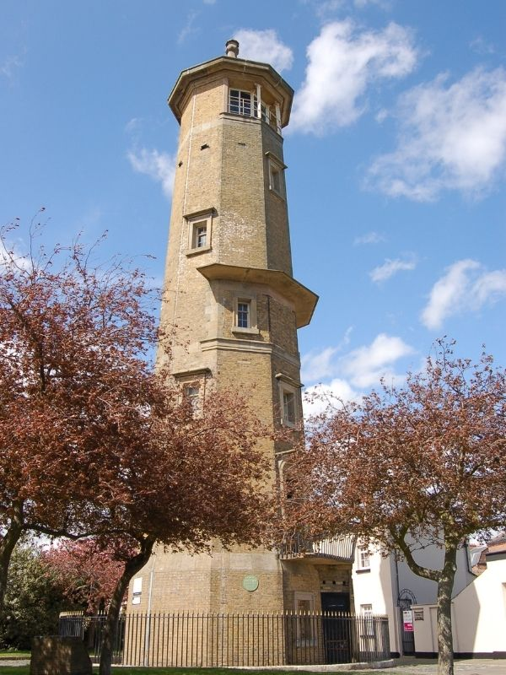
The first lights were ‘fire’ lights. One mounted over the Town gateway and another on the coast edge. Aligning the two lights enabled ships to take the correct approach into the harbour mouth. The illustration shows them in the 18th century.
By the early 1800’s with further increases in use new High and Low lighthouses were designed by John Rennie and in use from 1818 until 1863. They were eventually purchased by the Town Council in 1909 and still exist today. The Low one as a Maritime Museum.
New lighthouses commissioned by Trinity House in 1862 were built a little further south off Dovercourt due to shifting sand bars in the Stour estuary and in service from 1863. These again were at differing heights to enable ships to align with them to take the correct way into harbour. By 1917 even these were obsolete and since then a system of marker buoys has been used. The list description for these two lights says that they are believed to be unique in the use of prefabricated structure and advanced use of materials and construction methods. A most important one was the early use of screw pile foundations driven deep into the soft ground. They appear to have been very successful as the lights do not appear to have moved. Now also owned by the Town Council a major structural survey was commissioned this year to see what works may be needed to keep these very rare metal structures in good order. The Dovercourt lights marked a milestone in the history of lighthouse design and in the sequence of navigational aids developed for this important harbour now able to take the world’s largest container ships visiting Felixstowe docks.

The lighthouses during the survey. This one the land side. The other had to be surveyed at low tide.
The land side light The light on the groin

Report prepared by Jane Giffould
Cannock Mill, Colchester
As an EIAG stand volunteer at Bourne Mill for the Mills Open Day I found this to be an interesting and enjoyable event. It was well attended by local and other visitors who enjoyed both the NT maintained mill and the general setting of the mill pond and surrounding woodland.
The mill is one of a number which once operated on the Bourne stream, and a NT leaflet provides details of a local walk which I took a break to explore. It proved to be a pleasant ten-minute stroll through woodland following the stream down the valley to Cannock Mill. The area is well maintained by the Council and has, for much of the route, a wooden walkway raised above wet parts of the valley floor. Surrounding houses are masked by trees creating an oasis of peace on the outskirts of Colchester. The path passes a first mill pond, now available for fishing, then a second pond which has been restored immediately to the rear of Cannock Mill.
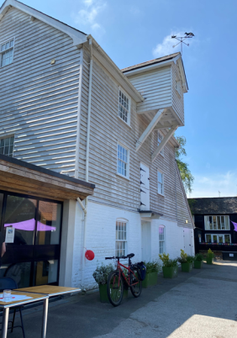
The mill site as a long-recorded history. It belonged to St. Botolph`s priory and is mentioned in a document of 1311 as `the mill near Wick or the old mill in the wood`. It is believed to have been rebuilt as an overshot mill in c 1600, then having two ponds. It was rebuilt again in the early 1800`s, having three storeys and a hoist loft, with slate roofs. It was variously used for milling grain and for fulling.
It was not in use for much of the later 20th century. However, it was listed as Grade ii and was maintained for many years by a sensitive owner who lived in an adjacent Victorian house. The house, mill and surrounding land were acquired and redeveloped for a cohousing development which was completed in 2019. This is made up of 23 separate residential units for which the former mill serves as a communal space for all the residents.
The photo shows the quality of the external restoration of the mill. The community had opened the building for public tours on that day but there was not time for me to do a full internal tour. However, the interior has been fully renovated to provide a communal kitchen and drawing room, lounge, library, guest rooms and workshops, all with disabled access. Following completion of the development it won `Best Community or Group Self Build Project` at the Build It Awards.
Text and photo: Dave Buckley

East of England Region Industrial Archaeology Conference

On 10th June we hosted this year’s EERIAC at Chelmsford Museum, which proved to be a very successful event. Attendance was 28, the highest since pre-covid times, with delegates coming from the Norfolk, Suffolk and Cambridge IA Societies as well as EIAG members. Feedback at and after the event was very positive and complimentary. In the morning Alan Pamphilon gave a very concise history of Chelmsford’s extensive industrial past, then followed by Brian Izzard who shared his personal reflections of working for Marconi’s. After the lunch break delegates had an opportunity to view the displays in the museum particularly those relating to Chelmsford industries and take part in one of three guided walks around the Moulsham area to view some of the important industrial sites such as Clarkson’s National Steam Car Company, Crompton’s Arc Works and John Hall’s silk mill which became Marconi’s wireless factory.

As well as looking up at these important historic buildings on the walks, we also looked down at the roads and pavements to spot the ironwork associated with the water supply industry and drainage many of which were manufactured in Chelmsford by Christy and Norris at their ironworks in Broomfield Road. We will be hearing more about Christy's at our Annual Meeting on 11th November when Peter Wynn will be giving a talk on The Christy family of Broomfield: the rise and fall of their engineering businesses. (See details above.)

Tony Crosby

Industrial Heritage Fair 2024

We are already beginning the planning for the EIAG’s fifth Industrial Heritage Fair to be held in 2024. It is proposed that it will be a joint event with the National Trust held in their Grange Barn in Coggeshall on Saturday 14th September 2024, which is during Heritage Open Days. We will also discuss with the local history organisations and sites what input they could have during the day. Save the Date!
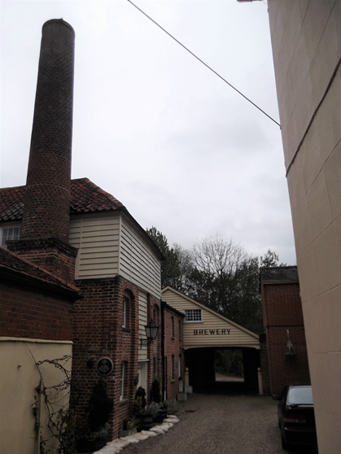
Coggeshall has a wealth of industrial history – milling, textiles (both wool and silk), malting and brewing, the production of isinglass for the brewing industry, a smithy and a foundry. We shall also seek to involve the Museum and the Coggeshall Society, and we have already had the offer of tours of Coggeshall Mill. Full details will appear in this Newsletter as plans progress and are firmed up, so watch this space!

Photo of Coggeshall Brewery – Tony Crosby

Upminster Windmill is now Open

Paul Sainsbury
Upminster Windmill was built by a local farmer called James Nokes. He acquired the land on 7 Nov 1803. By 16 Sept 1805 the windmill had been built. It was up and running by 9 Dec 1805. As the wind was unreliable, a steam mill was added and was in operation by 7 June 1812. The windmill continued working, via several owners until it closed in 1935.

The mill had been neglected throughout WW2 and had begun to fall apart. During this period, the mill field (as part of the Dig For Britain) was entirely converted into allotments. In 1960, all 16 buildings (inc. mill house and cottage, steam mill and various stables and granaries) on the mill site, with the exception of the windmill, were demolished. Over the following years, various attempts (by the Friends groups) were made to keep the windmill intact.

Finally, in 2016 funding was received via the National Lottery Heritage Fund, Veolia Environmental Trust, and the partnership between the Friends of Upminster Windmill and London Borough of Havering. This also included many thousands of volunteer hours. Work began to completely restore the windmill to full working order, which was completed in the spring of 2023. The windmill is now fully functioning and is able to grind corn/wheat. A new digital telemetry system called. Smartmolen has been installed to monitor the behaviour of the cap and sails. This has been rolled out to several other mills across the country. The windmill is a Grade ll* listed building, and in terms of quality, completeness, and significance it is widely considered to be amongst the very best remaining English smock mills.

Upminster Windmill opened to the public in May 2023. Please visit our website www.upminsterwindmill.org for further information, bookings, and open days. Our garden and Visitor Centre are also open.

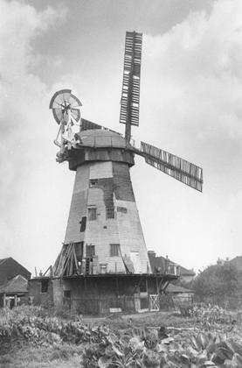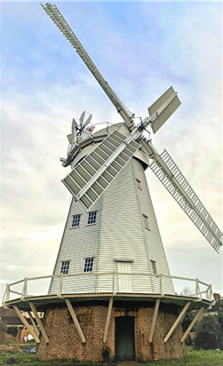
Post War Post Restoration

