THE PLACE-NAMES

OF CHADWELL St. MARY

Recorder: James Kemble

Essex Place-names Project (Essex Society for Archaeology & History), 2013 (e-book).

www.essex.ac.uk/history/esah/essexplacenames

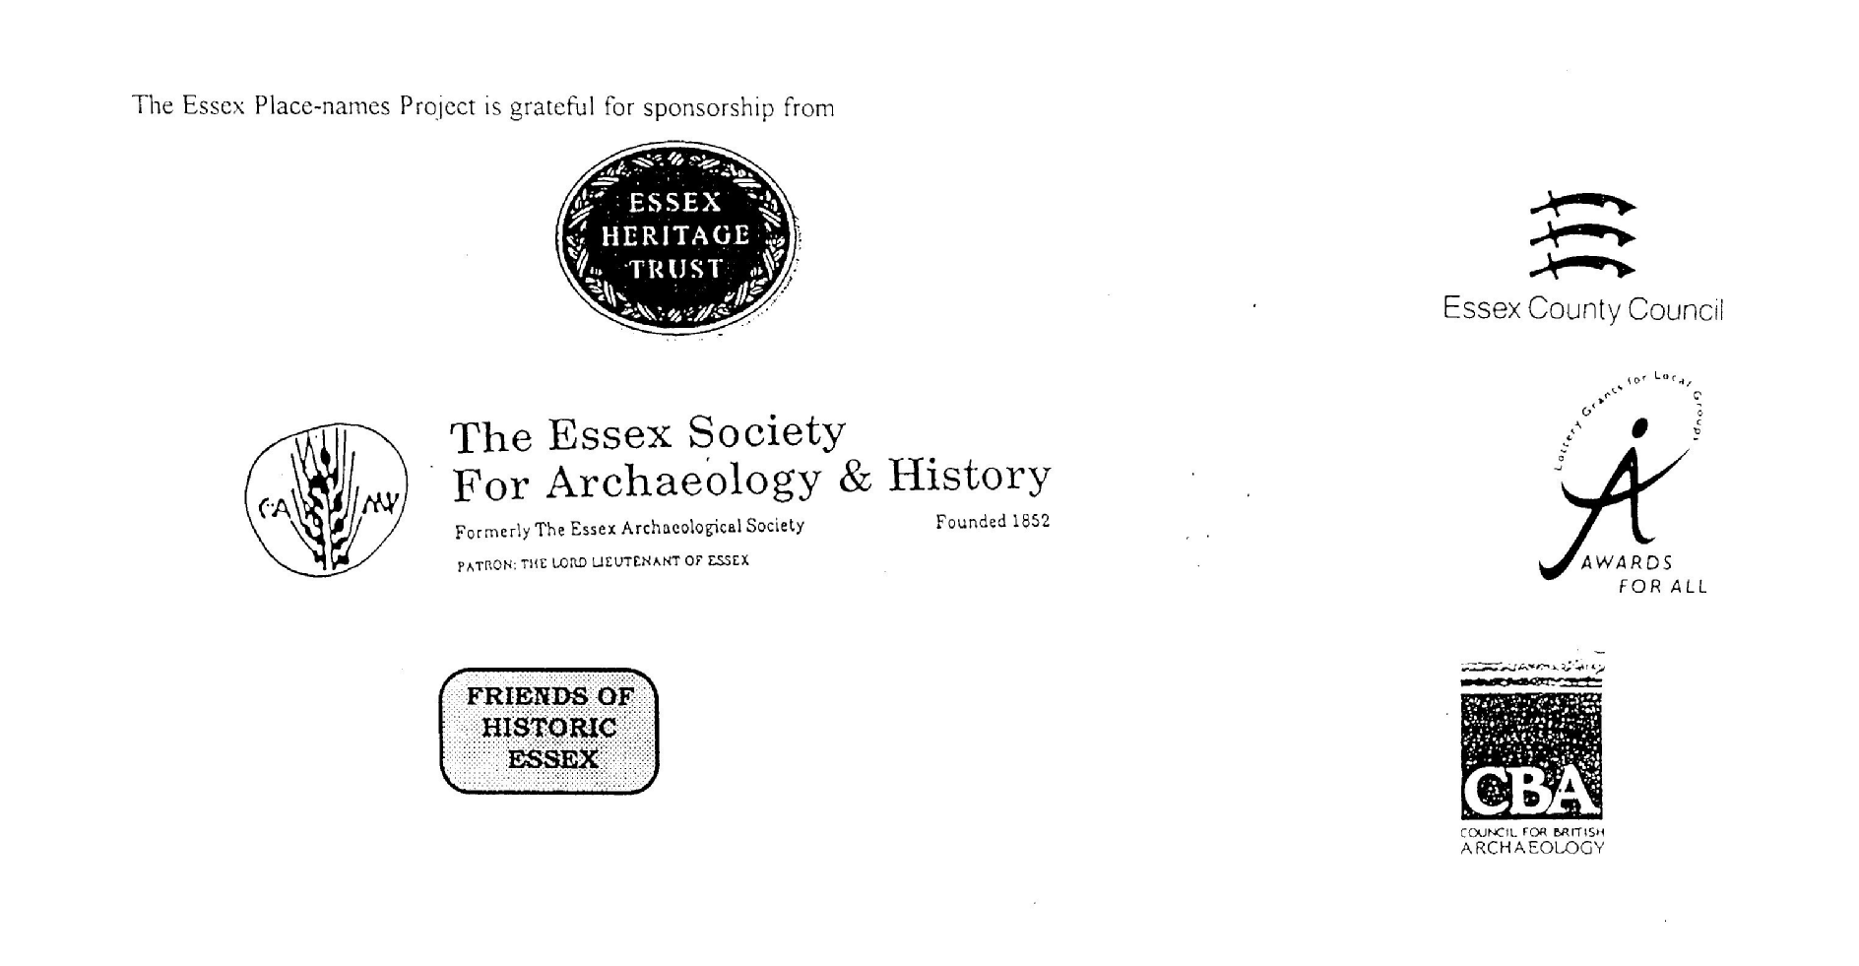

ESSEX PLACE-NAMES PROJECT.

The Essex Place-names Project is a County-wide survey to record place- and field-names from historical documents such as Tithe maps and apportionments, estate maps, sale
and auction catalogues, conveyances, terriers, deeds, rolls, inquisitions and surveys.

The second element of the Project is to investigate on-the-ground visible remains which correspond to the Place-names for actual or potential archaeological, agricultural and industrial
sites, and to record natural (topographical) and man-made features which may relate to the Place-name. This involves field-survey in rural and outside investigation in built-up areas.

It is anticipated that the Project will lead to identification of archaeological sites and lost historic buildings; it will enable analysis of indicators of early settlement, land holding, agricultural and industrial practices of the County. It will refine the more precise meaning of descriptive words and elements used by earlier settlers as they gave names appropriate to the topography of the landscape of their time.

For convenience the surveys are based on the parish, recognising that present civil parish boundaries are not necessarily identical to former ecclesiastical boundaries. Local Recorders
are supplied with templates of Record Forms to ensure consistency of recording across the County, and forward completed forms to a Central Coordinator for transfer to a county
computer database which is available to researchers on the internet at www.essex.ac.uk/history/esah/essexplacenames, and updated periodically.

This publication presents part of the information recorded from the Tithe or Estate Award and Map, and from other documents for this parish. The full record is contained on the master
database at Essex County Council (Historic Environment Section) and on the (above) website. Parish books are available to be downloaded from the website link ‘Books’ on the Home page. Please notify errors to the Project Coordinator at the Essex Record Office.

THE TITHE MAP AND APPORTIONMENT.

Since medieval times a tenth of the produce of land and stock had been paid by landholders to the church. At the Dissolution of the Monasteries, the property of many religious houses,
including the right to collect tithes, passed into lay hands. The Tithe Commutation Act which received Royal assent on 13th August 1836 abolished a rent payable in kind and
substituted rent-charges apportioned on each plot or parcel. The tithe-rent payable was assessed on the average value of wheat, barley and oats and was to fluctuate with price movements.

The commutation could be by voluntary agreement between the local owners and payers or, if agreement failed, could be compulsorily imposed by commissioners. A Valuer was to be
appointed to apportion the rent of each parcel of land and tenants could deduct that rent-charge from their rent paid to the landlord. The task fell to the Tithe Commissioners to produce a
map and an Apportionment (Award). A large-scale survey was produced for over 70% of England and Wales in the following 9 years, and about another 8% up to 1855. Most of the
parishes in Essex were surveyed. The map scales vary. The Award records ownership, tenancy and land-use, field by field and parcel by parcel (often quoting the field name) with the
ground area and rent-charge.

Land that was tithe-free tends to be less accurately mapped and contains few if any of the details recorded for those parcels subject to tithe. Rights of way and roads also tend to be
neglected. Boundaries of the tithe areas are shown as are some natural features such as streams, ponds, gardens, greens and commons. Buildings are often shown coloured red if dwellings
or grey if not. Because the Award may have been agreed only some time after the map was finished, discrepancies occur between the two. Enclosure Awards, when extant, usually date to the 18th and early 19th centuries. J.Kemble.
Reproduced by permission
of Essex County Council.

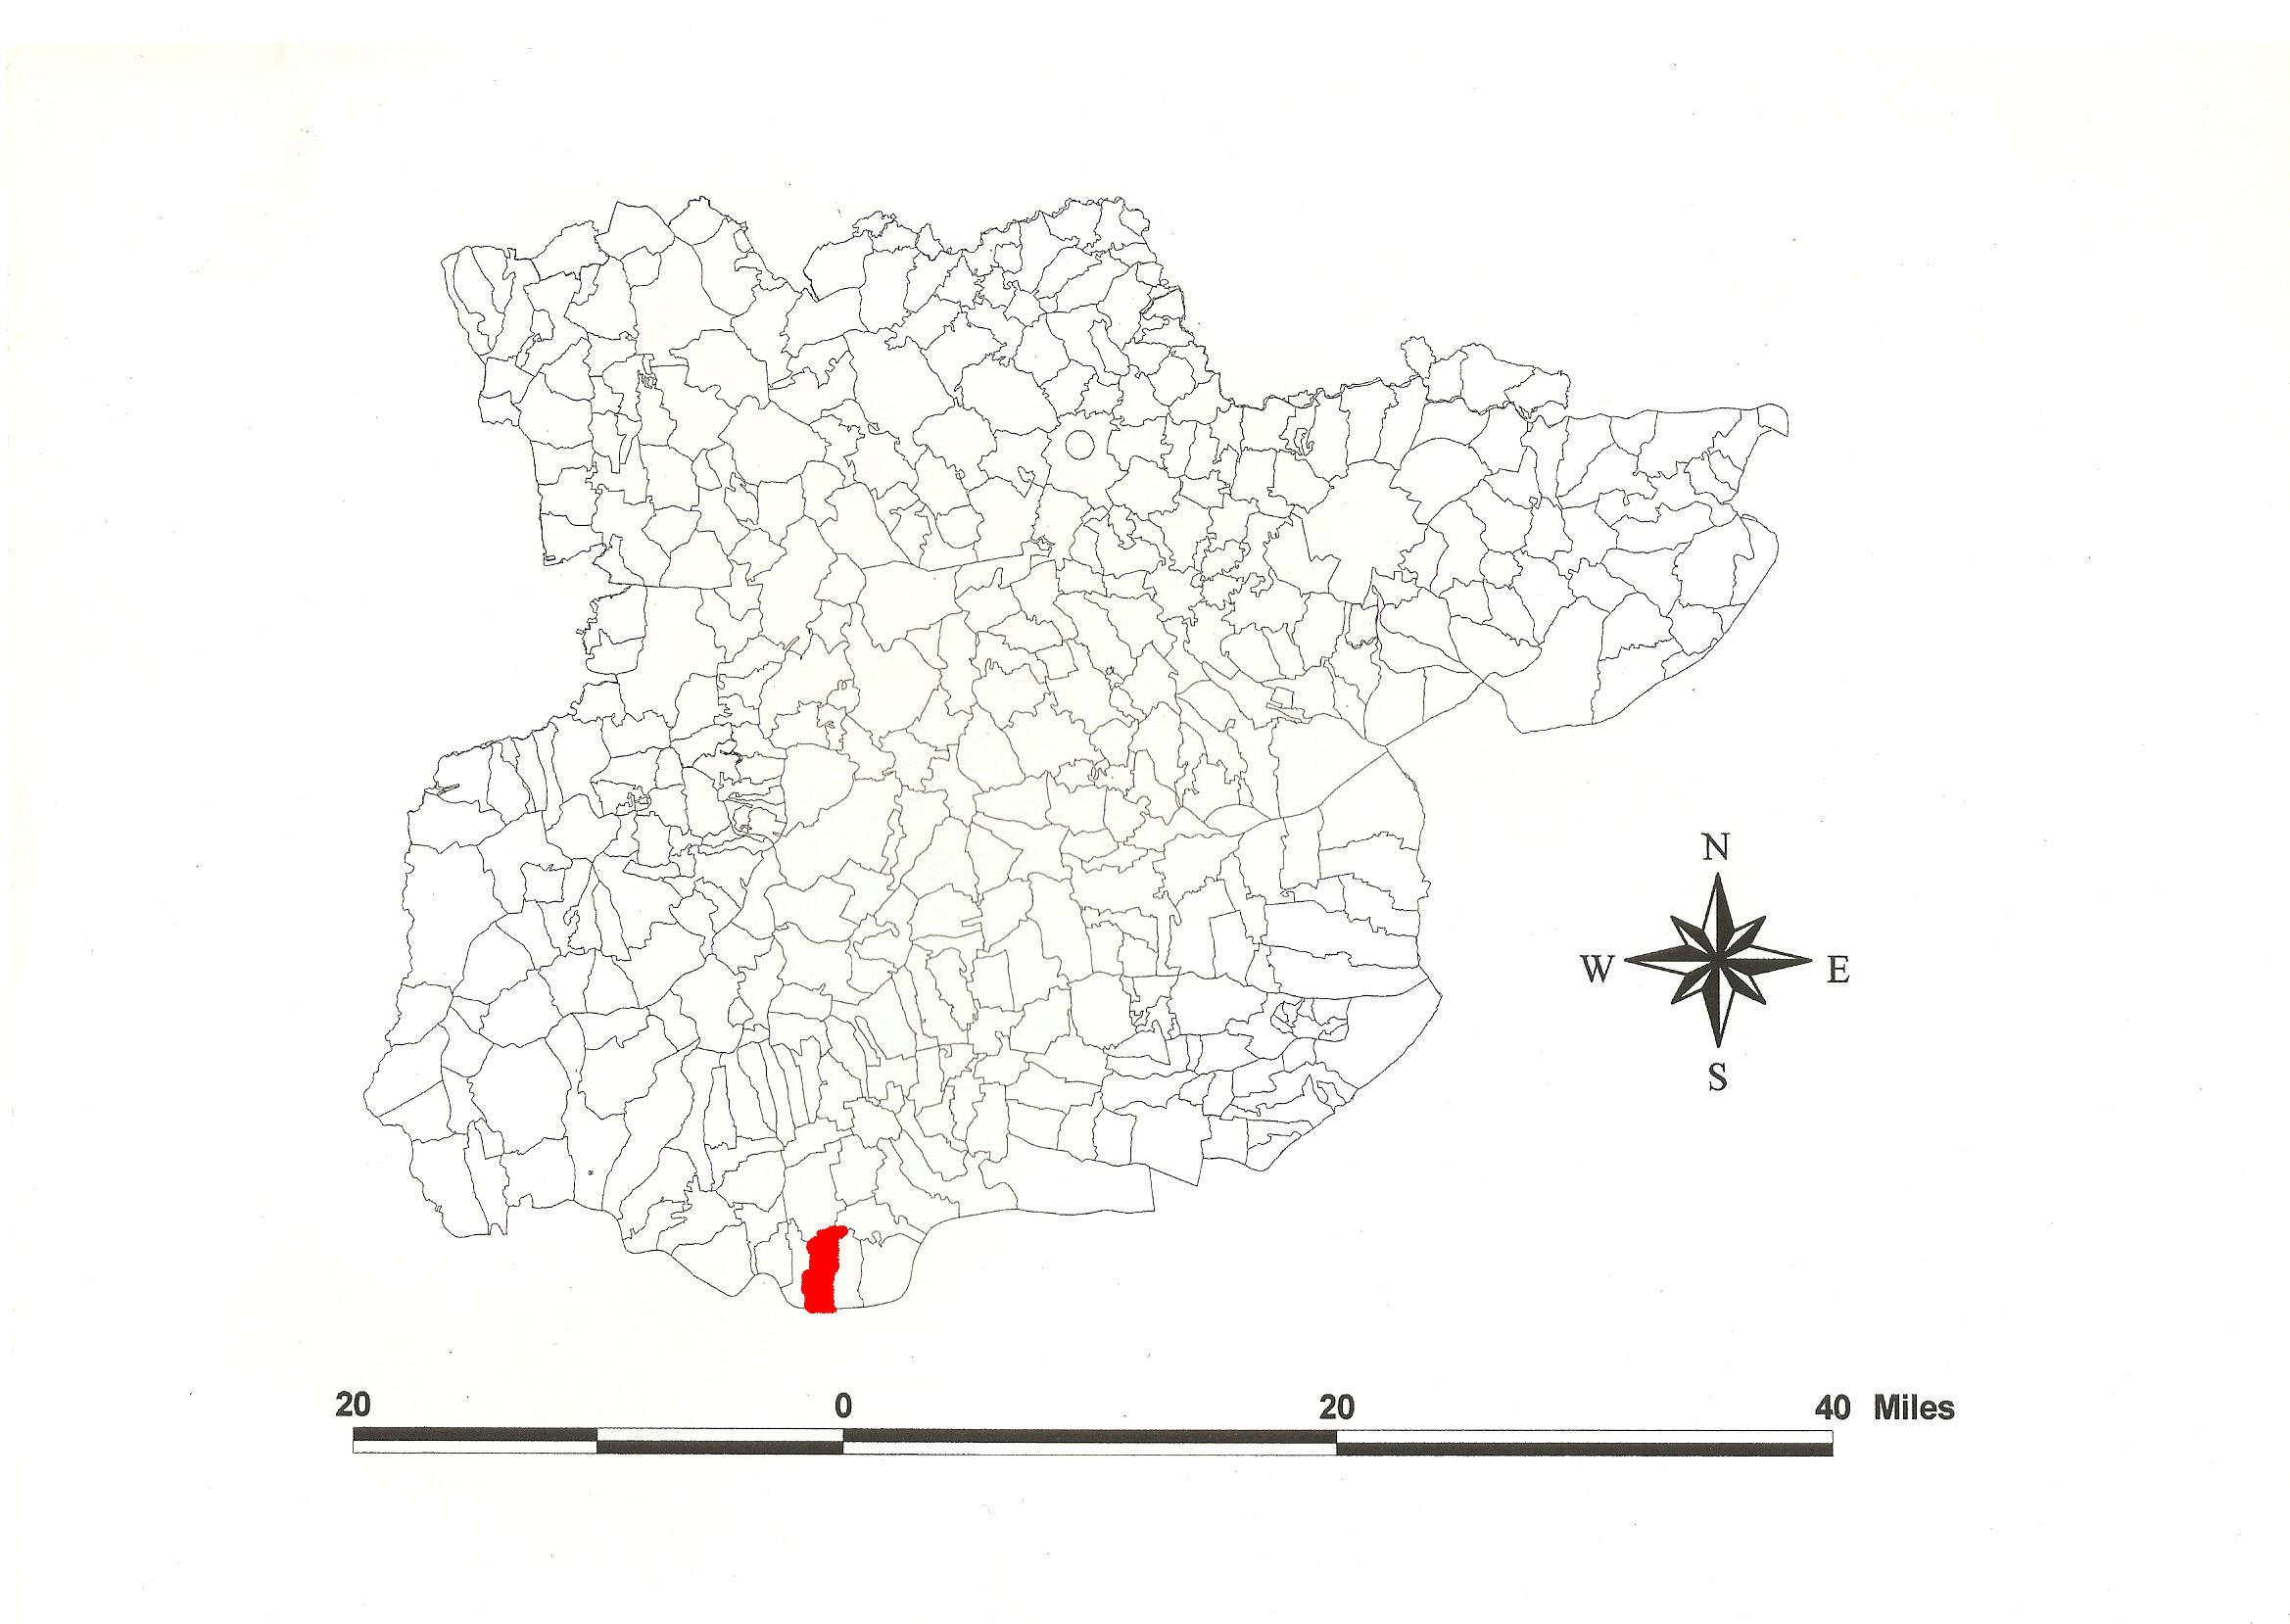
Chadwell St. Mary Parish in the County of Essex.
Reproduced by permission
of Essex County Council.

Chadwell St. Mary Parish (in Barstable Hundred).

The Tithe Award of Chadwell St. Mary (Essex Record Office D/CT 70a), dated 1838, shows a rent-charge of £480 payable to Rev. John Philip Herringham, rector. The whole parish measured 1753 acres 4 perches of which 1110 acres 2 roods were arable, 516 acres 3 roods 21 perches meadow and pasture, 30a 8p wood, Heath yielding no Tithe 16a 1r, Furze yielding no Tithe 4a 2r 32p, waste 74a 2r 15p, glebe about 40 acres. The Tithe Commissioners were William Blamire and R. Jones, the Valuers Henry Clayton of Ingatestone and John Eaton Joyner of West Thurrock.

The Tithe map (ERO: D/CT 70b) was surveyed at a scale of 20” to a mile and measures 64”x42”. It was countersigned by Roger Kynaston, Assistant Tithe Commissioner.

In Domesday Book, 1086, Hugolin held Celde uuella from the Bishop of London which Aelfric, a free man, had held with a fishery before 1066 as a manor for 2 hides. Here was one priest. Thorold’s son held Celdewella from Odo, bishop of Bayeux, “the grasping prelate”, which Edwold, King Edward’s reeve, had held for 1½ hides. In Celdeuuella Godman, a free man, held 20 acres but could not pay compensation for an offence. Grim gave 30 shillings on his behalf and held the land by permission of Hubert of Port (who came from Port-en-Bessin in Calvados) (Morris, 1983; Kemble, 2007). Watts (2004) translates this from Old English ceald wella, ‘cold spring’ + the name of the church’s dedication. The association with the priest St. Chad, brother of St. Cedd (Kemble, 2013) is etymologically unsustainable.

There were these manors: 1. Chadwell Hall was held by de Wokindon of the Bishop of London c.1250. 2. Ingloby, the house gone by 1768. Stephen de Gravesend bishop of London in 1337 passed lands to William Vigerons. 3. Long House was held by William Skrene (died 1430) and Alice his wife. 4. Bigging belonged to Stratford Langthorne abbey. 5. Coupers was held by Roger Tasker (died 1595) with tenements called Shepherds, Mots, Slepers and Tholmans (Morant, 1768).

To the south of Linford Road and the west of Sandy Lane have been excavated a Iron Age/Roman settlement, coins and a coffin (Manning, 1962). The church of St Mary has a Norman nave and south doorway. The west tower with buttresses is 15th century. Sleepers Farm (Tithe parcel no 203) to the west of the church is timber-framed with a jettied cross-wing, also 15th century (Pevsner, 2007).

The meeting place of the Hundred, the moot, was at Barstable, the site marked by a stapol or pillar. Christy (1926) places it at Old Barstable Hall, formerly at the southwest extremity of Basildon parish on high ground. The first element may be a personal name, Bearda, or perhaps from O.E. beardede, hairy (Reaney, 1935).

Place- and field-names from the maps (ERO: D/Dru P1/1) and the Manor of Barowhall and Longhouse in Chadwell and Little Thurrock of James Ravenscrofte by Silvanus Morgan and Richard Colet dated 1632 and (ERO: D/Dru P2) dated 1646, and from other documents are shown against the Tithe Names in the “Alias” column.

References:
Christy, M, 1926. The Essex Hundred Moots. Trans Essex Archaeological Society, ns xviii (3), p194.
Kemble, J., 2007. Essex Place-names, Places, Streets & People. Historical Publications, London.
Kemble, J., 2013. The Place-names of West Tilbury. www.essex.ac.uk/history/esah/essexplacenames. Then click on ‘Books’.
Manning, W.H., 1962. Iron Age & Roman Site at Chadwell St Mary. Trans. Essex Archaeological Soc., 3rd series, i (2), 127.
Morant, P., 1768. History & Antiquities of the County of Essex, i, 228
Morris, J., 1983. Domesday Book – Essex, Kent. Phillimore.
Pevsner, N., Bettley, J., 2007. Buildings of England – Essex. Yale.
Reaney, P., 1935. Place-names of Essex. Cambridge.
Watts, V., 2004. Dictionary of English Place-names. Cambridge.

The Tithe Award Place-names of Chadwell – by Parcel No.

Tithe Award Place-name | Alias | Fld No | Grd Ref | x | y | Acr | rd | pch | land use | Owner | Occupier | Other information
.. |  | 1 | TQ |  |  | 1 | 1 | 2 | grass | Branfill, Champion Edward | Turner, Richard
.. | Great Hodipole, 1632,D/DRu P1/1 | 2 | TQ | 634 | 753 | 9 | 1 | 16 | grass | Branfill, Champion Edward | Turner, Richard | Tilbury Docks, 1964,OS
.. | Little Hodipole, 1632,D/DRu P1/1 | 3 | TQ | 634 | 757 | 6 | 1 | 22 | grass | Branfill, Champion Edward | Turner, Richard | Tilbury Docks, 1964,OS
.. | Old werk marsh, 1632,D/DRu P1/1 | 4 | TQ | 634 | 760 | 18 | 2 | 4 | grass | Branfill, Champion Edward | Turner, Richard
.. | Barrrow marsh, 1632,D/DRu P1/1 | 5 | TQ | 734 | 766 | 17 | 3 | 21 | grass | Branfill, Champion Edward | Turner, Richard | cut by railway, 1875,OS
.. |  | 7 | TQ |  |  | 13 | 0 | 2 | grass | Branfill, Champion Edward | Turner, Richard
.. |  | 8,9 | TQ |  |  | 12 | 2 | 30 | grass | Branfill, Champion Edward | Turner, Richard
.. |  | 9a | TQ |  |  | 13 | 2 | 31 | grass | Branfill, Champion Edward | Turner, Richard
.. | Tullys, 1646,D/DRu P2 | 10 | TQ | 637 | 774 | 8 | 2 | 35 | grass | Theobald, Thompson | Cook, William
.. | Tullys, 1646,D/DRu P2 | 11 | TQ |  |  | 7 | 3 | 1 | grass | de Beauver, Benyon | Sandle, William
.. |  | 12 | TQ |  |  | 6 | 0 | 18 | grass | Branfill, Champion Edward | Driver, Edward
.. | Ocke Marsh, 1646,D/DRu P2 | 13 | TQ | 637 | 775 | 7 | 0 | 30 | grass | Branfill, Champion Edward | Driver, Edward
.. | Hogges Barow, 1646,D/DRu P2 | 14 | TQ | 637 | 776 | 4 | 0 | 27 | grass | Branfill, Champion Edward | Driver, Edward | [barrow]
.. | Little Marsh Bar Hogge, 1646,D/DRu P2 | 15 | TQ | 638 | 780 | 8 | 3 | 8 | grass | Branfill, Champion Edward | Turner, Richard
.. | West Phane, 1646,D/DRu P2 | 16 | TQ | 640 | 780 | 9 | 3 | 32 | grass | Branfill, Champion Edward | Turner, Richard
.. | West Phane, 1646,D/DRu P2 | 17 | TQ |  |  | 2 | 2 | 14 | grass | Branfill, Champion Edward | Jackson, Martha
.. | West Phane, 1646,D/DRu P2 | 18 | TQ |  |  | 3 | 0 | 37 | grass | Branfill, Champion Edward | Jackson, Martha
Cottage, garden | Hutts House, 1875,OS | 19 | TQ | 642 | 781 | 0 | 1 | 35 |  | Branfill, Champion Edward | Turner, Richard
.. |  | 20 | TQ |  |  | 7 | 0 | 17 | grass | Branfill, Champion Edward | Turner, Richard
.. |  | 21 | TQ |  |  | 10 | 2 | 36 | grass | Branfill, Champion Edward | Turner, Richard
.. |  | 22 | TQ |  |  | 10 | 0 | 18 | grass | Branfill, Champion Edward | Turner, Richard
Wood |  | 23 | TQ |  |  | 0 | 2 | 2 | wood | Branfill, Champion Edward | Turner, Richard
.. |  | 24 | TQ | 639 | 776 | 11 | 2 | 31 | grass | Branfill, Champion Edward | Turner, Richard
.. |  | 25 | TQ |  |  | 8 | 0 | 10 | grass | Branfill, Champion Edward | Turner, Richard
.. | Old wike marsh, 1646,D/DRu P2 | 26 | TQ | 640 | 773 | 11 | 3 | 34 | grass | Branfill, Champion Edward | Turner, Richard
.. | Old wike marsh, 1646,D/DRu P2 | 27 | TQ |  |  | 10 | 0 | 8 | grass | Branfill, Champion Edward | Turner, Richard
.. |  | 28 | TQ |  |  | 9 | 3 | 8 | grass | Branfill, Champion Edward | Turner, Richard
.. |  | 29 | TQ |  |  | 2 | 1 | 20 | arable | Jackson, Martha | Jackson, Martha
.. |  | 30 | TQ | 639 | 770 | 3 | 1 | 18 | arable | Branfill, Champion Edward | Jackson, Martha
.. |  | 31 | TQ |  |  | 14 | 0 | 10 | arable | St Pauls, Dean of | Asplin, Peter
.. |  | 32 | TQ |  |  | 4 | 3 | 25 | arable | Turner, Richard | Turner, Richard
.. |  | 33 | TQ |  |  | 2 | 2 | 14 | arable | Jackson, Martha | Jackson, Martha
.. | Homme m'rsh, 1632,D/DRu P1/1 | 34 | TQ | 635 | 765 | 14 | 2 | 3 | grass | Branfill, Champion Edward | Turner, Richard | cut by railway, 1875,OS
.. |  | 35 | TQ |  |  | 21 | 0 | 22 | grass | Branfill, Champion Edward | Turner, Richard
.. | Thisley m'rsh, 1632,D/DRy P1/1 | 36 | TQ | 635 | 760 | 34 | 1 | 23 | grass | Branfill, Champion Edward | Turner, Richard
.. |  | 37 | TQ |  |  | 17 | 1 | 0 | grass | Branfill, Champion Edward | Turner, Richard
.. |  | 38 | TQ |  |  | 11 | 3 | 3 | grass | Branfill, Champion Edward | Turner, Richard
.. |  | 39 | TQ |  |  | 1 | 3 | 39 | grass | Baker, Jane | Gowers, Edward
.. |  | 40 | TQ | 635 | 755 | 22 | 1 | 6 | grass | Errington, George Henry | Surridge, Robert
Wood |  | 41 | TQ |  |  | 4 | 1 | 0 | wood | Errington, George Henry | Surridge, Robert
.. |  | 42 | TQ |  |  | 27 | 0 | 22 | grass | Errington, George Henry | Surridge, Robert
.. |  | 43 | TQ |  |  | 7 | 0 | 15 | arable | Branfill, Champion Edward | Jackson, Martha
.. |  | 44 | TQ |  |  | 1 | 3 | 14 | salting | Branfill, Champion Edward | Jackson, Martha
.. |  | 45 | TQ |  |  | 28 | 2 | 5 | grass | Errington, George Henry | Surridge, Robert
Homestead | Marsh Farm, 1875,OS | 46 | TQ | 642 | 758 | 0 | 3 | 3 |  | Errington, George Henry | Surridge, Robert
.. |  | 47 | TQ |  |  | 18 | 1 | 15 | grass | Errington, George Henry | Surridge, Robert
.. |  | 48 | TQ |  |  | 4 | 1 | 34 | grass | Errington, George Henry | Surridge, Robert | cut by railway, 1875,OS
.. |  | 49a,b | TQ |  |  | 19 | 1 | 5 | arable | Errington, George Henry | Surridge, Robert
.. |  | 50a | TQ |  |  | 17 | 1 | 30 | arable | Errington, George Henry | Surridge, Robert
.. |  | 51 | TQ | 641 | 766 | 6 | 2 | 38 | arable | Errington, George Henry | Surridge, Robert
.. |  | 52 | TQ |  |  | 11 | 0 | 2 | arable | Errington, George Henry | Surridge, Robert
.. |  | 53 | TQ |  |  | 2 | 0 | 1 | arable | Branfill, Champion Edward | Jackson, Martha
.. |  | 54 | TQ |  |  | 10 | 0 | 30 | arable | Errington, George Henry | Surridge, Robert
.. |  | 55 | TQ |  |  | 7 | 3 | 28 | arable | Errington, George Henry | Surridge, Robert
.. |  | 56 | TQ |  |  | 4 | 3 | 16 | arable | Baker, Jane | Gowers, Edward
.. |  | 57 | TQ |  |  | 7 | 3 | 32 | arable | Errington, George Henry | Surridge, Robert
Wood |  | 58 | TQ | 641 | 770 | 5 | 0 | 11 | wood | St Pauls, Dean of | Asplin, Peter
Manor Way |  | 59 | TQ | 641 | 774 | 2 | 0 | 28 |  | .. | ..
Manor Way |  | 59a | TQ |  |  | 1 | 3 | 32 |  | .. | ..
.. |  | 60 | TQ |  |  | 5 | 3 | 22 | arable | Branfill, Champion Edward | Jackson, Martha
.. |  | 61 | TQ |  |  | 5 | 3 | 3 | grass | Errington, George Henry | Surridge, Robert
.. |  | 62 | TQ |  |  | 3 | 0 | 29 | grass | Baker, Jane | Gowers, Edward
.. |  | 63 | TQ |  |  | 7 | 3 | 3 | grass | Baker, Jane | Gowers, Edward
.. |  | 64 | TQ |  |  | 4 | 0 | 18 | grass | Branfill, Champion Edward | Jackson, Martha
.. | West Phane, 1646,D/DRu P2 | 65 | TQ | 643 | 780 | 3 | 2 | 30 | grass | Branfill, Champion Edward | Jackson, Martha
.. | West Phane, 1646,D/DRu P2 | 66 | TQ |  |  | 7 | 1 | 34 | grass | Branfill, Champion Edward | Jackson, Martha
Manor Way |  | 67 | TQ |  |  | 4 | 3 | 0 |  | Branfill, Champion Edward | Jackson, Martha
.. |  | 68 | TQ |  |  | 2 | 3 | 25 | grass | Branfill, Champion Edward | Driver, Edward
.. |  | 69 | TQ |  |  | 3 | 2 | 8 | grass | Branfill, Champion Edward | Driver, Edward
.. | Crabe Phane, 1646,D/DRu P2 | 70 | TQ | 646 | 778 | 3 | 1 | 1 | grass | Branfill, Champion Edward | Driver, Edward
.. | Cherie, 1646,D/DRu P2 | 71 | TQ | 646 | 777 | 4 | 3 | 21 | arable | Branfill, Champion Edward | Driver, Edward
.. | Reedes fann, 1646,D/DRu P2 | 72 | TQ | 646 | 776 | 2 | 1 | 22 | arable | Branfill, Champion Edward | Jackson, Martha
.. |  | 73 | TQ |  |  | 10 | 0 | 2 | grass | Errington, George Henry | Surridge, Robert
.. |  | 74 | TQ |  |  | 5 | 3 | 10 | grass | Herringham, Rev John Philip | Bird, Thompson
.. |  | 75 | TQ |  |  | 6 | 3 | 9 | arable | Herringham, Rev John Philip | Bird, Thompson
.. |  | 76 | TQ |  |  | 3 | 3 | 27 | arable | Branfill, Champion Edward | Driver, Edward
.. |  | 77 | TQ | 644 | 770 | 1 | 3 | 26 | arable | Branfill, Champion Edward | Driver, Edward
.. |  | 78 | TQ |  |  | 3 | 1 | 10 | arable | Errington, George Henry | Asplin, Peter
.. |  | 79 | TQ |  |  | 10 | 1 | 14 | arable | Errington, George Henry | Miller, Philip
.. |  | 80 | TQ | 644 | 765 | 9 | 2 | 28 | arable | Errington, George Henry | Miller, Philip
.. |  | 81 | TQ |  |  | 2 | 1 | 32 | arable | Branfill, Champion Edward | Jackson, Martha
.. |  | 82 | TQ |  |  | 5 | 2 | 38 | arable | Baker, Jane | Gowers, Edward
.. |  | 83 | TQ |  |  | 4 | 1 | 36 | arable | Branfill, Champion Edward | Jackson, Martha
Manor Way |  | 84 | TQ |  |  | 0 | 3 | 25 |  | .. | ..
.. |  | 85 | TQ |  |  | 7 | 1 | 38 | arable | Errington, George Henry | Asplin, Peter
.. | Engine Shed, 1875,OS | 86 | TQ | 644 | 756 | 6 | 3 | 0 | arable | Errington, George Henry | Asplin, Peter
.. | Carriage Shed, 1875,OS | 87 | TQ | 644 | 755 | 11 | 2 | 39 | arable | Errington, George Henry | Asplin, Peter
.. | Tilbury Station [rail], 1875,OS | 88 | TQ | 644 | 753 | 3 | 1 | 0 | grass | Errington, George Henry | Asplin, Peter
.. |  | 89 | TQ |  |  | 1 | 0 | 33 | salting | Errington, George Henry | Asplin, Peter
.. | Ferry House, 1777,C | 90 | TQ | 645 | 751 | 3 | 1 | 19 | salting | Christs Hospital, gvnrs of | Jackson, Martha | [Ferry to Gravesend, 1875,OS]
.. |  | 91 | TQ |  |  | 23 | 0 | 23 | grass | Christs Hospital, gvnrs of | Jackson, Martha
Worlds End P.H. |  | 92 | TQ | 645 | 752 | 0 | 2 | 9 | inn | Her Majesty | Creed, Wm; Board of Ordnance
.. |  | 93 | TQ |  |  | 2 | 1 | 15 | grass | Her Majesty | Creed, Wm; Board of Ordnance
.. |  | 94 | TQ |  |  | 3 | 2 | 29 | grass | Her Majesty | Creed, Wm; Board of Ordnance
Tilbury Fort (part) |  | 95 | TQ | 650 | 754 | 22 | 0 | 32 |  | Her Majesty | Creed, Wm; Board of Ordnance
High Road | The Fort Road, 1875,OS | 96 | TQ | 649 | 755 | 2 | 3 | 18 | .. | .. | ..
.. |  | 97 | TQ |  |  | 9 | 0 | 8 | arable | St Pauls, Dean of | Asplin, Peter
.. |  | 98 | TQ |  |  | 8 | 2 | 38 | arable | St Pauls, Dean of | Asplin, Peter
.. |  | 99 | TQ |  |  | 3 | 2 | 28 | arable | Errington, George Henry | Asplin, Peter
.. |  | 100 | TQ | 649 | 761 | 4 | 0 | 0 | arable | Baker, Jane | Gowers, Edward | cut by railway, 1875,OS
.. |  | 101 | TQ |  |  | 4 | 1 | 17 | arable | Christs Hospital, gvnrs of | Jackson, Martha
.. |  | 102 | TQ |  |  | 7 | 1 | 35 | arable | Christs Hospital, gvnrs of | Jackson, Martha
.. |  | 103 | TQ |  |  | 7 | 1 | 28 | arable | Christs Hospital, gvnrs of | Jackson, Martha | cut by railway, 1875,OS
.. | Cockaynes, 1646,D/DRu P2 | 104 | TQ | 647 | 761 | 5 | 1 | 38 | grass | Christs Hospital, gvnrs of | Jackson, Martha
.. |  | 105 | TQ |  |  | 3 | 2 | 24 | arable | Christs Hospital, gvnrs of | Jackson, Martha
Homestead | Milk House, 1777,C | 106 | TQ | 646 | 762 | 0 | 2 | 18 |  | Christs Hospital, gvnrs of | Jackson, Martha
.. |  | 107 | TQ |  |  | 0 | 1 | 29 |  | Christs Hospital, gvnrs of | Jackson, Martha
.. |  | 108 | TQ |  |  | 5 | 1 | 36 | grass | Errington, George Henry | Miller, Philip
.. |  | 109 | TQ |  |  | 0 | 3 | 8 |  | Errington, George Henry | Miller, Philip
.. |  | 110 | TQ |  |  | 8 | 1 | 24 | grass | Errington, George Henry | Miller, Philip
Chase Way |  | 111 | TQ |  |  | 0 | 3 | 29 | . | .. | ..
Manor Way |  | 111a | TQ | 645 | 766 | 3 | 0 | 0 |  | .. | ..
.. |  | 112 | TQ |  |  | 13 | 0 | 36 | arable | Errington, George Henry | Miller, Philip
.. |  | 113 | TQ |  |  | 11 | 1 | 10 | arable | St Pauls, Dean of | Asplin, Peter
.. |  | 114 | TQ |  |  | 7 | 0 | 8 | arable | St Pauls, Dean of | Asplin, Peter
.. |  | 115 | TQ |  |  | 7 | 3 | 23 | arable | Christs Hospital, gvnrs of | Jackson, Martha
.. |  | 116 | TQ |  |  | 3 | 0 | 26 | arable | Merton College Oxford | Ellis, Mary
.. |  | 117 | TQ |  |  | 4 | 1 | 18 | arable | St Pauls, Dean of | Asplin, Peter
.. | MELHOP, 1646,D/DRu P2 | 118 | TQ | 648 | 766 | 7 | 1 | 17 | arable | Errington, George Henry | Miller, Philip
Manor Way |  | 119 | TQ |  |  | 0 | 3 | 28 |  | .. | ..
Manor Way |  | 120 | TQ | 647 | 767 | 3 | 2 | 20 |  | .. | ..
.. |  | 121 | TQ |  |  | 7 | 1 | 32 | arable | Errington, George Henry | Miller, Philip
.. |  | 122 | TQ |  |  | 6 | 0 | 15 | grass | Christs Hospital, gvnrs of | Jackson, Martha
.. |  | 123 | TQ |  |  | 6 | 1 | 36 | arable | St Pauls, Dean of | Asplin, Peter
.. |  | 124 | TQ |  |  | 12 | 0 | 26 | arable | St Pauls, Dean of | Asplin, Peter
.. |  | 125 | TQ | 652 | 769 | 1 | 1 | 11 | arable | Turner, Richard | Turner, Richard
.. |  | 126 | TQ |  |  | 8 | 3 | 31 | arable | Christs Hospital, gvnrs of | Jackson, Martha
.. |  | 127 | TQ |  |  | 7 | 1 | 23 | arable | Christs Hospital, gvnrs of | Jackson, Martha
.. |  | 128 | TQ |  |  | 2 | 3 | 17 | arable | Branfill, Champion Edward | Jackson, Martha
.. |  | 129 | TQ |  |  | 3 | 1 | 11 | grass | Branfill, Champion Edward | Jackson, Martha
.. |  | 130 | TQ | 646 | 770 | 7 | 1 | 10 | grass | Errington, George Henry | Miller, Philip
.. |  | 131 | TQ |  |  | 7 | 2 | 0 | grass | Baker, Jane | Gowers, Edward
.. |  | 132 | TQ |  |  | 6 | 0 | 8 | arable | Baker, Jane | Gowers, Edward
.. |  | 133 | TQ |  |  | 8 | 0 | 30 | grass | Baker, Jane | Gowers, Edward
.. |  | 134 | TQ |  |  | 5 | 2 | 24 | grass | Baker, Jane | Gowers, Edward
.. |  | 135 | TQ | 648 | 771 | 7 | 2 | 7 | arable | St Pauls, Dean of | Asplin, Peter
.. |  | 136 | TQ |  |  | 10 | 0 | 16 | arable | St Pauls, Dean of | Asplin, Peter
.. |  | 137 | TQ |  |  | 8 | 2 | 2 | grass | St Pauls, Dean of | Asplin, Peter
.. |  | 138 | TQ |  |  | 4 | 0 | 0 | grass | Errington, George Henry | Asplin, Peter
.. |  | 139 | TQ |  |  | 4 | 3 | 20 | arable | Christs Hospital, gvnrs of | Jackson, Martha
Manor Way |  | 140 | TQ | 652 | 776 | 0 | 2 | 16 |  | .. | ..
.. |  | 141 | TQ |  |  | 13 | 0 | 28 | arable | Errington, George Henry | Miller, Philip
.. |  | 142 | TQ |  |  | 12 | 2 | 32 | grass | Errington, George Henry | Miller, Philip
.. |  | 143 | TQ |  |  | 3 | 0 | 15 | grass | Branfill, Champion Edward | Jackson, Martha
.. |  | 144 | TQ |  |  | 0 | 1 | 30 | grass | St Pauls, Dean of | Asplin, Peter
.. |  | 145 | TQ | 651 | 777 | 0 | 2 | 32 | grass | St Pauls, Dean of | Asplin, Peter
.. |  | 146 | TQ |  |  | 0 | 3 | 24 | grass | Errington, George Henry | Miller, Philip
Homestead | Little Biggin, 1875,OS | 147 | TQ | 651 | 776 | 0 | 2 | 30 |  | Errington, George Henry | Miller, Philip
.. | le Bromhel, 1339,Ipm; Broomhill, 1875,OS | 148 | TQ | 652 | 776 | 4 | 0 | 36 | arable | Errington, George Henry | Miller, Philip
.. |  | 149 | TQ |  |  | 6 | 2 | 20 | grass | St Pauls, Dean of | Asplin, Peter
.. |  | 150 | TQ |  |  | 0 | 2 | 0 | arable | Merton College Oxford | Ellis, Mary
Homestead | Byggynge, tHy8, MnAt; Biggin, 1875,OS | 151 | TQ | 652 | 778 | 1 | 0 | 34 |  | St Pauls, Dean of | Asplin, Peter
House, yard |  | 152 | TQ |  |  | 0 | 2 | 11 |  | St Pauls, Dean of | Asplin, Peter
House, yard |  | 153 | TQ |  |  | 0 | 1 | 0 |  | St Pauls, Dean of | Asplin, Peter
House, yard, garden |  | 154 | TQ |  |  | 0 | 1 | 5 |  | St Pauls, Dean of | Asplin, Peter
Cottage, garden | Gladwins, 1875,OS | 155 | TQ | 651 | 778 | 0 | 1 | 9 |  | Turner, Richard | Turner, Richard
Cottage, garden |  | 156 | TQ |  |  | 0 | 2 | 23 |  | Turner, Richard | Turner, Richard
.. |  | 157 | TQ |  |  | 0 | 3 | 26 | grass | Errington, George Henry | Miller, Philip
Cottage, garden |  | 158 | TQ |  |  | 0 | 0 | 10 |  | Gower, Edward | Gower, James
.. |  | 159 | TQ |  |  | 2 | 2 | 24 | arable | Errington, George Henry | Miller, Philip
Cottage, garden | Moncke House, 1646,D/DRu P2 | 160 | TQ | 649 | 780 | 0 | 1 | 3 |  | Gayler, Mary | Causton, John
.. | Southfield Barn, 1875,OS | 161 | TQ | 649 | 778 | 7 | 2 | 7 | arable | Christs Hospital, gvnrs of | Jackson, Martha
Cottage, garden |  | 162 | TQ |  |  | 0 | 2 | 10 |  | Brookes, Richard | Bray, Thomas
.. |  | 163 | TQ |  |  | 2 | 2 | 36 | arable | Branfill, Champion Edward | Jackson, Martha
.. |  | 164 | TQ |  |  | 10 | 3 | 23 | arable | St Pauls, Dean of | Asplin, Peter
.. |  | 164a | TQ |  |  | 2 | 2 | 0 | arable | Errington, George Henry | Miller, Philip
.. |  | 165 | TQ | 651 | 782 | 4 | 0 | 0 | grass | Errington, George Henry | Asplin, Peter
.. |  | 166 | TQ |  |  | 1 | 1 | 18 |  | Errington, George Henry | Asplin, Peter
Wood |  | 167 | TQ |  |  | 0 | 2 | 14 | wood | Errington, George Henry | Miller, Philip
Wood |  | 168 | TQ |  |  | 0 | 1 | 28 | wood | Errington, George Henry | Miller, Philip
.. |  | 169 | TQ |  |  | 1 | 1 | 8 | arable | Errington, George Henry | Miller, Philip
Wood |  | 170 | TQ | 654 | 781 | 1 | 0 | 1 | wood | Christs Hospital, gvnrs of | Jackson, Martha
.. |  | 171 | TQ |  |  | 1 | 3 | 27 | arable | Christs Hospital, gvnrs of | Jackson, Martha
Wood |  | 172 | TQ |  |  | 0 | 2 | 35 | wood | Christs Hospital, gvnrs of | Jackson, Martha
.. |  | 173 | TQ |  |  | 3 | 3 | 11 | arable | Errington, George Henry | Miller, Philip
Wood |  | 174 | TQ |  |  | 0 | 3 | 22 | wood | Merton College Oxford | Ellis, Mary
.. |  | 175 | TQ | 652 | 784 | 7 | 1 | 11 | arable | Merton College Oxford | Ellis, Mary
Cottage, garden |  | 176 | TQ |  |  | 0 | 0 | 35 |  | Catline, Bannister Thomas | Rush, John; another
Cottage, garden |  | 177 | TQ | 652 | 785 | 0 | 1 | 2 |  | Catline, Bannister Thomas | French, William; another
.. |  | 178 | TQ |  |  | 3 | 1 | 36 | arable | Errington, George Henry | Miller, Philip
.. |  | 179 | TQ |  |  | 1 | 1 | 0 | arable | Errington, George Henry | Asplin, Peter
.. |  | 180 | TQ | 650 | 784 | 2 | 2 | 34 | arable | Branfill, Champion Edward | Jackson, Martha
.. |  | 181 | TQ |  |  | 6 | 2 | 35 | arable | Christs Hospital, gvnrs of | Jackson, Martha
.. |  | 182 | TQ |  |  | 2 | 2 | 32 | arable | Christs Hospital, gvnrs of | Jackson, Martha
.. |  | 183 | TQ |  |  | 5 | 2 | 8 | arable | Errington, George Henry | Miller, Philip
Homestead, yard etc | Bullhall, 1875,OS | 184 | TQ | 649 | 781 | 0 | 1 | 10 |  | Errington, George Henry | Miller, Philip
.. |  | 185 | TQ |  |  | 6 | 0 | 24 | arable | Baker, Jane | Gowers, Edward
Homestead | Hobbes at Hatches, 1590,Russell; Hobhill Farm, 1875,OS | 186 | TQ | 646 | 779 | 0 | 2 | 9 |  | Baker, Jane | Gowers, Edward
.. |  | 187 | TQ |  |  | 0 | 2 | 31 | grass | Baker, Jane | Gowers, Edward
.. | Hob's Hill, 1777,C | 188 | TQ | 646 | 780 | 1 | 1 | 15 | grass | Baker, Jane | Gowers, Edward | Barrow mound, 1777,C
.. |  | 189 | TQ |  |  | 1 | 1 | 35 | grass | Baker, Jane | Gowers, Edward
.. | St Chad's Well, 1875,OS | 190 | TQ | 645 | 780 | 0 | 2 | 0 | grass | Branfill, Champion Edward | Jackson, Martha
.. |  | 191 | TQ |  |  | 0 | 2 | 0 | grass | Branfill, Champion Edward | Jackson, Martha
Homestead | Luckings, 1875,OS | 192 | TQ | 646 | 782 | 0 | 1 | 26 |  | Errington, George Henry | Asplin, Peter
.. |  | 193 | TQ |  |  | 2 | 0 | 33 | arable | Errington, George Henry | Asplin, Peter
.. |  | 194 | TQ |  |  | 0 | 2 | 37 | arable | Branfill, Champion Edward | Jackson, Martha
.. |  | 195 | TQ | 648 | 782 | 9 | 0 | 34 | arable | Errington, George Henry | Surridge, Robert
Garden |  | 196 | TQ |  |  | 0 | 0 | 23 |  | Baker, Jane | Gowers, Edward
.. |  | 197 | TQ |  |  | 1 | 0 | 19 | arable | Branfill, Champion Edward | Jackson, Martha
.. |  | 198 | TQ |  |  | 2 | 3 | 1 | arable | Branfill, Champion Edward | Jackson, Martha
.. |  | 199 | TQ |  |  | 5 | 1 | 5 | arable | Errington, George Henry | Asplin, Peter
.. |  | 200 | TQ | 647 | 784 | 5 | 3 | 16 | arable | Errington, George Henry | Surridge, Robert
Cottage, garden |  | 201 | TQ |  |  | 0 | 0 | 30 |  | Stevens, William | Dadd, Richard
Church yard | [St Marys] | 202 | TQ | 647 | 785 | 0 | 1 | 31 |  | Herringham, Rev John Philip | Bird, Thompson
Homestead | Slepers, 1768,M; Sleepers, 1875,OS | 203 | TQ | 647 | 785 | 0 | 3 | 0 |  | Branfill, Champion Edward | Driver, Edward | John Slepere, 1420, Ct
.. |  | 204 | TQ |  |  | 2 | 3 | 20 | arable | Branfill, Champion Edward | Driver, Edward
Homestead | Celdeuuella, 1086,DB; Chadwell Hall, 1875,OS | 205 | TQ | 647 | 784 | 1 | 0 | 0 |  | Errington, George Henry | Surridge, Robert
Homestead | Long House, 1646,D/DRu P2 | 206 | TQ | 646 | 783 | 0 | 1 | 15 |  | Branfill, Champion Edward | Jackson, Martha
Homestead |  | 207 | TQ |  |  | 1 | 0 | 32 |  | Branfill, Champion Edward | Jackson, Martha
Cottage, garden |  | 208 | TQ |  |  | 0 | 0 | 38 |  | Branfill, Champion Edward | Jackson, Martha
.. | Trappes, 1646,D/DRu P2 | 209 | TQ | 645 | 781 | 15 | 1 | 36 | arable | Errington, George Henry | Surridge, Robert
.. |  | 210 | TQ |  |  | 0 | 3 | 7 | arable | Errington, George Henry | Surridge, Robert
.. | Barow Hall, 1646,D/DRu P2 | 211 | TQ | 643 | 782 | 4 | 0 | 30 | arable | Branfill, Champion Edward | Jackson, Martha | Barrow mound, 1777,C
.. |  | 212 | TQ |  |  | 2 | 3 | 30 | arable | St Pauls, Dean of | Asplin, Peter
.. |  | 213 | TQ |  |  | 1 | 3 | 27 | grass | Branfill, Champion Edward | Turner, Richard
.. |  | 214 | TQ |  |  | 0 | 3 | 33 | grass | Branfill, Champion Edward | Turner, Richard
.. |  | 215 | TQ |  |  | 2 | 0 | 2 | grass | Branfill, Champion Edward | Turner, Richard
.. | Barowhall Mead, 1646,D/DRu P2 | 216 | TQ | 642 | 782 | 21 | 1 | 35 | arable | Branfill, Champion Edward | Turner, Richard | [barrowhall mead]
.. | Hutts Hill, 1875,OS | 217 | TQ | 644 | 784 | 3 | 1 | 34 | arable | Branfill, Champion Edward | Turner, Richard
Cottage, garden |  | 218 | TQ |  |  | 2 | 2 | 17 |  | Turner, Richard | Turner, Richard
Cottage, garden |  | 219 | TQ |  |  | 0 | 0 | 29 |  | Turner, Richard | Birchell, William; others
Cottage, garden |  | 220 | TQ | 643 | 785 | 0 | 0 | 30 |  | Turner, Richard | Birchell, William; others
.. |  | 221 | TQ |  |  | 8 | 0 | 28 | arable | Branfill, Champion Edward | Turner, Richard
.. |  | 222 | TQ |  |  | 3 | 3 | 30 | arable | St Pauls, Dean of | Asplin, Peter
.. |  | 223 | TQ |  |  | 7 | 0 | 24 | grass | Branfill, Champion Edward | Turner, Richard
Homestead | Chadwell Place, 1777,C | 224 | TQ | 639 | 784 | 1 | 2 | 10 |  | Branfill, Champion Edward | Turner, Richard
.. |  | 225 | TQ |  |  | 2 | 0 | 10 | arable | Branfill, Champion Edward | Turner, Richard
.. |  | 226 | TQ |  |  | 4 | 1 | 1 | grass | Branfill, Champion Edward | Turner, Richard
.. | Dead womans close,1646,D/DRu P2 | 227 | TQ | 638 | 790 | 49 | 0 | a |  | Branfill, Champion Edward | Turner, Richard
Wood | Terrels Heath, 1880,OS | 230 | TQ | 640 | 792 | 21 | 2 | 1 | wood | Branfill, Champion Edward | Driver, Edward
.. |  | 231 | TQ |  |  | 15 | 2 | 33 | arable | Branfill, Champion Edward | Driver, Edward
.. |  | 232 | TQ |  |  | 6 | 1 | 21 | arable | Branfill, Champion Edward | Driver, Edward
.. |  | 233 | TQ |  |  | 11 | 1 | 15 | arable | Branfill, Champion Edward | Turner, Richard
.. |  | 234 | TQ |  |  | 13 | 2 | 32 | arable | Branfill, Champion Edward | Turner, Richard
.. |  | 235 | TQ | 640 | 787 | 2 | 2 | 24 | arable | Branfill, Champion Edward | Turner, Richard
.. |  | 236 | TQ |  |  | 2 | 1 | 9 | arable | Jackson, Martha | Jackson, Martha
.. |  | 237 | TQ |  |  | 4 | 1 | 20 | arable | Branfill, Champion Edward | Turner, Richard
.. |  | 238 | TQ |  |  | 5 | 0 | 16 | arable | St Pauls, Dean of | Asplin, Peter
.. |  | 239 | TQ |  |  | 1 | 2 | 28 | arable | Jackson, Martha | Jackson, Martha
.. |  | 240 | TQ | 641 | 786 | 9 | 3 | 38 | arable | Branfill, Champion Edward | Jackson, Martha
.. |  | 241 | TQ |  |  | 5 | 1 | 1 | arable | Branfill, Champion Edward | Jackson, Martha
.. |  | 242 | TQ |  |  | 6 | 0 | 23 | arable | Branfill, Champion Edward | Jackson, Martha
Cottage, garden |  | 243 | TQ |  |  | 0 | 0 | 16 |  | Jackson, Martha | Eastwood, James
Cross Keys P.H. |  | 244 | TQ | 646 | 786 | 0 | 0 | 14 | inn | Jackson, Martha | Ennever, John
Homestead |  | 245 | TQ | 646 | 786 | 0 | 1 | 8 |  | Jackson, Martha | Jackson, Martha
.. |  | 246 | TQ |  |  | 0 | 3 | 5 | arable | Jackson, Martha | Jackson, Martha
Garden |  | 247 | TQ |  |  | 0 | 0 | 17 |  | Jackson, Martha | Ennever, John
.. |  | 248 | TQ |  |  | 8 | 0 | 34 | arable | Branfill, Champion Edward | Driver, Edward
.. |  | 249 | TQ |  |  | 10 | 0 | 2 | arable | Herringham, Rev John Philip | Bird, Thompson
.. |  | 250 | TQ | 646 | 787 | 10 | 1 | 29 | arable | Herringham, Rev John Philip | Bird, Thompson
.. |  | 251 | TQ |  |  | 1 | 2 | 17 | arable | Herringham, Rev John Philip | Bird, Thompson
Rectory | Chadwell Parsonge, 1777,C | 252 | TQ | 646 | 787 | 0 | 2 | 37 |  | Herringham, Rev John Philip | Bird, Thompson
Yard |  | 253 | TQ |  |  | 0 | 1 | 29 |  | Herringham, Rev John Philip | Bird, Thompson
.. |  | 254 | TQ |  |  | 5 | 3 | 7 | arable | Herringham, Rev John Philip | Bird, Thompson
Garden |  | 255 | TQ |  |  | 1 | 3 | 1 |  | Baker, Jane | Gowers, Edward
.. |  | 256 | TQ |  |  | 0 | 3 | 30 | arable | Branfill, Champion Edward | Driver, Edward
.. |  | 257 | TQ |  |  | 10 | 1 | 0 | arable | Errington, George Henry | Surridge, Robert
.. | Small proffit, 1646,D/DRu P2 | 258 | TQ | 648 | 786 | 2 | 0 | 5 | arable | Branfill, Champion Edward | Driver, Edward
.. | Small proffit, 1646,D/DRu P2 | 259 | TQ |  |  | 3 | 3 | 4 | arable | Errington, George Henry | Asplin, Peter
.. | Small proffit, 1646,D/DRu P2 | 260 | TQ | 649 | 786 | 3 | 1 | 7 | arable | Errington, George Henry | Surridge, Robert
.. |  | 261 | TQ |  |  | 1 | 1 | 30 | arable | Branfill, Champion Edward | Jackson, Martha
.. |  | 262 | TQ |  |  | 4 | 0 | 33 | arable | Baker, Jane | Gowers, Edward
.. |  | 263 | TQ |  |  | 4 | 0 | 36 | arable | Errington, George Henry | Miller, Philip
.. |  | 264 | TQ |  |  | 2 | 1 | 30 | arable | Branfill, Champion Edward | Jackson, Martha
.. |  | 265 | TQ | 651 | 786 | 1 | 1 | 16 | arable | Baker, Jane | Gowers, Edward
.. |  | 266 | TQ |  |  | 0 | 3 | 27 | arable | Branfill, Champion Edward | Jackson, Martha
.. |  | 267 | TQ |  |  | 1 | 0 | 34 | arable | Errington, George Henry | Miller, Philip
.. |  | 268 | TQ |  |  | 1 | 0 | 38 | arable | Branfill, Champion Edward | Jackson, Martha
.. | Butt feild, 1646,D/DRu P2 | 269 | TQ | 652 | 786 | 13 | 2 | 18 | arable | Branfill, Champion Edward | Turner, Richard
.. |  | 270 | TQ |  |  | 7 | 0 | 12 | arable | St Pauls, Dean of | Asplin, Peter
.. |  | 272 | TQ |  |  | 1 | 1 | 2 | arable | Baker, Jane | Gowers, Edward
.. |  | 273 | TQ |  |  | 2 | 2 | 12 | arable | Errington, George Henry | Miller, Philip
.. |  | 274 | TQ |  |  | 5 | 1 | 13 | arable | Branfill, Champion Edward | Jackson, Martha
.. |  | 275 | TQ | 651 | 789 | 5 | 2 | 11 | arable | St Pauls, Dean of | Asplin, Peter
.. |  | 276 | TQ |  |  | 2 | 0 | 17 | arable | St Pauls, Dean of | Asplin, Peter
.. |  | 277 | TQ |  |  | 2 | 1 | 9 | arable | Merton College Oxford | Ellis, Mary
.. |  | 278 | TQ |  |  | 5 | 2 | 31 | arable | Errington, George Henry | Miller, Philip
.. |  | 279 | TQ |  |  | 14 | 1 | 0 | arable | St Pauls, Dean of | Asplin, Peter
.. |  | 280 | TQ | 652 | 794 | 13 | 1 | 19 | arable | Radcliffe, Rev John | Turner, Richard
Roadway |  | 281 | TQ |  |  | 0 | 1 | 32 |  | Radcliffe, Rev John | Turner, Richard
.. |  | 282 | TQ |  |  | 5 | 1 | 5 | arable | Christs Hospital, gvnrs of | Jackson, Martha
.. | New Close, 1646,D/DRu P2 | 283 | TQ | 650 | 790 | 25 | 0 | 19 | arable | Errington, George Henry | Surridge, Robert
.. | Crabett feild, 1646,D/DRu P2 | 284 | TQ | 650 | 793 | 23 | 3 | 26 | arable | Errington, George Henry | Surridge, Robert
.. |  | 285 | TQ |  |  | 29 | 3 | 32 | arable | Errington, George Henry | Surridge, Robert
.. |  | 286 | TQ |  |  | 5 | 2 | 21 | arable | Baker, Jane | Randall, William
.. |  | 287 | TQ |  |  | 5 | 0 | 25 | arable | Baker, Jane | Randall, William
.. |  | 288 | TQ |  |  | 4 | 1 | 27 | arable | Errington, George Henry | Surridge, Robert
Wood | Old House Wood, 1875,OS | 289 | TQ | 649 | 796 | 3 | 1 | 18 | wood | Errington, George Henry | Surridge, Robert
.. |  | 290 | TQ |  |  | 15 | 1 | 14 | heath | Radcliffe, Rev John | Turner, Richard
.. |  | 291 | TQ |  |  | 1 | 1 | 21 | heath | Hill, Mary | Lees, Edward
Biggin Heath | Biggin Heath, 1875,OS | 292 | TQ | 652 | 798 | 9 | 3 | 12 | waste | Her Majesty | Board of Ordnance
.. |  | 293 | TQ |  |  | 1 | 0 | 26 | heath | Radcliffe, Rev John | Turner, Richard
.. |  | 294 | TQ |  |  | 4 | 1 | 7 | arable | Radcliffe, Rev John | Turner, Richard
.. |  | 295 | TQ | 653 | 798 | 4 | 1 | 28 | arable | Gowers, Samuel | Gowers, Edward
.. |  | 296 | TQ |  |  | 8 | 3 | 28 | arable | Gowers, Samuel | Gowers, Edward
Wood |  | 297 | TQ |  |  | 2 | 1 | 27 | wood | Gowers, Samuel | Gowers, Edward
.. |  | 298 | TQ |  |  | 6 | 0 | 39 | arable | Gowers, Samuel | Gowers, Edward
Roadway |  | 299 | TQ |  |  | 0 | 3 | 0 |  | Gowers, Samuel | Gowers, Edward
.. |  | 300 | TQ |  |  | 7 | 2 | 25 | arable | Gowers, Samuel | Gowers, Edward
Homestead | Brokes, 1488,Ipm; le Brooke, 1548,Harl; Brook Farm, 1875,OS | 301 | TQ | 655 | 800 | 2 | 3 | 33 |  | Gowers, Samuel | Gowers, Edward | John atte Brok, 1327,SubRoll
Wood |  | 302 | TQ |  |  | 0 | 1 | 31 | wood | Gowers, Samuel | Gowers, Edward
.. |  | 303 | TQ |  |  | 8 | 1 | 4 | arable | Gowers, Samuel | Gowers, Edward
.. |  | 304 | TQ |  |  | 13 | 2 | 35 | arable | Gowers, Samuel | Gowers, Edward
.. |  | 305 | TQ |  |  | 9 | 0 | 29 | arable | Gowers, Samuel | Gowers, Edward
Wood |  | 306 | TQ |  |  | 0 | 2 | 24 | wood | Gowers, Samuel | Gowers, Edward
.. |  | 307 | TQ | 660 | 798 | 5 | 1 | 14 | arable | Gowers, Samuel | Gowers, Edward

For abbreviations see Reaney, P., 1935, Place-names of Essex, Cambridge; and Kemble, J., 2007, Essex Place-names, Places, Streets & People, Historical Publications, p.153.

The Tithe Award Place-names of Chadwell – by Owner.

Tithe Award Place-name | Alias | Fld No | Grd Ref | x | y | Acr | rd | pch | land use | Owner | Occupier | Other information
Chase Way |  | 111 | TQ |  |  | 0 | 3 | 29 | . | .. | ..
Manor Way |  | 111a | TQ | 645 | 766 | 3 | 0 | 0 |  | .. | ..
Manor Way |  | 119 | TQ |  |  | 0 | 3 | 28 |  | .. | ..
Manor Way |  | 120 | TQ | 647 | 767 | 3 | 2 | 20 |  | .. | ..
Manor Way |  | 140 | TQ | 652 | 776 | 0 | 2 | 16 |  | .. | ..
Manor Way |  | 59 | TQ | 641 | 774 | 2 | 0 | 28 |  | .. | ..
Manor Way |  | 59a | TQ |  |  | 1 | 3 | 32 |  | .. | ..
Manor Way |  | 84 | TQ |  |  | 0 | 3 | 25 |  | .. | ..
High Road | The Fort Road, 1875,OS | 96 | TQ | 649 | 755 | 2 | 3 | 18 | .. | .. | ..
.. |  | 100 | TQ | 649 | 761 | 4 | 0 | 0 | arable | Baker, Jane | Gowers, Edward | cut by railway, 1875,OS
.. |  | 131 | TQ |  |  | 7 | 2 | 0 | grass | Baker, Jane | Gowers, Edward
.. |  | 132 | TQ |  |  | 6 | 0 | 8 | arable | Baker, Jane | Gowers, Edward
.. |  | 133 | TQ |  |  | 8 | 0 | 30 | grass | Baker, Jane | Gowers, Edward
.. |  | 134 | TQ |  |  | 5 | 2 | 24 | grass | Baker, Jane | Gowers, Edward
.. |  | 185 | TQ |  |  | 6 | 0 | 24 | arable | Baker, Jane | Gowers, Edward
Homestead | Hobbes at Hatches, 1590,Russell; Hobhill Farm, 1875,OS | 186 | TQ | 646 | 779 | 0 | 2 | 9 |  | Baker, Jane | Gowers, Edward
.. |  | 187 | TQ |  |  | 0 | 2 | 31 | grass | Baker, Jane | Gowers, Edward
.. | Hob's Hill, 1777,C | 188 | TQ | 646 | 780 | 1 | 1 | 15 | grass | Baker, Jane | Gowers, Edward | Barrow mound, 1777,C
.. |  | 189 | TQ |  |  | 1 | 1 | 35 | grass | Baker, Jane | Gowers, Edward
Garden |  | 196 | TQ |  |  | 0 | 0 | 23 |  | Baker, Jane | Gowers, Edward
Garden |  | 255 | TQ |  |  | 1 | 3 | 1 |  | Baker, Jane | Gowers, Edward
.. |  | 262 | TQ |  |  | 4 | 0 | 33 | arable | Baker, Jane | Gowers, Edward
.. |  | 265 | TQ | 651 | 786 | 1 | 1 | 16 | arable | Baker, Jane | Gowers, Edward
.. |  | 272 | TQ |  |  | 1 | 1 | 2 | arable | Baker, Jane | Gowers, Edward
.. |  | 62 | TQ |  |  | 3 | 0 | 29 | grass | Baker, Jane | Gowers, Edward
.. |  | 63 | TQ |  |  | 7 | 3 | 3 | grass | Baker, Jane | Gowers, Edward
.. |  | 82 | TQ |  |  | 5 | 2 | 38 | arable | Baker, Jane | Gowers, Edward
.. |  | 39 | TQ |  |  | 1 | 3 | 39 | grass | Baker, Jane | Gowers, Edward
.. |  | 56 | TQ |  |  | 4 | 3 | 16 | arable | Baker, Jane | Gowers, Edward
.. |  | 286 | TQ |  |  | 5 | 2 | 21 | arable | Baker, Jane | Randall, William
.. |  | 287 | TQ |  |  | 5 | 0 | 25 | arable | Baker, Jane | Randall, William
.. |  | 12 | TQ |  |  | 6 | 0 | 18 | grass | Branfill, Champion Edward | Driver, Edward
.. | Ocke Marsh, 1646,D/DRu P2 | 13 | TQ | 637 | 775 | 7 | 0 | 30 | grass | Branfill, Champion Edward | Driver, Edward
.. | Hogges Barow, 1646,D/DRu P2 | 14 | TQ | 637 | 776 | 4 | 0 | 27 | grass | Branfill, Champion Edward | Driver, Edward | [barrow]
Homestead | Slepers, 1768,M; Sleepers, 1875,OS | 203 | TQ | 647 | 785 | 0 | 3 | 0 |  | Branfill, Champion Edward | Driver, Edward | John Slepere, 1420, Ct
.. |  | 204 | TQ |  |  | 2 | 3 | 20 | arable | Branfill, Champion Edward | Driver, Edward
Wood | Terrels Heath, 1880,OS | 230 | TQ | 640 | 792 | 21 | 2 | 1 | wood | Branfill, Champion Edward | Driver, Edward
.. |  | 231 | TQ |  |  | 15 | 2 | 33 | arable | Branfill, Champion Edward | Driver, Edward
.. |  | 232 | TQ |  |  | 6 | 1 | 21 | arable | Branfill, Champion Edward | Driver, Edward
.. |  | 248 | TQ |  |  | 8 | 0 | 34 | arable | Branfill, Champion Edward | Driver, Edward
.. |  | 256 | TQ |  |  | 0 | 3 | 30 | arable | Branfill, Champion Edward | Driver, Edward
.. | Small proffit, 1646,D/DRu P2 | 258 | TQ | 648 | 786 | 2 | 0 | 5 | arable | Branfill, Champion Edward | Driver, Edward
.. |  | 68 | TQ |  |  | 2 | 3 | 25 | grass | Branfill, Champion Edward | Driver, Edward
.. |  | 69 | TQ |  |  | 3 | 2 | 8 | grass | Branfill, Champion Edward | Driver, Edward
.. | Crabe Phane, 1646,D/DRu P2 | 70 | TQ | 646 | 778 | 3 | 1 | 1 | grass | Branfill, Champion Edward | Driver, Edward
.. | Cherie, 1646,D/DRu P2 | 71 | TQ | 646 | 777 | 4 | 3 | 21 | arable | Branfill, Champion Edward | Driver, Edward
.. |  | 76 | TQ |  |  | 3 | 3 | 27 | arable | Branfill, Champion Edward | Driver, Edward
.. |  | 77 | TQ | 644 | 770 | 1 | 3 | 26 | arable | Branfill, Champion Edward | Driver, Edward
.. |  | 128 | TQ |  |  | 2 | 3 | 17 | arable | Branfill, Champion Edward | Jackson, Martha
.. |  | 129 | TQ |  |  | 3 | 1 | 11 | grass | Branfill, Champion Edward | Jackson, Martha
.. |  | 143 | TQ |  |  | 3 | 0 | 15 | grass | Branfill, Champion Edward | Jackson, Martha
.. |  | 163 | TQ |  |  | 2 | 2 | 36 | arable | Branfill, Champion Edward | Jackson, Martha
.. | West Phane, 1646,D/DRu P2 | 17 | TQ |  |  | 2 | 2 | 14 | grass | Branfill, Champion Edward | Jackson, Martha
.. | West Phane, 1646,D/DRu P2 | 18 | TQ |  |  | 3 | 0 | 37 | grass | Branfill, Champion Edward | Jackson, Martha
.. |  | 180 | TQ | 650 | 784 | 2 | 2 | 34 | arable | Branfill, Champion Edward | Jackson, Martha
.. | St Chad's Well, 1875,OS | 190 | TQ | 645 | 780 | 0 | 2 | 0 | grass | Branfill, Champion Edward | Jackson, Martha
.. |  | 191 | TQ |  |  | 0 | 2 | 0 | grass | Branfill, Champion Edward | Jackson, Martha
.. |  | 194 | TQ |  |  | 0 | 2 | 37 | arable | Branfill, Champion Edward | Jackson, Martha
.. |  | 197 | TQ |  |  | 1 | 0 | 19 | arable | Branfill, Champion Edward | Jackson, Martha
.. |  | 198 | TQ |  |  | 2 | 3 | 1 | arable | Branfill, Champion Edward | Jackson, Martha
Homestead | Long House, 1646,D/DRu P2 | 206 | TQ | 646 | 783 | 0 | 1 | 15 |  | Branfill, Champion Edward | Jackson, Martha
Homestead |  | 207 | TQ |  |  | 1 | 0 | 32 |  | Branfill, Champion Edward | Jackson, Martha
Cottage, garden |  | 208 | TQ |  |  | 0 | 0 | 38 |  | Branfill, Champion Edward | Jackson, Martha
.. | Barow Hall, 1646,D/DRu P2 | 211 | TQ | 643 | 782 | 4 | 0 | 30 | arable | Branfill, Champion Edward | Jackson, Martha | Barrow mound, 1777,C
.. |  | 240 | TQ | 641 | 786 | 9 | 3 | 38 | arable | Branfill, Champion Edward | Jackson, Martha
.. |  | 241 | TQ |  |  | 5 | 1 | 1 | arable | Branfill, Champion Edward | Jackson, Martha
.. |  | 242 | TQ |  |  | 6 | 0 | 23 | arable | Branfill, Champion Edward | Jackson, Martha
.. |  | 261 | TQ |  |  | 1 | 1 | 30 | arable | Branfill, Champion Edward | Jackson, Martha
.. |  | 264 | TQ |  |  | 2 | 1 | 30 | arable | Branfill, Champion Edward | Jackson, Martha
.. |  | 266 | TQ |  |  | 0 | 3 | 27 | arable | Branfill, Champion Edward | Jackson, Martha
.. |  | 268 | TQ |  |  | 1 | 0 | 38 | arable | Branfill, Champion Edward | Jackson, Martha
.. |  | 274 | TQ |  |  | 5 | 1 | 13 | arable | Branfill, Champion Edward | Jackson, Martha
.. |  | 30 | TQ | 639 | 770 | 3 | 1 | 18 | arable | Branfill, Champion Edward | Jackson, Martha
.. |  | 43 | TQ |  |  | 7 | 0 | 15 | arable | Branfill, Champion Edward | Jackson, Martha
.. |  | 44 | TQ |  |  | 1 | 3 | 14 | salting | Branfill, Champion Edward | Jackson, Martha
.. |  | 53 | TQ |  |  | 2 | 0 | 1 | arable | Branfill, Champion Edward | Jackson, Martha
.. |  | 60 | TQ |  |  | 5 | 3 | 22 | arable | Branfill, Champion Edward | Jackson, Martha
.. |  | 64 | TQ |  |  | 4 | 0 | 18 | grass | Branfill, Champion Edward | Jackson, Martha
.. | West Phane, 1646,D/DRu P2 | 65 | TQ | 643 | 780 | 3 | 2 | 30 | grass | Branfill, Champion Edward | Jackson, Martha
.. | West Phane, 1646,D/DRu P2 | 66 | TQ |  |  | 7 | 1 | 34 | grass | Branfill, Champion Edward | Jackson, Martha
Manor Way |  | 67 | TQ |  |  | 4 | 3 | 0 |  | Branfill, Champion Edward | Jackson, Martha
.. | Reedes fann, 1646,D/DRu P2 | 72 | TQ | 646 | 776 | 2 | 1 | 22 | arable | Branfill, Champion Edward | Jackson, Martha
.. |  | 81 | TQ |  |  | 2 | 1 | 32 | arable | Branfill, Champion Edward | Jackson, Martha
.. |  | 83 | TQ |  |  | 4 | 1 | 36 | arable | Branfill, Champion Edward | Jackson, Martha
.. |  | 1 | TQ |  |  | 1 | 1 | 2 | grass | Branfill, Champion Edward | Turner, Richard
.. | Little Marsh Bar Hogge, 1646,D/DRu P2 | 15 | TQ | 638 | 780 | 8 | 3 | 8 | grass | Branfill, Champion Edward | Turner, Richard
.. | West Phane, 1646,D/DRu P2 | 16 | TQ | 640 | 780 | 9 | 3 | 32 | grass | Branfill, Champion Edward | Turner, Richard
Cottage, garden | Hutts House, 1875,OS | 19 | TQ | 642 | 781 | 0 | 1 | 35 |  | Branfill, Champion Edward | Turner, Richard
.. | Great Hodipole, 1632,D/DRu P1/1 | 2 | TQ | 634 | 753 | 9 | 1 | 16 | grass | Branfill, Champion Edward | Turner, Richard | Tilbury Docks, 1964,OS
.. |  | 20 | TQ |  |  | 7 | 0 | 17 | grass | Branfill, Champion Edward | Turner, Richard
.. |  | 21 | TQ |  |  | 10 | 2 | 36 | grass | Branfill, Champion Edward | Turner, Richard
.. |  | 213 | TQ |  |  | 1 | 3 | 27 | grass | Branfill, Champion Edward | Turner, Richard
.. |  | 214 | TQ |  |  | 0 | 3 | 33 | grass | Branfill, Champion Edward | Turner, Richard
.. |  | 215 | TQ |  |  | 2 | 0 | 2 | grass | Branfill, Champion Edward | Turner, Richard
.. | Barowhall Mead, 1646,D/DRu P2 | 216 | TQ | 642 | 782 | 21 | 1 | 35 | arable | Branfill, Champion Edward | Turner, Richard | [barrowhall mead]
.. | Hutts Hill, 1875,OS | 217 | TQ | 644 | 784 | 3 | 1 | 34 | arable | Branfill, Champion Edward | Turner, Richard
.. |  | 22 | TQ |  |  | 10 | 0 | 18 | grass | Branfill, Champion Edward | Turner, Richard
.. |  | 221 | TQ |  |  | 8 | 0 | 28 | arable | Branfill, Champion Edward | Turner, Richard
.. |  | 223 | TQ |  |  | 7 | 0 | 24 | grass | Branfill, Champion Edward | Turner, Richard
Homestead | Chadwell Place, 1777,C | 224 | TQ | 639 | 784 | 1 | 2 | 10 |  | Branfill, Champion Edward | Turner, Richard
.. |  | 225 | TQ |  |  | 2 | 0 | 10 | arable | Branfill, Champion Edward | Turner, Richard
.. |  | 226 | TQ |  |  | 4 | 1 | 1 | grass | Branfill, Champion Edward | Turner, Richard
.. | Dead womans close,1646,D/DRu P2 | 227 | TQ | 638 | 790 | 49 | 0 | a |  | Branfill, Champion Edward | Turner, Richard
Wood |  | 23 | TQ |  |  | 0 | 2 | 2 | wood | Branfill, Champion Edward | Turner, Richard
.. |  | 233 | TQ |  |  | 11 | 1 | 15 | arable | Branfill, Champion Edward | Turner, Richard
.. |  | 234 | TQ |  |  | 13 | 2 | 32 | arable | Branfill, Champion Edward | Turner, Richard
.. |  | 235 | TQ | 640 | 787 | 2 | 2 | 24 | arable | Branfill, Champion Edward | Turner, Richard
.. |  | 237 | TQ |  |  | 4 | 1 | 20 | arable | Branfill, Champion Edward | Turner, Richard
.. |  | 24 | TQ | 639 | 776 | 11 | 2 | 31 | grass | Branfill, Champion Edward | Turner, Richard
.. |  | 25 | TQ |  |  | 8 | 0 | 10 | grass | Branfill, Champion Edward | Turner, Richard
.. | Old wike marsh, 1646,D/DRu P2 | 26 | TQ | 640 | 773 | 11 | 3 | 34 | grass | Branfill, Champion Edward | Turner, Richard
.. | Butt feild, 1646,D/DRu P2 | 269 | TQ | 652 | 786 | 13 | 2 | 18 | arable | Branfill, Champion Edward | Turner, Richard
.. | Old wike marsh, 1646,D/DRu P2 | 27 | TQ |  |  | 10 | 0 | 8 | grass | Branfill, Champion Edward | Turner, Richard
.. |  | 28 | TQ |  |  | 9 | 3 | 8 | grass | Branfill, Champion Edward | Turner, Richard
.. | Little Hodipole, 1632,D/DRu P1/1 | 3 | TQ | 634 | 757 | 6 | 1 | 22 | grass | Branfill, Champion Edward | Turner, Richard | Tilbury Docks, 1964,OS
.. | Homme m'rsh, 1632,D/DRu P1/1 | 34 | TQ | 635 | 765 | 14 | 2 | 3 | grass | Branfill, Champion Edward | Turner, Richard | cut by railway, 1875,OS
.. |  | 35 | TQ |  |  | 21 | 0 | 22 | grass | Branfill, Champion Edward | Turner, Richard
.. | Thisley m'rsh, 1632,D/DRy P1/1 | 36 | TQ | 635 | 760 | 34 | 1 | 23 | grass | Branfill, Champion Edward | Turner, Richard
.. |  | 37 | TQ |  |  | 17 | 1 | 0 | grass | Branfill, Champion Edward | Turner, Richard
.. |  | 38 | TQ |  |  | 11 | 3 | 3 | grass | Branfill, Champion Edward | Turner, Richard
.. | Old werk marsh, 1632,D/DRu P1/1 | 4 | TQ | 634 | 760 | 18 | 2 | 4 | grass | Branfill, Champion Edward | Turner, Richard
.. | Barrrow marsh, 1632,D/DRu P1/1 | 5 | TQ | 734 | 766 | 17 | 3 | 21 | grass | Branfill, Champion Edward | Turner, Richard | cut by railway, 1875,OS
.. |  | 7 | TQ |  |  | 13 | 0 | 2 | grass | Branfill, Champion Edward | Turner, Richard
.. |  | 8,9 | TQ |  |  | 12 | 2 | 30 | grass | Branfill, Champion Edward | Turner, Richard
.. |  | 9a | TQ |  |  | 13 | 2 | 31 | grass | Branfill, Champion Edward | Turner, Richard
Cottage, garden |  | 162 | TQ |  |  | 0 | 2 | 10 |  | Brookes, Richard | Bray, Thomas
Cottage, garden |  | 177 | TQ | 652 | 785 | 0 | 1 | 2 |  | Catline, Bannister Thomas | French, William; another
Cottage, garden |  | 176 | TQ |  |  | 0 | 0 | 35 |  | Catline, Bannister Thomas | Rush, John; another
.. |  | 101 | TQ |  |  | 4 | 1 | 17 | arable | Christs Hospital, gvnrs of | Jackson, Martha
.. |  | 102 | TQ |  |  | 7 | 1 | 35 | arable | Christs Hospital, gvnrs of | Jackson, Martha
.. |  | 103 | TQ |  |  | 7 | 1 | 28 | arable | Christs Hospital, gvnrs of | Jackson, Martha | cut by railway, 1875,OS
.. | Cockaynes, 1646,D/DRu P2 | 104 | TQ | 647 | 761 | 5 | 1 | 38 | grass | Christs Hospital, gvnrs of | Jackson, Martha
.. |  | 105 | TQ |  |  | 3 | 2 | 24 | arable | Christs Hospital, gvnrs of | Jackson, Martha
Homestead | Milk House, 1777,C | 106 | TQ | 646 | 762 | 0 | 2 | 18 |  | Christs Hospital, gvnrs of | Jackson, Martha
.. |  | 107 | TQ |  |  | 0 | 1 | 29 |  | Christs Hospital, gvnrs of | Jackson, Martha
.. |  | 115 | TQ |  |  | 7 | 3 | 23 | arable | Christs Hospital, gvnrs of | Jackson, Martha
.. |  | 122 | TQ |  |  | 6 | 0 | 15 | grass | Christs Hospital, gvnrs of | Jackson, Martha
.. |  | 126 | TQ |  |  | 8 | 3 | 31 | arable | Christs Hospital, gvnrs of | Jackson, Martha
.. |  | 127 | TQ |  |  | 7 | 1 | 23 | arable | Christs Hospital, gvnrs of | Jackson, Martha
.. |  | 139 | TQ |  |  | 4 | 3 | 20 | arable | Christs Hospital, gvnrs of | Jackson, Martha
.. | Southfield Barn, 1875,OS | 161 | TQ | 649 | 778 | 7 | 2 | 7 | arable | Christs Hospital, gvnrs of | Jackson, Martha
Wood |  | 170 | TQ | 654 | 781 | 1 | 0 | 1 | wood | Christs Hospital, gvnrs of | Jackson, Martha
.. |  | 171 | TQ |  |  | 1 | 3 | 27 | arable | Christs Hospital, gvnrs of | Jackson, Martha
Wood |  | 172 | TQ |  |  | 0 | 2 | 35 | wood | Christs Hospital, gvnrs of | Jackson, Martha
.. |  | 181 | TQ |  |  | 6 | 2 | 35 | arable | Christs Hospital, gvnrs of | Jackson, Martha
.. |  | 182 | TQ |  |  | 2 | 2 | 32 | arable | Christs Hospital, gvnrs of | Jackson, Martha
.. |  | 282 | TQ |  |  | 5 | 1 | 5 | arable | Christs Hospital, gvnrs of | Jackson, Martha
.. | Ferry House, 1777,C | 90 | TQ | 645 | 751 | 3 | 1 | 19 | salting | Christs Hospital, gvnrs of | Jackson, Martha | [Ferry to Gravesend, 1875,OS]
.. |  | 91 | TQ |  |  | 23 | 0 | 23 | grass | Christs Hospital, gvnrs of | Jackson, Martha
.. | Tullys, 1646,D/DRu P2 | 11 | TQ |  |  | 7 | 3 | 1 | grass | de Beauver, Benyon | Sandle, William
.. |  | 78 | TQ |  |  | 3 | 1 | 10 | arable | Errington, George Henry | Asplin, Peter
.. |  | 85 | TQ |  |  | 7 | 1 | 38 | arable | Errington, George Henry | Asplin, Peter
.. | Engine Shed, 1875,OS | 86 | TQ | 644 | 756 | 6 | 3 | 0 | arable | Errington, George Henry | Asplin, Peter
.. | Carriage Shed, 1875,OS | 87 | TQ | 644 | 755 | 11 | 2 | 39 | arable | Errington, George Henry | Asplin, Peter
.. | Tilbury Station [rail], 1875,OS | 88 | TQ | 644 | 753 | 3 | 1 | 0 | grass | Errington, George Henry | Asplin, Peter
.. |  | 89 | TQ |  |  | 1 | 0 | 33 | salting | Errington, George Henry | Asplin, Peter
.. |  | 99 | TQ |  |  | 3 | 2 | 28 | arable | Errington, George Henry | Asplin, Peter
.. |  | 138 | TQ |  |  | 4 | 0 | 0 | grass | Errington, George Henry | Asplin, Peter
.. |  | 165 | TQ | 651 | 782 | 4 | 0 | 0 | grass | Errington, George Henry | Asplin, Peter
.. |  | 166 | TQ |  |  | 1 | 1 | 18 |  | Errington, George Henry | Asplin, Peter
.. |  | 179 | TQ |  |  | 1 | 1 | 0 | arable | Errington, George Henry | Asplin, Peter
Homestead | Luckings, 1875,OS | 192 | TQ | 646 | 782 | 0 | 1 | 26 |  | Errington, George Henry | Asplin, Peter
.. |  | 193 | TQ |  |  | 2 | 0 | 33 | arable | Errington, George Henry | Asplin, Peter
.. |  | 199 | TQ |  |  | 5 | 1 | 5 | arable | Errington, George Henry | Asplin, Peter
.. | Small proffit, 1646,D/DRu P2 | 259 | TQ |  |  | 3 | 3 | 4 | arable | Errington, George Henry | Asplin, Peter
.. |  | 108 | TQ |  |  | 5 | 1 | 36 | grass | Errington, George Henry | Miller, Philip
.. |  | 109 | TQ |  |  | 0 | 3 | 8 |  | Errington, George Henry | Miller, Philip
.. |  | 110 | TQ |  |  | 8 | 1 | 24 | grass | Errington, George Henry | Miller, Philip
.. |  | 112 | TQ |  |  | 13 | 0 | 36 | arable | Errington, George Henry | Miller, Philip
.. | MELHOP, 1646,D/DRu P2 | 118 | TQ | 648 | 766 | 7 | 1 | 17 | arable | Errington, George Henry | Miller, Philip
.. |  | 121 | TQ |  |  | 7 | 1 | 32 | arable | Errington, George Henry | Miller, Philip
.. |  | 130 | TQ | 646 | 770 | 7 | 1 | 10 | grass | Errington, George Henry | Miller, Philip
.. |  | 141 | TQ |  |  | 13 | 0 | 28 | arable | Errington, George Henry | Miller, Philip
.. |  | 142 | TQ |  |  | 12 | 2 | 32 | grass | Errington, George Henry | Miller, Philip
.. |  | 146 | TQ |  |  | 0 | 3 | 24 | grass | Errington, George Henry | Miller, Philip
Homestead | Little Biggin, 1875,OS | 147 | TQ | 651 | 776 | 0 | 2 | 30 |  | Errington, George Henry | Miller, Philip
.. | le Bromhel, 1339,Ipm; Broomhill, 1875,OS | 148 | TQ | 652 | 776 | 4 | 0 | 36 | arable | Errington, George Henry | Miller, Philip
.. |  | 157 | TQ |  |  | 0 | 3 | 26 | grass | Errington, George Henry | Miller, Philip
.. |  | 159 | TQ |  |  | 2 | 2 | 24 | arable | Errington, George Henry | Miller, Philip
.. |  | 164a | TQ |  |  | 2 | 2 | 0 | arable | Errington, George Henry | Miller, Philip
Wood |  | 167 | TQ |  |  | 0 | 2 | 14 | wood | Errington, George Henry | Miller, Philip
Wood |  | 168 | TQ |  |  | 0 | 1 | 28 | wood | Errington, George Henry | Miller, Philip
.. |  | 169 | TQ |  |  | 1 | 1 | 8 | arable | Errington, George Henry | Miller, Philip
.. |  | 173 | TQ |  |  | 3 | 3 | 11 | arable | Errington, George Henry | Miller, Philip
.. |  | 178 | TQ |  |  | 3 | 1 | 36 | arable | Errington, George Henry | Miller, Philip
.. |  | 183 | TQ |  |  | 5 | 2 | 8 | arable | Errington, George Henry | Miller, Philip
Homestead, yard etc | Bullhall, 1875,OS | 184 | TQ | 649 | 781 | 0 | 1 | 10 |  | Errington, George Henry | Miller, Philip
.. |  | 263 | TQ |  |  | 4 | 0 | 36 | arable | Errington, George Henry | Miller, Philip
.. |  | 267 | TQ |  |  | 1 | 0 | 34 | arable | Errington, George Henry | Miller, Philip
.. |  | 273 | TQ |  |  | 2 | 2 | 12 | arable | Errington, George Henry | Miller, Philip
.. |  | 278 | TQ |  |  | 5 | 2 | 31 | arable | Errington, George Henry | Miller, Philip
.. |  | 79 | TQ |  |  | 10 | 1 | 14 | arable | Errington, George Henry | Miller, Philip
.. |  | 80 | TQ | 644 | 765 | 9 | 2 | 28 | arable | Errington, George Henry | Miller, Philip
.. |  | 40 | TQ | 635 | 755 | 22 | 1 | 6 | grass | Errington, George Henry | Surridge, Robert
Wood |  | 41 | TQ |  |  | 4 | 1 | 0 | wood | Errington, George Henry | Surridge, Robert
.. |  | 42 | TQ |  |  | 27 | 0 | 22 | grass | Errington, George Henry | Surridge, Robert
.. |  | 45 | TQ |  |  | 28 | 2 | 5 | grass | Errington, George Henry | Surridge, Robert
Homestead | Marsh Farm, 1875,OS | 46 | TQ | 642 | 758 | 0 | 3 | 3 |  | Errington, George Henry | Surridge, Robert
.. |  | 47 | TQ |  |  | 18 | 1 | 15 | grass | Errington, George Henry | Surridge, Robert
.. |  | 48 | TQ |  |  | 4 | 1 | 34 | grass | Errington, George Henry | Surridge, Robert | cut by railway, 1875,OS
.. |  | 49a,b | TQ |  |  | 19 | 1 | 5 | arable | Errington, George Henry | Surridge, Robert
.. |  | 50a | TQ |  |  | 17 | 1 | 30 | arable | Errington, George Henry | Surridge, Robert
.. |  | 51 | TQ | 641 | 766 | 6 | 2 | 38 | arable | Errington, George Henry | Surridge, Robert
.. |  | 52 | TQ |  |  | 11 | 0 | 2 | arable | Errington, George Henry | Surridge, Robert
.. |  | 54 | TQ |  |  | 10 | 0 | 30 | arable | Errington, George Henry | Surridge, Robert
.. |  | 55 | TQ |  |  | 7 | 3 | 28 | arable | Errington, George Henry | Surridge, Robert
.. |  | 57 | TQ |  |  | 7 | 3 | 32 | arable | Errington, George Henry | Surridge, Robert
.. |  | 61 | TQ |  |  | 5 | 3 | 3 | grass | Errington, George Henry | Surridge, Robert
.. |  | 73 | TQ |  |  | 10 | 0 | 2 | grass | Errington, George Henry | Surridge, Robert
.. |  | 195 | TQ | 648 | 782 | 9 | 0 | 34 | arable | Errington, George Henry | Surridge, Robert
.. |  | 200 | TQ | 647 | 784 | 5 | 3 | 16 | arable | Errington, George Henry | Surridge, Robert
Homestead | Celdeuuella, 1086,DB; Chadwell Hall, 1875,OS | 205 | TQ | 647 | 784 | 1 | 0 | 0 |  | Errington, George Henry | Surridge, Robert
.. | Trappes, 1646,D/DRu P2 | 209 | TQ | 645 | 781 | 15 | 1 | 36 | arable | Errington, George Henry | Surridge, Robert
.. |  | 210 | TQ |  |  | 0 | 3 | 7 | arable | Errington, George Henry | Surridge, Robert
.. |  | 257 | TQ |  |  | 10 | 1 | 0 | arable | Errington, George Henry | Surridge, Robert
.. | Small proffit, 1646,D/DRu P2 | 260 | TQ | 649 | 786 | 3 | 1 | 7 | arable | Errington, George Henry | Surridge, Robert
.. | New Close, 1646,D/DRu P2 | 283 | TQ | 650 | 790 | 25 | 0 | 19 | arable | Errington, George Henry | Surridge, Robert
.. | Crabett feild, 1646,D/DRu P2 | 284 | TQ | 650 | 793 | 23 | 3 | 26 | arable | Errington, George Henry | Surridge, Robert
.. |  | 285 | TQ |  |  | 29 | 3 | 32 | arable | Errington, George Henry | Surridge, Robert
.. |  | 288 | TQ |  |  | 4 | 1 | 27 | arable | Errington, George Henry | Surridge, Robert
Wood | Old House Wood, 1875,OS | 289 | TQ | 649 | 796 | 3 | 1 | 18 | wood | Errington, George Henry | Surridge, Robert
Cottage, garden | Moncke House, 1646,D/DRu P2 | 160 | TQ | 649 | 780 | 0 | 1 | 3 |  | Gayler, Mary | Causton, John
Cottage, garden |  | 158 | TQ |  |  | 0 | 0 | 10 |  | Gower, Edward | Gower, James
.. |  | 295 | TQ | 653 | 798 | 4 | 1 | 28 | arable | Gowers, Samuel | Gowers, Edward
.. |  | 296 | TQ |  |  | 8 | 3 | 28 | arable | Gowers, Samuel | Gowers, Edward
Wood |  | 297 | TQ |  |  | 2 | 1 | 27 | wood | Gowers, Samuel | Gowers, Edward
.. |  | 298 | TQ |  |  | 6 | 0 | 39 | arable | Gowers, Samuel | Gowers, Edward
Roadway |  | 299 | TQ |  |  | 0 | 3 | 0 |  | Gowers, Samuel | Gowers, Edward
.. |  | 300 | TQ |  |  | 7 | 2 | 25 | arable | Gowers, Samuel | Gowers, Edward
Homestead | Brokes, 1488,Ipm; le Brooke, 1548,Harl; Brook Farm, 1875,OS | 301 | TQ | 655 | 800 | 2 | 3 | 33 |  | Gowers, Samuel | Gowers, Edward | John atte Brok, 1327,SubRoll
Wood |  | 302 | TQ |  |  | 0 | 1 | 31 | wood | Gowers, Samuel | Gowers, Edward
.. |  | 303 | TQ |  |  | 8 | 1 | 4 | arable | Gowers, Samuel | Gowers, Edward
.. |  | 304 | TQ |  |  | 13 | 2 | 35 | arable | Gowers, Samuel | Gowers, Edward
.. |  | 305 | TQ |  |  | 9 | 0 | 29 | arable | Gowers, Samuel | Gowers, Edward
Wood |  | 306 | TQ |  |  | 0 | 2 | 24 | wood | Gowers, Samuel | Gowers, Edward
.. |  | 307 | TQ | 660 | 798 | 5 | 1 | 14 | arable | Gowers, Samuel | Gowers, Edward
Biggin Heath | Biggin Heath, 1875,OS | 292 | TQ | 652 | 798 | 9 | 3 | 12 | waste | Her Majesty | Board of Ordnance
Worlds End P.H. |  | 92 | TQ | 645 | 752 | 0 | 2 | 9 | inn | Her Majesty | Creed, Wm; Board of Ordnance
.. |  | 93 | TQ |  |  | 2 | 1 | 15 | grass | Her Majesty | Creed, Wm; Board of Ordnance
.. |  | 94 | TQ |  |  | 3 | 2 | 29 | grass | Her Majesty | Creed, Wm; Board of Ordnance
Tilbury Fort (part) |  | 95 | TQ | 650 | 754 | 22 | 0 | 32 |  | Her Majesty | Creed, Wm; Board of Ordnance
Church yard | [St Marys] | 202 | TQ | 647 | 785 | 0 | 1 | 31 |  | Herringham, Rev John Philip | Bird, Thompson
.. |  | 249 | TQ |  |  | 10 | 0 | 2 | arable | Herringham, Rev John Philip | Bird, Thompson
.. |  | 250 | TQ | 646 | 787 | 10 | 1 | 29 | arable | Herringham, Rev John Philip | Bird, Thompson
.. |  | 251 | TQ |  |  | 1 | 2 | 17 | arable | Herringham, Rev John Philip | Bird, Thompson
Rectory | Chadwell Parsonge, 1777,C | 252 | TQ | 646 | 787 | 0 | 2 | 37 |  | Herringham, Rev John Philip | Bird, Thompson
Yard |  | 253 | TQ |  |  | 0 | 1 | 29 |  | Herringham, Rev John Philip | Bird, Thompson
.. |  | 254 | TQ |  |  | 5 | 3 | 7 | arable | Herringham, Rev John Philip | Bird, Thompson
.. |  | 74 | TQ |  |  | 5 | 3 | 10 | grass | Herringham, Rev John Philip | Bird, Thompson
.. |  | 75 | TQ |  |  | 6 | 3 | 9 | arable | Herringham, Rev John Philip | Bird, Thompson
.. |  | 291 | TQ |  |  | 1 | 1 | 21 | heath | Hill, Mary | Lees, Edward
.. |  | 29 | TQ |  |  | 2 | 1 | 20 | arable | Jackson, Martha | Jackson, Martha
.. |  | 33 | TQ |  |  | 2 | 2 | 14 | arable | Jackson, Martha | Jackson, Martha
Cottage, garden |  | 243 | TQ |  |  | 0 | 0 | 16 |  | Jackson, Martha | Eastwood, James
Cross Keys P.H. |  | 244 | TQ | 646 | 786 | 0 | 0 | 14 | inn | Jackson, Martha | Ennever, John
Garden |  | 247 | TQ |  |  | 0 | 0 | 17 |  | Jackson, Martha | Ennever, John
.. |  | 236 | TQ |  |  | 2 | 1 | 9 | arable | Jackson, Martha | Jackson, Martha
.. |  | 239 | TQ |  |  | 1 | 2 | 28 | arable | Jackson, Martha | Jackson, Martha
Homestead |  | 245 | TQ | 646 | 786 | 0 | 1 | 8 |  | Jackson, Martha | Jackson, Martha
.. |  | 246 | TQ |  |  | 0 | 3 | 5 | arable | Jackson, Martha | Jackson, Martha
.. |  | 116 | TQ |  |  | 3 | 0 | 26 | arable | Merton College Oxford | Ellis, Mary
.. |  | 150 | TQ |  |  | 0 | 2 | 0 | arable | Merton College Oxford | Ellis, Mary
Wood |  | 174 | TQ |  |  | 0 | 3 | 22 | wood | Merton College Oxford | Ellis, Mary
.. |  | 175 | TQ | 652 | 784 | 7 | 1 | 11 | arable | Merton College Oxford | Ellis, Mary
.. |  | 277 | TQ |  |  | 2 | 1 | 9 | arable | Merton College Oxford | Ellis, Mary
.. |  | 280 | TQ | 652 | 794 | 13 | 1 | 19 | arable | Radcliffe, Rev John | Turner, Richard
Roadway |  | 281 | TQ |  |  | 0 | 1 | 32 |  | Radcliffe, Rev John | Turner, Richard
.. |  | 290 | TQ |  |  | 15 | 1 | 14 | heath | Radcliffe, Rev John | Turner, Richard
.. |  | 293 | TQ |  |  | 1 | 0 | 26 | heath | Radcliffe, Rev John | Turner, Richard
.. |  | 294 | TQ |  |  | 4 | 1 | 7 | arable | Radcliffe, Rev John | Turner, Richard
.. |  | 31 | TQ |  |  | 14 | 0 | 10 | arable | St Pauls, Dean of | Asplin, Peter
Wood |  | 58 | TQ | 641 | 770 | 5 | 0 | 11 | wood | St Pauls, Dean of | Asplin, Peter
.. |  | 97 | TQ |  |  | 9 | 0 | 8 | arable | St Pauls, Dean of | Asplin, Peter
.. |  | 98 | TQ |  |  | 8 | 2 | 38 | arable | St Pauls, Dean of | Asplin, Peter
.. |  | 113 | TQ |  |  | 11 | 1 | 10 | arable | St Pauls, Dean of | Asplin, Peter
.. |  | 114 | TQ |  |  | 7 | 0 | 8 | arable | St Pauls, Dean of | Asplin, Peter
.. |  | 117 | TQ |  |  | 4 | 1 | 18 | arable | St Pauls, Dean of | Asplin, Peter
.. |  | 123 | TQ |  |  | 6 | 1 | 36 | arable | St Pauls, Dean of | Asplin, Peter
.. |  | 124 | TQ |  |  | 12 | 0 | 26 | arable | St Pauls, Dean of | Asplin, Peter
.. |  | 135 | TQ | 648 | 771 | 7 | 2 | 7 | arable | St Pauls, Dean of | Asplin, Peter
.. |  | 136 | TQ |  |  | 10 | 0 | 16 | arable | St Pauls, Dean of | Asplin, Peter
.. |  | 137 | TQ |  |  | 8 | 2 | 2 | grass | St Pauls, Dean of | Asplin, Peter
.. |  | 144 | TQ |  |  | 0 | 1 | 30 | grass | St Pauls, Dean of | Asplin, Peter
.. |  | 145 | TQ | 651 | 777 | 0 | 2 | 32 | grass | St Pauls, Dean of | Asplin, Peter
.. |  | 149 | TQ |  |  | 6 | 2 | 20 | grass | St Pauls, Dean of | Asplin, Peter
Homestead | Byggynge, tHy8, MnAt; Biggin, 1875,OS | 151 | TQ | 652 | 778 | 1 | 0 | 34 |  | St Pauls, Dean of | Asplin, Peter
House, yard |  | 152 | TQ |  |  | 0 | 2 | 11 |  | St Pauls, Dean of | Asplin, Peter
House, yard |  | 153 | TQ |  |  | 0 | 1 | 0 |  | St Pauls, Dean of | Asplin, Peter
House, yard, garden |  | 154 | TQ |  |  | 0 | 1 | 5 |  | St Pauls, Dean of | Asplin, Peter
.. |  | 164 | TQ |  |  | 10 | 3 | 23 | arable | St Pauls, Dean of | Asplin, Peter
.. |  | 212 | TQ |  |  | 2 | 3 | 30 | arable | St Pauls, Dean of | Asplin, Peter
.. |  | 222 | TQ |  |  | 3 | 3 | 30 | arable | St Pauls, Dean of | Asplin, Peter
.. |  | 238 | TQ |  |  | 5 | 0 | 16 | arable | St Pauls, Dean of | Asplin, Peter
.. |  | 270 | TQ |  |  | 7 | 0 | 12 | arable | St Pauls, Dean of | Asplin, Peter
.. |  | 275 | TQ | 651 | 789 | 5 | 2 | 11 | arable | St Pauls, Dean of | Asplin, Peter
.. |  | 276 | TQ |  |  | 2 | 0 | 17 | arable | St Pauls, Dean of | Asplin, Peter
.. |  | 279 | TQ |  |  | 14 | 1 | 0 | arable | St Pauls, Dean of | Asplin, Peter
Cottage, garden |  | 201 | TQ |  |  | 0 | 0 | 30 |  | Stevens, William | Dadd, Richard
.. | Tullys, 1646,D/DRu P2 | 10 | TQ | 637 | 774 | 8 | 2 | 35 | grass | Theobald, Thompson | Cook, William
Cottage, garden |  | 219 | TQ |  |  | 0 | 0 | 29 |  | Turner, Richard | Birchell, William; others
Cottage, garden |  | 220 | TQ | 643 | 785 | 0 | 0 | 30 |  | Turner, Richard | Birchell, William; others
.. |  | 32 | TQ |  |  | 4 | 3 | 25 | arable | Turner, Richard | Turner, Richard
.. |  | 125 | TQ | 652 | 769 | 1 | 1 | 11 | arable | Turner, Richard | Turner, Richard
Cottage, garden | Gladwins, 1875,OS | 155 | TQ | 651 | 778 | 0 | 1 | 9 |  | Turner, Richard | Turner, Richard
Cottage, garden |  | 156 | TQ |  |  | 0 | 2 | 23 |  | Turner, Richard | Turner, Richard
Cottage, garden |  | 218 | TQ |  |  | 2 | 2 | 17 |  | Turner, Richard | Turner, Richard

For abbreviations see Reaney, P., 1935, Place-names of Essex, Cambridge; and Kemble, J., 2007, Essex Place-names, Places, Streets & People, Historical Publications, p.153.

Chadwell.

Map 1

Map 2

Map 3

6 inches = 1 mile

O.S. c.1875.

Sheets 83, 84, 88, 89

Tithe Parcel Nos. superimposed.

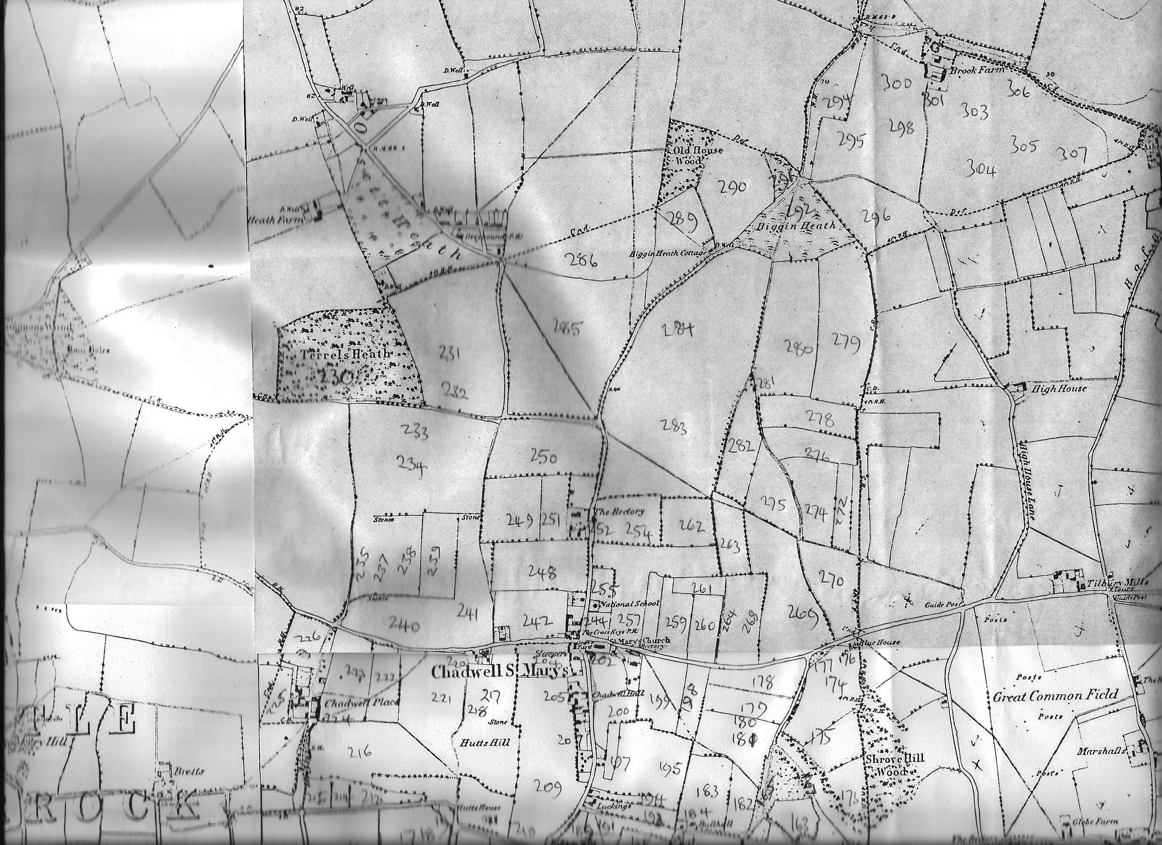
Map 1.
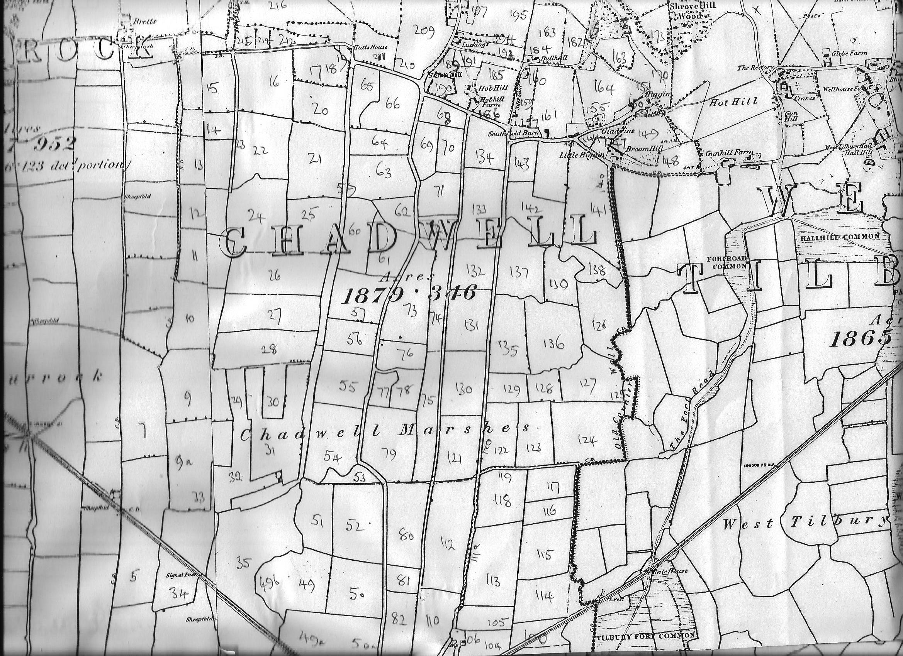
Map 2.
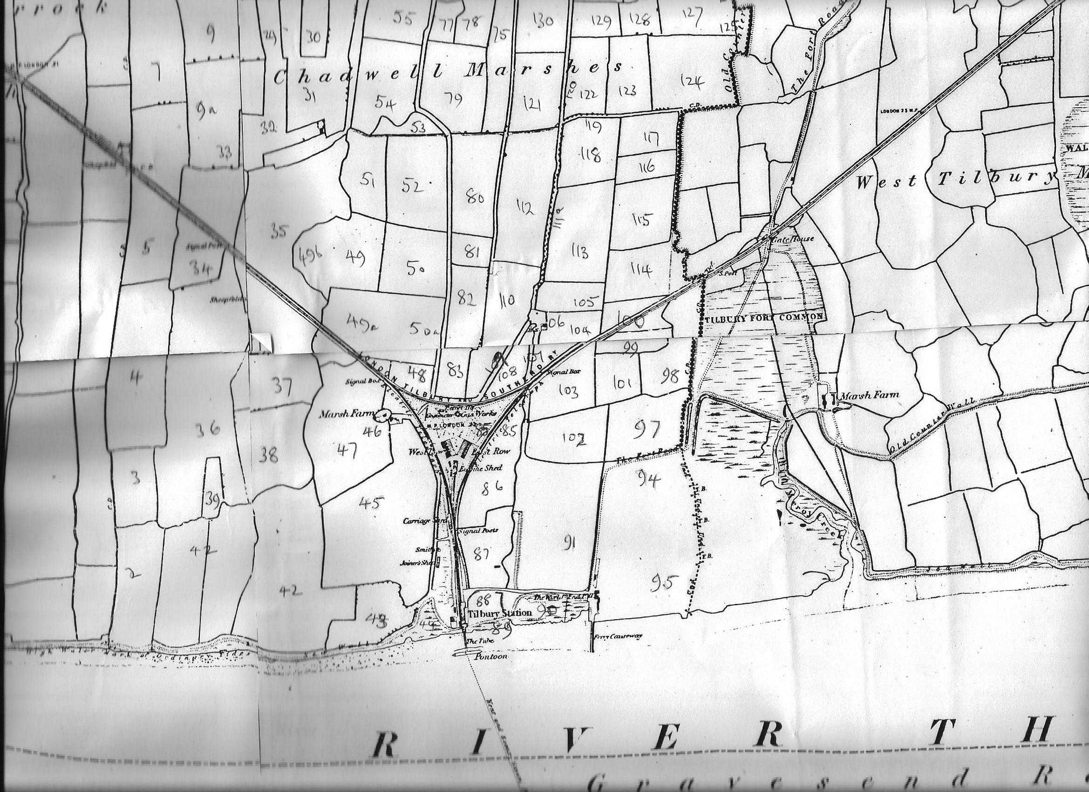
Map 3.

