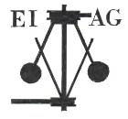**Essex Industrial Archaeology Group**

**(Incorporating The Essex Mills Group)**

**NEWSLETTER**

**Number 46 October 2022**

**Welcome to this edition of the**

**Essex Industrial Archaeology Group’s (EIAG) Newsletter**

This edition contains reports on two Fairs held this autumn: the National Trust’s Local History Fair in Coggeshall and our own Industrial Heritage Fair. Based on the talks at the latter is a very informative article making a comparison between Silver End and East Tilbury company villages There are two new books and hi-tech news from Upminster Windmill.

If you have any comments on the Newsletter generally or specific items in it, or wish to make a contribution to the next Newsletter, please contact us via our email address - [essexiag@gmail.com](mailto:essexiag@gmail.com).

Contributions for the Newsletter should be sent by the end of the month prior to publication (i.e. by end of March, June, September and December), please.

**Programme of EIAG events 2022**

***EIAG Annual Meeting*.** Saturday 12th November 2022, 2:00 – 4:00 pm, at Chelmsford Museum, Oaklands Park, Chelmsford. The business of the Annual Meeting will be followed by an illustrated talk by Bob Sier on the *History of Essex Tide Mills*. Free to members, £2 for non-members.

**EIAG Annual Meeting**

The Annual Meeting will start with the usual business of looking back over the last year, looking forward to events next year and also, most importantly, electing your Committee. Next year EIAG will be 10 years old and most current Committee members have served from the beginning. We need new members to ensure the sustainability of the Group well into the future, to bring in new ideas for activities, and to take on roles both to relieve current members of those responsibilities and also to take up new roles which are being identified. Committee has already identified a need to promote the Group and its events to a wider audience, particularly younger people We are therefore looking for someone conversant with social media to manage our presence on these platforms, and also someone who can identify events across the county at which EIAG could have a presence to raise our profile. Please talk to current Committee members at the Annual Meeting if you have an interest in joining the Committee and especially if you would be interested in taking on particular roles.

**National Trust – Local History Fair**

On Sunday 18th September the National Trust, as part of Heritage Open Days, held a Local History Fair at the Grange Barn, Coggeshall and EIAG were invited to have a stand at the event. Accordingly a shared EIAG, ESAH and the Friends of Chelmsford Museum (FCM) stand was ‘manned’ throughout the day by Dave Buckley, Jane Giffould, Tony Crosby and Howard Brooks – see photo below. There were various other county and local heritage organisations present with stands promoting their activities and publications. It was also possible for visitors to join guided walks of the Abbey grounds and Coggeshall town, take refreshments provided by the National Trust, and listen to a series of talks by experts about different aspects of the history of the barn.

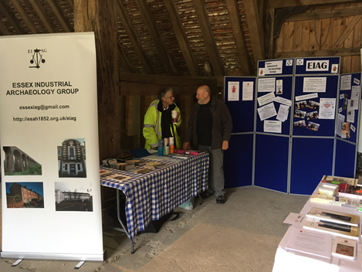The Grange Barn is one of the oldest timber-framed buildings to be discovered anywhere in Europe. It was built by monks of the Cistercian Order, who established their Abbey at a site on the River Blackwater near to Coggeshall in 1140. The barn was built nearby a little later, most probably in the mid-1200`s, to store and process the crops from the Abbey farms. By that time bequests had provided the monks with an extensive area of `monastic grange` land and the barn, its size and the carpentry skills required for its construction, were a clear demonstration of the wealth and influence of the medieval Abbey.

The dissolution of the monasteries by Henry VIII resulted in the closing down of the Abbey in 1538. Much of the complex of buildings was demolished but parts that were retained can still be seen standing while the foundations of the Cloister have been located as parch marks in the grass on aerial photos. The original impressive timber frame of the barn also survives although it has undergone various changes over the centuries. The walls have been raised and the original wattle and daub infill replaced with brick, the roof strengthened, and the doors and porches enlarged.

In 1966 the Grange Barn was designated a Grade II Listed Building. However, this did not prevent it falling in to dis-repair and in 1972 emergency repairs were required to stop it collapsing. It was only after the formation of a Trust in 1975 and the raising of considerable grant aid that a major restoration was undertaken under the supervision of timber framed building specialists. This gave us the magnificent building that can be seen today. It is now in the care of the National Trust, is accessible to the public and I recommend a visit to see both the barn and also the historic town of Coggeshall.

**Dave Buckley**

**Industrial Heritage Fair**

On Saturday 1st October EIAG held its fourth Industrial Heritage Fair at Silver End Village Hall in the Crittall company village. We partnered with the Silver End Heritage Society (SEHS) to organise the event and are very grateful to them for all their help in ensuring the day ran smoothly. We are also very grateful to the local W.I. for providing excellent refreshments throughout the day. There were not as many exhibitors as at previous Fairs as many societies and museums have been affected by the pandemic and did not have the resources to attend as they usually do.

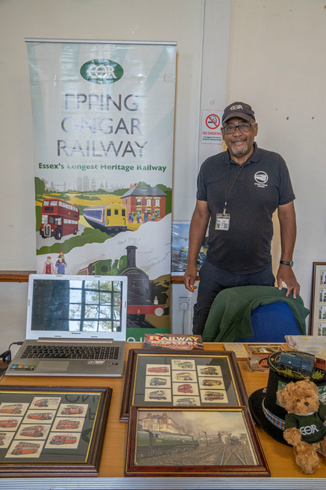However, there were 13 exhibitors and a steady flow of visitors. The ‘official’ opening was performed by Simon Brice D.L. The event also featured two guided walks of the village led by SEHS members to see the design of the village, the facilities provided for the Crittall workers who lived there, and the architecture of the houses and other community buildings. In the afternoon there were three talks, two on Silver End, again given by SEHS members, and the third, in order to make a comparison, given by Mike Tarbard on the Bata company village of East Tilbury.

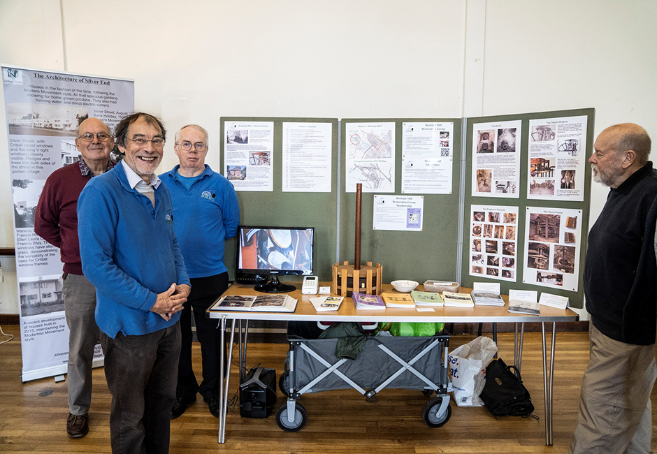

(Photos of the Industrial Heritage Fair kindly provided by **Robert Hall**)

Mike’s talk included a comparison between the characteristics of the two company villages and the facilities provided in each. Following the event he and Jackie Nesbitt, Secretary of the SEHS, compiled the table below which shows how alike the design and facilities in the two villages were.

Many thanks to **Mike Tarbard** and **Jackie Nesbitt** for this very informative table.



**Formula 1 style telemetry for our 200-year-old windmill**

Windmills are liable to storm damage, with particular vulnerability when the wind comes from behind the sails. The free rotation of the cap, driven by the fantail, should prevent this, though a sudden change in the wind or a mechanical failure can leave the mill exposed. Remote monitoring through our webcam has been enhanced by the introduction of an ingenious piece of “Internet of Things” technology devised and built by one of our members, Justin Coombs, on our behalf.

There are four elements:

* A weather station, kindly donated by Cliff Featherston and installed on the roof of the visitor centre, monitors the weather conditions.
* A specially designed digital compass has been installed in the cap of the mill. This is a battery powered device which measures the orientation of the cap using a digital magnetometer and transmits the readings through a wireless signal.
* The signals are picked up by an “Internet of Things” gateway installed in the visitor centre.
* The device is part of The Things Network - just zoom into the worldwide map at <https://www.thethingsnetwork.org/map> - and look for Upminster Windmill.

Data from the weather station and the compass travels through the internet to smartmolen.com for processing and analysis. The live data, together with the forecast weather, is now displayed on our website.

This is the first time a device of this type has been installed in a windmill. Further enhancements are planned to issue alerts when the mill is at risk and to provide deeper analysis and insight into the cap’s behaviour under different wind conditions. We also intend to present this insight on a digital display in the visitor centre which will bring to life the challenges of harnessing wind power.

To view either the live camera and compass or the live weather station, select one of

the following link: <http://www.upminsterwindmill.org/live-camera.html>

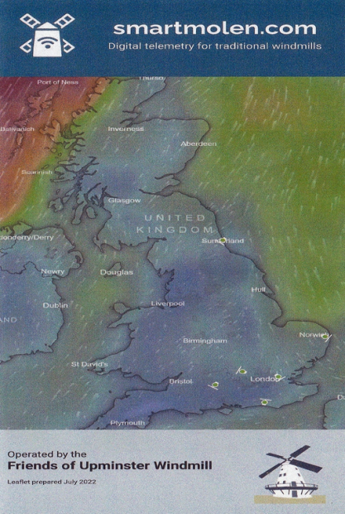Over the last year we've made a lot of progress with the Smartmolen live monitoring technology.

We've now installed digital compasses in 9 mills, whose live cap/buck orientation is shown on a single wind map. You can see the current wind map, historical data and forecast conditions as well as cameras at Upminster and Wilton, on the website smartmolen.com.

It's been very interesting to watch the different characteristics of how each mill responds to a change in wind conditions and satisfying to see them form patterns around weather systems moving across the country.

We're also building quite a large dataset of historical cap movement (a million records and counting) as we record the cap orientation of each mill every few minutes.

Below are the mills which have been fitted with the Smartmolen sensors.

* Upminster (Greater London)
* Aythorpe Roding (Essex)
* Drapers (Kent)
* Jill (West Sussex)
* Lacey Green (Buckinghamshire)
* Polkey’s (Norfolk)
* Hardley (Norfolk)
* Wilton (Wiltshire)
* Fulwell (Tyne and Wear).

**Paul Sainsbury / Friends of Upminster Windmill**

**FORECAST22 EXHIBITION**

I recently attended a private view which was held for the opening of the current temporary exhibition at Chelmsford Museum called `Forecast22: Broadcasting Across the Ether`. This can be seen in the special exhibition room at the museum and may be of interest to some members.

|  |  |
| --- | --- |
| |  | | --- | | Scan of the Writtle Hut | |
| |  | | --- | | Forecast22 is a digital artwork and interactive website celebrating the centenary of the first UK public radio broadcasts. Artist Sian Fan has collaborated with Chelmsford Museum to explore this important moment in history, when Marconi Company engineers were asked to create a pioneering weekly radio show. The resulting programmes were broadcast from a small hut in Writtle, which is now re-erected and protected in the Chelmsford Museum Industrial Archaeology store at Sandford Mill.  Visitors to the museum have the opportunity to experience the digital artwork within a physical supporting exhibition. However, as a website, Forecast22 is available beyond Chelmsford to around the world. This is seen to echo the expansion of UK broadcasting from that small hut in Writtle to the digitally connected world of today.  The exhibition can be visited until 12th March 2023 and the Forecast22 website can be accessed until 14th October 2023. For more information on events that will be programmed as part of the supporting exhibition, visit <https://www.chelmsford.gov.uk/museums/whats-on/>  **Dave Buckley**  **Recent publications – in time for Christmas!**  The Colne Valley & Halstead Railway, incorporated in 1856 and opened in stages between 1860 and 1863, ran for a distance of 19 miles from a junction with the Great Eastern Railway Marks Tey to Cambridge and Bury St Edmunds cross-country route at Chappel to terminate at its own station at Haverhill, wholly within the County of Essex. In 1865 a connection was made to Haverhill GER station on the same cross-country route in neighbouring Suffolk. For the majority of its 57 years of independence the CV&HR was in financial difficulties, with services being operated by agents including in 1865 Sir Daniel Gooch of the Great Western Railway. A motley collection of rolling stock was hired and a Cornish entrepreneur provided backing for the organisation, but by 1874 the railway went into receivership and it took an Act of 1885 to rectify matters. Several attempts were made to entice the GER to take over the line but these were rebuffed as investigation proved the infrastructure and maintenance left much to be desired. The first decades of the 20th century, under the stewardship of Elyot S. Hawkins from the Cambrian Railways, brought vast improvements – but grouping under the L&NER from July 1923 could not have come sooner for the company was experiencing insoluble problems. Having become just another branch line, the route played an important part in World War Two with military traffic for local airfields. British Railways management, whilst introducing modem rolling stock, decided the line duplicated other routes and passenger services were withdrawn on 1st January 1962 and freight finally from April 1965. To the last, local staff remained patriotic to the line, boasting they were ‘Colne Valley and proud of it’.  312 pages. 275x215mm. Printed on gloss art paper with colour laminated board covers. ISBN13:9781915069061 £40.00 +p&p  **(From Lightmoor Press)**  **https://images.squarespace-cdn.com/content/v1/5f6cad22c0b8621101120185/1660568716559-TL9T4TKP9AIPJ9RP7WX9/Front.png?format=500w**A mill has stood on the banks of the Stort at Little Parndon for a millennium or more. During all that time it has seen countless millers come and go, many of whom are buried in the churchyard, alongside great lords of the manor and humble mill workers. From Saxon peasants, through sixties crafts people and right up to today, this is the story of just some of them, the times in which they lived, and the many challenges they faced both with the mill itself and the river.  Available from the Gallery for £12 or online at <https://www.parndonmillgallery.org/publication>  ISBN 9781399929134  **H & T C Godfrey – Chelmsford and Saffron Walden**  A recent visit to Bishop’s Stortford Museum in the South Mill Arts Centre revealed a display of six boards advertising former local businesses (see photo left). Although half are from Hertfordshire businesses, the other half are from Essex businesses, ones in Dunmow, Harlow and H & T C Godfrey of Chelmsford and Saffron Walden. Godfrey’s ropeworks in Moulsham Street, Chelmsford features in the EIAG publication the *Chelmsford Industrial Trail*, and so is well documented. However, the Saffron Walden branch is new to me! So more research will follow, but if any EIAG members have information on Godfrey’s of Saffron Walden please do let us know via our email address – [essexiag@gmail.com](mailto:essexiag@gmail.com)  **Tony Crosby**  **MERRY CHRISTMAS AND A HAPPY NEW YEAR TO ALL EIAG MEMBERS** | |