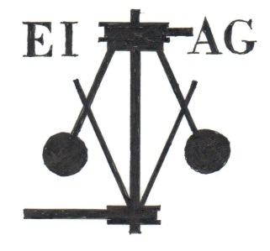
Essex Industrial Archaeology Group

NEWSLETTER

Number 5 June 2015

Welcome …

… to this edition of the Essex Industrial Archaeology Group’s (EIAG) Newsletter. We apologise that it is a bit later than planned. As well as the usual advance notices of events and reports on recent events, the main news is the progress being made with the developing programme for the Industrial Heritage Fair in October.
If you have any comments on the Newsletter generally or the items in it, or wish to make a contribution to the next Newsletter, please contact us via our email address - essexiag@gmail.com.

Next Visit

The next visit in the ESAH programme of industrial interest is to the

Bata Reminiscence and Resource Centre, East Tilbury, with a guided tour of the Bata company village and view of the factory site

Saturday 4th July at 10:00

£5.00 in advance or £6.00 on the day

Bookings can be made with Dr Graham Gould 0208 556 1423 or DrGEGould@aol.com

Other EIAG/ESAH events in 2015

The Essex Society for Archaeology & History in its programme of visits and talks for 2015 includes the following of industrial interest as suggested by members of the EIAG:

- Wednesday 16th September – Museum of Power, Langford, Maldon
- Saturday 14th November – EIAG Annual meeting and lecture by Keith Falconer, former Head of Industrial Archaeology at English Heritage and Chairman of the Association for Industrial Archaeology, Chelmsford Museum
- But the main event for this year is the

INDUSTRIAL HERITAGE FAIR

This is being held on:

SATURDAY 10TH OCTOBER 2015

from 10:00 to 4:00

at BRAINTREE DISTRICT MUSEUM
Manor Street, Braintree CM7 3HW

There are already 15 societies and organisations signed up to have stands at the Fair and more are available. These include local groups such as Alderford water mill, Upminster Windmill and the Bulmer Brick and Tile Company, plus national organisations such as the Association for Industrial Archaeology and the European Route for Industrial Heritage (ERIH), which has a route covering Essex and the rest of East Anglia.

There will be five short talks given on the textile industries of Essex, the public water supply in Colchester, industry of the Tilbury area and ERIH.

Visitors will also be able to see the displays on local industry in the Braintree District Museum (for which an admission fee is payable) and there will be Braintree Town Trail leaflets available should visitors wish to follow a self-guided trail of industrial heritage sites in Braintree.

It all promises to be a very exciting, interesting and stimulating day, so please put the date in your diaries, tell your family and friends all about it and encourage any local heritage groups to which you belong to take part in the day.

Further details will appear in future EIAG Newsletters or email us at essexiag@gmail.com

Important up-date on Marconi’s Hall Street factory project

As reported in last month’s newsletter, a partnership which includes the Marconi Heritage Group and Chelmsford Civic Society are seeking to buy the lease on half of the ground floor of the Marconi Hall Street factory – the first wireless factory in the world – to create a community and heritage asset. They have launched a national and international appeal for the funds to purchase a 99 year lease, after which they will be applying to the Heritage Lottery Fund for equipping and fitting it out as an educational and heritage resource. Pledges are already mounting up, but much more is needed. To read more about the appeal and pledge money to this very worthwhile project go to: https://spacehive.com/marconiscienceworX

East of England Region Industrial Archaeology Conference
(EERIAC)
6 June 2015, Denver, Norfolk.

On a glorious sunny summer’s day a group of about 30 people interested in Industrial Archaeology met in the small village of Denver, Norfolk, just south of Downham Market, near the confluence of the Great Ouse, Bedford Rivers New and Old, and Wissey River. This was the once a year meeting for all those with an interest in Industrial Archaeology in East of England and was run by the Norfolk Industrial Archaeology Group. The main theme was topics relating to industry in Norfolk with a special interest in the Denver area.

The morning was devoted to a selection of interesting presentations.
- We learnt about the Denver Windmill which is now unfortunately closed.
- This was followed by detail on the local sugar factory at Wissington. It is the largest beet sugar factory in the world providing an output of 1/3 of the whole world output. As well as sugar for food consumption it also produces ethanol for fuel. The excess heat from the process is used to heat tomato sheds. This year is the centenary for UK Beet Sugars. One of the first sugar beet factories was at Lavenham.
- Shale oil in Norfolk was known by the locals for at least a century, despite a certain Dr William Forbes-Leslie claiming to have found it at the start of the 20th century. He set up English Oilfields Ltd, sold £300 000 worth of shares and built up the pits and mines. Unfortunately he did not bother to test the oil for useability, nor the mines for water levels. The high water levels along with an oil that was too sulphurous for use made shares at £4 drop to 6/10 1/2 . He moved to Somerset to try his luck there and was done for fraud.
- Fen Drainage was the final presentation. There was a history of the drainage of the fens along with the types of windmill used for pumping the water. This included Royalty getting fed up with their Lords not getting on with the job and so taking it on themselves. Cromwell, being a local, had initially been anti the drainage but changed his mind and promoted it leading to the 3 levels. Over the years there had to be a fair amount of regulation due to farmers draining their own land onto their neighbours rather than into the proper drains.

The short AGM gave a chance for Essex to publicise the forthcoming Industrial Heritage Fair. This was well received with quite a lot of interest shown.

The afternoon was used for visits. The first visit was to the outside of Denver Windmill. We discovered such points as a loo with a seat for 2 people and that nuclear scientist Nobel Prize winner Sir John Cockroft had used the machine shop to make some of his equipment.

The main visit was to the Denver sluice complex. It certainly was complex! The engineering works on the rivers date back many hundreds of years and relate to both draining and regulating the water in the Fens starting in 1651 with the Denver sluice bridge being built in 1740.

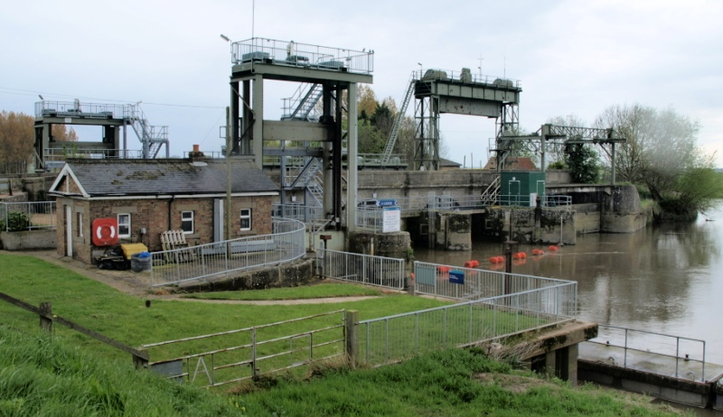
AG Wright sluice, 2012
Part of the job is navigation of the Great Ouse and the Bedford Rivers, consequently there is a fairly large lock. However the main job of the sluices are to regulate the tidal waters that come up the river and can go as far as Erith, quite a long way inland. The sluices help protect Ely and Cambridge. Coming with the tidal waters is soil from the Yorkshire coast which then gets deposited to block the rivers. This needs to be kept from going too far up. Part of the complex is a relief channel which can flood onto adjoining land if necessary, such as in winter. In addition there is the cut off channel which is specifically for diverting water into Essex via the Stour River and into the enlarged Abberton and Hanningfield Reservoirs. However the Ouse has priority over Essex, if there is too much Yorkshire soil which needs flushing out then the water will be used for that rather than coming to Essex!

Overall an excellent and very interesting day with a good balance of inside and outside activities. See below for next year’s EERIAC conference to be run by Cambridge Group.

Essex on the EERIAC committee.
At the EERIAC conference Jane Giffould was nominated as the Essex rep on the EERIAC committee.

Advance Notice for EERIAC conference in 2016

Cambridge will be hosting the 2016 conference. They have decided to visit the Shuttleworth collection at Old Warden, Beds on Saturday 11 June 2016 at a price of £20. This visit is open to all who want to join them. To fit with the payment system of Shuttleworth and keep the price down to £20 they need to have at least 50 participants. They need to know potential numbers before the end of the year to know if it remains feasible. If you would like to make a provisional booking for a place please contact Jane Giffould, jgiffould@aol.com. (If I fly in I might be able to offer a couple of seats for passengers.)

Report of Essex Society for Archaeology and History AGM

The Annual General Meeting of the Essex Society for Archaeology and History (ESAH), of which the Essex Industrial Archaeology Group (EIAG) is a sub group, took place at Essex University on 13th June. It was a well, attended meeting at which Adrian Corder-Birch, who is Vice Chairman of EIAG, was unanimously elected as President of ESAH. The good links between EIAG and ESAH were further strengthened by the election of Dave Buckley as a Vice President. In addition Tony Crosby and Paul Sainsbury were both elected as ex-officio members of the Council of Management of ESAH.
At the meeting Adrian Corder-Birch gave a report of the work of EIAG, the forthcoming programme and particularly promoted the Industrial Heritage Fair at Braintree District Museum on 10th October.

Recent Article – The Marconi Legacy: assessing the heritage of the wireless communications industry in Essex

In the Spring 2015 edition of Essex Journal (EJ) is an article on the Marconi Legacy by Tim Wander, who has published a number of books on the history of Marconi’s, and Tony Crosby, EIAG Chairman. The article briefly traces the history of the development of the Marconi Companies in Essex, of wireless communications and of the Marconi sites in the County. It goes on to assess the significance and current condition of these sites in order to indicate what heritage of the industry survives and what has been lost forever. You can subscribe to EJ online at www.essexjournal.co.uk/subscribe.

Understanding Industrial Assets - Conservation & Management

Historic England (formerly English Heritage) and the University of Leicester are offering a two day CPD course aimed at developing attendees understanding of industrial assets and their conservation and management. The course will take place on Tuesday 22 and Wednesday 23 September 2015 at the University of Leicester and full details can be found on the University’s website at:

http://www2.le.ac.uk/departments/history/heritage/understanding-industrial-assets-conservation-management

Europe

This year is the European Industrial and Technical Heritage Year (EITHY). Full details of the aims of the year and the events associated with it, including our own Industrial Heritage Fair, can be found on the EITHY website at: http://industrialheritage2015.eu/
European Industrial and Technical Heritage Year

