**Essex Industrial Archaeology Group**

**(Incorporating The Essex Mills Group)**

**NEWSLETTER**

**Number 55 January 2025**

**Happy New Year and Welcome to this edition of the**

**Essex Industrial Archaeology Group’s (EIAG) Newsletter**

In this edition we are, firstly, pleased to publish an article by Elphin Watkin on E N Mason and Sons Ltd. of Colchester, prompted by last November’s ESAH Symposium. There is then the excellent news of the National Lottery Heritage Fund grant which has been awarded for the restoration and conversion of Colchester’s iconic water tower, ‘Jumbo’. We also announce events to mark two major anniversaries – the publication in 1974 by the Essex Record Office of John Booker’s *Essex and the Industrial Revolution*; and the 200th Anniversary of the opening of the Stockton – Darlington Railway. Finally there is a summary of EIAG Committee’s consideration of whether to hold another Industrial Heritage Fair in 2026.

If you have any comments on the Newsletter generally or specific items in it, or wish to make a contribution to the next Newsletter, please contact us via our email address - [essexiag@gmail.com](mailto:essexiag@gmail.com).

Contributions for the Newsletter should be sent by the end of the month prior to publication (i.e. by end of March, June, September and December), please. Please submit text as a Word document and photos as separate files such as jpgs.

**Programme of ESAH/EIAG events 2025**

**Saturday 26th April 2025, 10:30 am– 1:00 pm – Essex Record Office.** Part-day mini conference to mark the 50th Anniversary of John Booker’s book – *Essex and the Industrial Revolution*. Fuller details below.

**Date to be announced (sometime in the autumn!)**. EIAG Annual Meeting, extended to a possible half-day meeting to include Essex railway-themed talks to commemorate the 200th Anniversary of the opening of the Stockton – Darlington Railway

**European Route of Industrial Heritage (ERIH) Board Changes**

ERIH Board announced last month that two ERIH founding members, John Rodger(GB) and Rainer Klenner (Germany), have stepped down from the Board after having served for many years. The Board thanked them for their outstanding work and tireless commitment. John Rodger, who played a major role in the recognition of the Blaenavon Industrial Landscape as a UNESCO World Heritage Site, was instrumental in establishing the ERIH network in the United Kingdom. A particular focus of his activities was the development and maintenance of the South Wales regional route. For a certain period, he also served as the National Representative for Wales. Rainer Klenne provided important impetus for the founding of ERIH. He felt that a network of sites developed for tourism offered an opportunity to increase their popularity and thereby promote awareness of the industrial heritage and support for its preservation with public funds. As webmaster, he was the most important architect of the rapidly growing ERIH website.

**E N Mason and Sons Ltd. Colchester**

The last Essex Society Annual Symposium was different in being mainly industrial and also mainly on Colchester and north east Essex.

The two very interesting Colchester talks on Paxman’s and Woods part covered a point that applied to both. The Company of E N Mason developed from Paxman’s and during the talk a picture of the old drawing office at Woods was shown which connected both as being the equipment they became famous for. Before the computer age every drawing office would have had a dyeline printer to reproduce copies of drawings and much of the supply for machines and materials was developed and came from Colchester. The Company of E N Mason & Sons Ltd, Arclight works was known to drawing offices much further afield than Colchester, exporting to over 50 countries.

Ernest Nathan Mason worked at Paxman’s in Colchester as a draughtsman and the works photographer.

He devised a method of making photographic [blueprints](https://en.wikipedia.org/wiki/Blueprint)[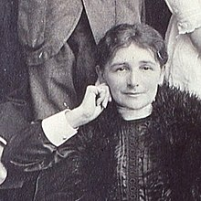](https://en.wikipedia.org/wiki/File:Bertha_Betsey_Mason-_A_Colchester_Businesswoman_(cropped).jpg) from engineering drawings.

In the census of 1901 Bertha Mason was noted without an occupation. However, in 1911, her occupation was "Photographic Printer" on her "own account" rather than an employee.

As he worked at Paxman’s his wife ran the business from their home listed in directories as 2 Winsley Road by 1910. After the early death of Mr Mason in 1914 the company of E N Mason is listed as 1 Queen Street. By c1915 the company E N Mason and Sons Ltd was formed under Bertha Betsey Mason and two sons. By 1928 they were employing about 200 people which in the next ten years increased to about 300. This had needed more factory space from the Arclight works in Maidenburgh Street which had opened in 1921.

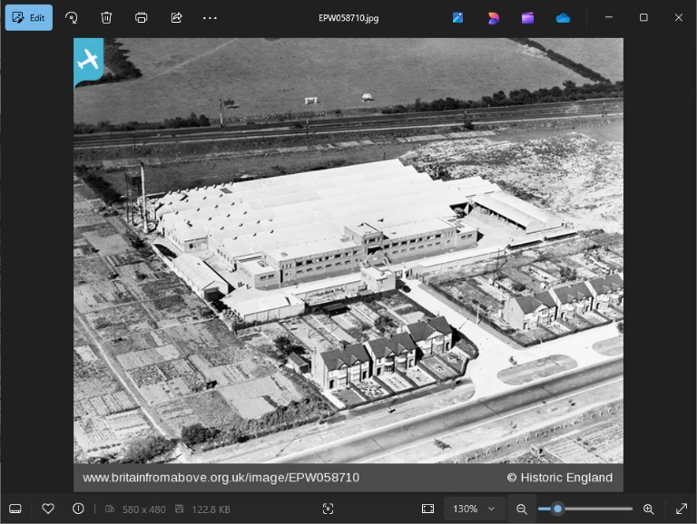In 1938 they opened the new factory on Cowdray Avenue sadly it was completed after Mrs Mason died.

During the War Mason's produced paper for maps and blueprints, portable photocopiers for use in lorries, as well as equipment for aircraft reconnaissance and tank landing craft.

Following the retirement of Bernard Mason in 1962, the firm declined and was taken over by various companies. Became NIG Mason until it became Ozalid's in 1969.

[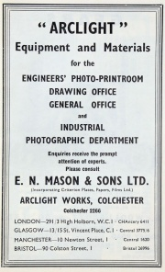](https://www.gracesguide.co.uk/File:Im1951MWYB-Mason.jpg)[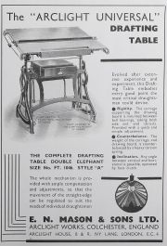](https://www.gracesguide.co.uk/File:Im1937Eng-Mason.jpg)

Pictures:

Bertha Mason

1938 New works at Cowdray Avenue

Drafting table from 1937

Some ARCLIGHT leaflets from c1950’s

[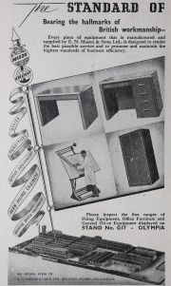](https://www.gracesguide.co.uk/File:Im1951BIF-BW2-Mason1.jpg)

**Jumbo Water Tower in Colchester**

An £8m grant to restore and convert the Grade II* listed Jumbo Water Tower in Colchester has been awarded by the National Lottery Heritage Fund (NLHF) to make it accessible to the public for the first time as a heritage and events space. Standing proud at 131 feet tall, Jumbo is the largest, intact listed water tower from a golden age of industrial water engineering. Constructed in 1883 using 1.2m locally produced bricks, it was built to hold 1,000 tons of clean water. It became redundant in 1984 and was on the buildings at risk register for 30 years.

Simon Hall MBE, Chair of Colchester North East Essex Heritage, said: “Thanks to National Lottery players, Jumbo will become a leading destination and a resource for the community, with life changing opportunities to get involved and learn skills. The funding will ensure we can inspire future generations and diverse groups, attract visitors, provide jobs and create a financially sustainable asset.”

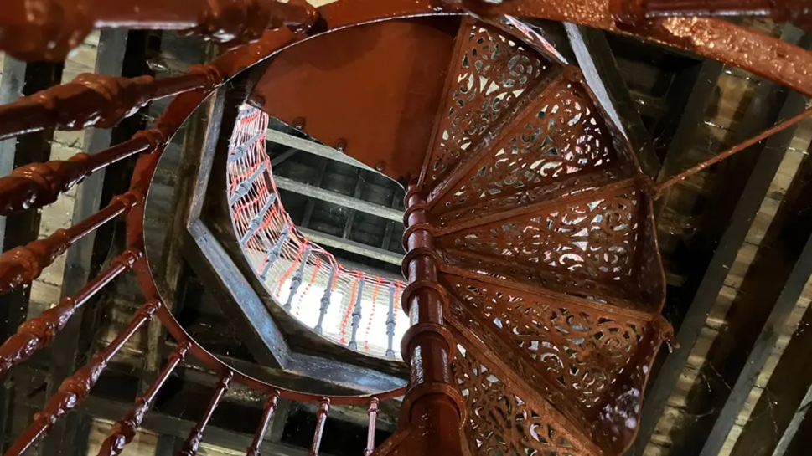

Internal photo of the cast-iron stairs (Jodie Halford/BBC)

"Jumbo" is currently home to 157 steps - and an additional flight of cast-iron stairs leads to the lantern room at the top of the building.

To read more follow this link to the BBC website: <https://www.bbc.co.uk/news/uk-england-tees-56168296>

**50th Anniversary of John Booker’s book**

***Essex and the Industrial Revolution***

Planning for this event with ERO staff has continued and the draft programme is as follows:

**Part-day mini conference to mark the 50th Anniversary of**

J**ohn Booker’s book – *Essex and the Industrial Revolution***

**Discovering the Industrial Revolution in Essex**

**John Booker’s legacy: past, present & future**

**Saturday 26th April 2025, 10:30 – 1:00 at the Essex Record Office**

*Draft programme tbc early March*

9:30 – 10:30: Registration & Coffee, plus time to view displays and networking

10:30 – 10:35: Welcome – Martin Astell, ERO Manager

10:35 – 10:55: John Booker: his Record Cards and Publication – ERO Staff

10:55 – 11:25: The Frederick Roberts Archive – Dr Catherine Pearson (ARU)

11:25 – 11:45: Comfort break and networking

11:45 – 12-15: Essex County Council Thematic Surveys of Industrial Monuments – Shane Gould (Historic England) tbc

12:15 – 12:35: Recent surveys and interpretation of industrial monuments – Tim Murphy (ECC Place Services) tbc

12:35 – 1:00: Q&A and future research agenda for Essex – Panel of Speakers

**Displays in adjacent room:**

ESAH EIAG

Frederick Roberts Archive Silver End Heritage Society

H21C – Courtaulds in Halstead

**Stockton & Darlington Railway 200th Anniversary**

This year is the 200th Anniversary of the opening of the Stockton & Darlington Railway on 27th September 1825. Following a suggestion from a member for an Essex event to mark this major milestone in the development of railways world-wide, it was agreed that Committee supported the idea in principle and discussion took place as to what EIAG may do.

At present we are considering extending the EIAG Annual Meeting in the autumn to a full half-day which would allow for a short business meeting, followed by two or three talks on the impact of railway development in Essex and the contribution of one of the main railway engineers in the county. We are monitoring what other events are taking place in Essex to mark this occasion, such as at the three heritage railway sites, to ensure there is no duplication.

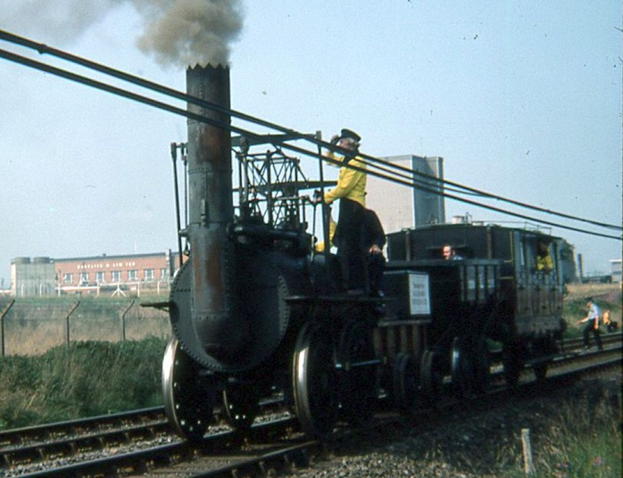

Replica Locomotion No.1 at the 150th Anniversary celebrations of the opening of the S&DR held in 1975 (Photo: Tony Crosby – a much younger version!)

**The East Anglia Railway Museum** (EARM), based at Chappel & Wakes Colne Station, are holding aspecial day of celebration for the 200th anniversary of the modern railway network on **Sunday 13th July 2025** in partnership with the Essex and South Suffolk Community Rail Partnership, Greater Anglia and the local community, including station adopters.This will be similar to the highly successful event in 2024 when they celebrated Chappel 175 – the 175th Anniversary of the Marks Tey to Sudbury Railway Line (see report of this event in EIAG Newsletter no. 53, July 2024).

**Also EARM** are holding an *Essex Electrics Exhibition* on **Saturday 12th April 2025** to mark the 40th Anniversary of the electrification of the Great Eastern Mainline as far as Ipswich**:**

The Epping and Ongar Railway are celebrating the 160th anniversary of the opening of the railway line from Loughton to Ongar with a special event on the **weekend of the 3rd & 4th May 2025.**

**The future of Industrial Heritage Fairs (IHF)**

Before deciding whether to hold another biennial IHF (next one would be in 2026) your Committee agrees that three main issues needed to be resolved:

1. Jane Giffould is stepping down from being our contact with the local museums, societies and industrial sites which are the potential stall holders – alerting them to the next IHF, sending out and receiving booking forms, chasing up, and organising the room layout. Jane has performed this task perfectly for all five of the previous Fairs and we are all most grateful for all her hard work. We would need to find someone, or maybe two, to take on this major task. If there are any members who would be willing to take over from Jane, please get in touch at the email address below? A job description can be provided along with discussion with Jane.
2. We do wonder if there still an appetite and capacity amongst potential stall holders for supporting another Fair? Although the number of stalls at each Fair has remained steady (apart from the immediate post-Covid event) many of the major sites in the county which have attended previously, did not attend in 2024. We are going to canvas all the organisations on Jane’s contact list to gauge how much interest there would be in supporting another Fair.
3. We need to find a suitable venue, preferably in the south of the county as it has been commented that there has only been one of the five previous Fairs (Watt Tyler CP in 2017) in that area. We agreed to investigate the possibility of East Tilbury Village Hall in the centre of the Bata estate, and Tilbury Riverside Terminal as potential venues. Any other suggestions would be much appreciated.

Committee would very much appreciate members’ thoughts, comments and suggestions as regards to EIAG organising future Industrial Heritage Fairs:

Q1. Should we organise one for 2026, and if so, would you attend as a visitor, or if you are a member of a museum, society or heritage site, would your organisation support a Fair by having a stand?

Q2. Would you be willing to help with the organisation of a Fair, especially to be our contact with the various potential organisations which may have a stand?

Q3. Do you have any suggestions for a venue in the south of the county – a large space such as a barn, village hall, museum etc., with at least one separate room for the talks – at or very close to a site and area of historic industrial interest?

We look forward to hearing from you at the usual EIAG email address - [essexiag@gmail.com](mailto:essexiag@gmail.com).

**Thank you**