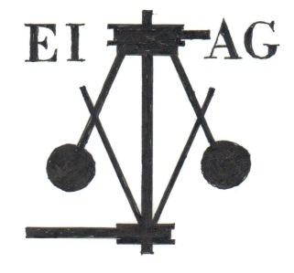
Essex Industrial Archaeology Group

NEWSLETTER

Number 6 August 2015

Welcome …

… to this edition of the Essex Industrial Archaeology Group’s (EIAG) Newsletter. The main item this month is details of the Industrial Heritage Fair being held on 10th October. It promises to be a very interesting and varied event with something that should appeal to you all, so do come along – it is free! Amongst the other news items is good news from the Colne Valley Railway and Braintree District Council.

If you have any comments on the Newsletter generally or the items in it, or wish to make a contribution to the next Newsletter, please contact us via our email address - essexiag@gmail.com.

INDUSTRIAL HERITAGE FAIR

SATURDAY 10TH OCTOBER 2015

from 10:00 to 4:00

at BRAINTREE DISTRICT MUSEUM
Manor Street, Braintree CM7 3HW

We are honoured to have The Lord Petre, Patron of the Essex Society for Archaeology & History, attending to officially open the Fair at 11:00 a.m.

All the stands have now been booked which means there will be over 20 industrial and transport heritage societies and organisations with displays about what they do, what they have to offer visitors and how you can get involved with them. These include the three heritage railways in Essex, local wind and water mills, the Bulmer Brick and Tile Company, Dunmow Maltings, the Marconi Heritage Group, Water Towers, Silver End Heritage and various museums. There will also be national organisations present - the Association for Industrial Archaeology and the European Route for Industrial Heritage (ERIH), which has a route covering Essex and the rest of East Anglia.

There will be five 20 minute talks on the wool and silk textile industries of Essex, the public water supply in Colchester, unusual industrial aspects of Thurrock and the ERIH.

Visitors will also be able to see the displays on local industry in the Braintree District Museum (for which an admission fee is payable) such as Courtaulds and Crittalls. There will be Braintree Town Trail leaflets available should visitors wish to follow a self-guided trail of industrial heritage sites in Braintree.

It all promises to be a very exciting, interesting and stimulating day, so please put the date in your diaries, tell your family and friends all about it and encourage any local heritage groups to which you belong to come along on the day.

For further details email us at essexiag@gmail.com

Next Visit

The next visit in the ESAH programme of industrial interest is to the

Museum of Power, Langford, Maldon

Wednesday 16th September 2015 at 10:00 a.m.

This visit will include a guided tour of the Museum, which is in a former public water supply pumping station and now houses a fascinating collection of industrial machinery. Pride of place is given to the magnificent Lilleshall triple-expansion steam engine which was returned to steam for the first time in 50 years in April 2011. There is a cafe on site for refreshments.

£5.00 in advance or £6.00 on the day

Bookings can be made with Dr Graham Gould 0208 556 1423 or DrGEGould@aol.com

The other EIAG event in 2015 is:

On Saturday 14th November the EIAG is holding its Annual Meeting and Lecture at Chelmsford Museum at 12:30 p.m. This year’s lecture will be given by Keith Falconer who was the Head of Industrial Archaeology at (the former) English Heritage and is the Chairman of the Association for Industrial Archaeology. He will be discussing the development of the discipline of industrial archaeology from the 1950s. We hope that members will support this important event.

August News – Good News

Colne Valley Railway

In the April edition we published a copy of a press release from the Colne Valley Railway (CVR) announcing that 2015 would be their last year on the current site. However there is now good news and the CVR have issued the following press release:

The Colne Valley Railway Preservation Society (CVR), a registered charity, is pleased to announce that it has been granted a one year extension to its lease by its current Landlord.
In addition Mr Young has agreed to sell to the CVR the section of the original “Colne Valley and Halstead Railway (CV&HR)” track bed that he owns. Included in this sale is the rolling stock, buildings, track and all other materials from the present railway site. The area being sold also includes the piece of land between the track bed and Yeldham Road, known as Newman’s Sidings. The remainder of the land is being retained by Mr Young as a prospective site for his own developments.

It must be noted that all these purchases are subject to CVR being successful in Stage 2 of its Heritage Lottery Fund (HLF) bid and securing the approximately £1.7 million of funds it has bid for. The HLF application is designed to provide two new buildings, an Interpretation Centre and a Skills Centre, and the security of tenure the site purchase will provide. Successful completion of the HLF Project will enable the CVR to deliver substantial benefits to the Heritage, People and Communities.

Mr Paul Lemon, Chairman of the Charity, is quoted as saying “We are grateful to Mr Chris Young for agreeing to sell us this unique section of the CV&HR track bed that has been the Railway’s home for the last 40 years, and for the extension to our lease on the present site. This sale should enable us to fully achieve our Charity’s main objective as well as remain open to the public during the transition period whilst we reconfigure the site. We are also grateful to the local landowners who have supported us in our search for a suitable alternative site and have agreed to consider the sale of additional land we might require.”

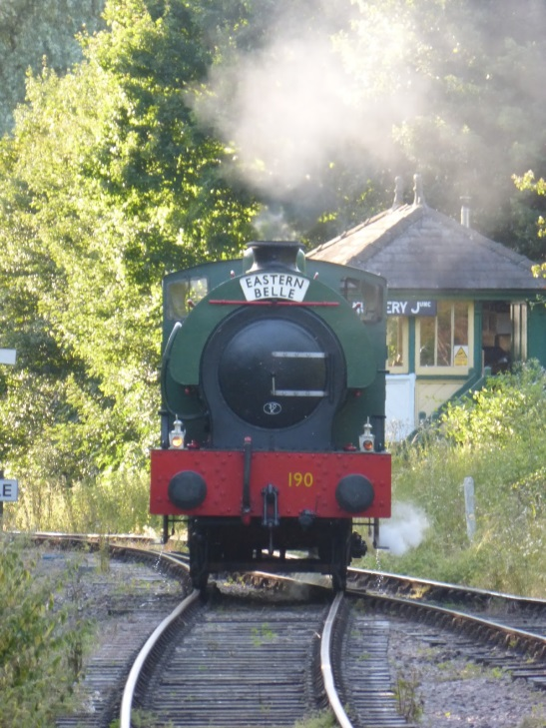

Braintree District Council – Local Heritage List

More good news! - this time that Braintree District Council (BDC) will on Wednesday 19th August be launching their Local Heritage List (LHL). ‘Local heritage listing is a means for a community and a local authority to jointly identify heritage assets that are valued as distinctive elements of the local historic environment, especially buildings and structures which are not Listed Buildings. It provides clarity on the location of assets and what it is about them that is significant, guaranteeing that strategic local planning properly takes account of the desirability of their conservation.’ (Historic England’s Good Practice Guide for Local Heritage Listing)

Working together Braintree & Bocking Civic Society (BBCS) and BDC have created a list of all buildings and structures in the District associated with the Courtauld family and business. BDC are currently consulting with the owners of these buildings and structures in Braintree and Bocking, initially, as the first step towards creating their LHL. The list includes factories, a workmen’s hall, village halls, a mechanics institute, public gardens, schools, drinking fountains, churches, Braintree Town Hall, hospitals, air raid shelters and dozens of staff houses across the District. The full list can be viewed on the B&BCS website at: http://www.bbcivsoc.org.uk/pdfs/0-Courtauld-LHL-Version-6.pdf

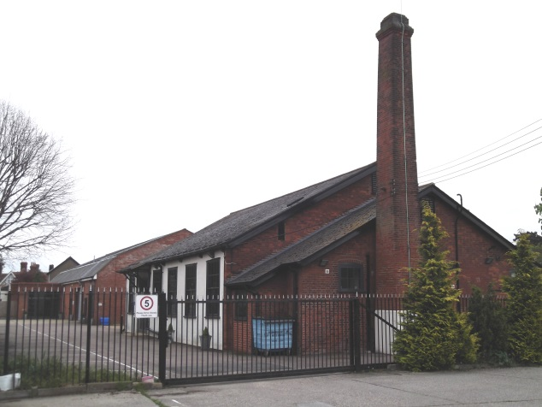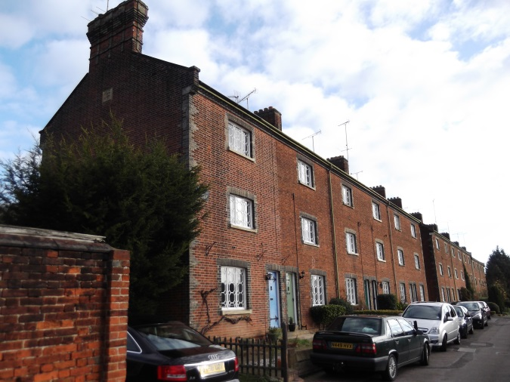

Crepe Factory, Earls Colne Factory Terrace, Halstead

Waltham Abbey Royal Gunpowder Mills
Summer Events

The summer programme of events at the Waltham Abbey Royal Gunpowder Mills can be found on their website at:
http://www.royalgunpowdermills.com/newsletters/Royal_Gunpowder_Mills_July2015.htm

Heritage Watch in Essex

Heritage Watch in Essex now has a page on the Essex Police website at:
http://www.essex.police.uk/my_neighbourhood/essex_watch/heritage_watch.aspx

European Industrial and Technical Heritage Year

