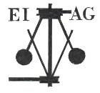**Essex Industrial Archaeology Group**

**(Incorporating The Essex Mills Group)**

**NEWSLETTER**

**Number 54 October 2024**

**Welcome to this edition of the**

**Essex Industrial Archaeology Group’s (EIAG) Newsletter**

This is (hopefully) a little earlier in the month than usual and is focused on three events – a report on the Industrial Heritage Fair held on 14th September; a look forward to next month’s ESAH Symposium and EIAG Annual Meeting; and further ahead into Spring 2025 to an anniversary event to be held at the Essex Record Office.

We would very much welcome your comments on our Newsletters – what have you particularly enjoyed, what would you like to see in the Newsletter, and any general comments you may have, please. Please contact us with your thoughts via our email address - [essexiag@gmail.com](mailto:essexiag@gmail.com). Contributions for the Newsletter should be sent by the end of the month prior to publication (i.e. by end of March, June, September and December), please, again to [essexiag@gmail.com](mailto:essexiag@gmail.com).

**Industrial Heritage Fair (IHF) 2024**

This year our IHF was held in partnership with the National Trust and as part of Heritage Open Days at the Grange Barn in Coggeshall. It was a dry and very sunny, warm day which was a relief as the Barn can be very chilly when there is no warming sunshine! There were 20 exhibitors both in the Barn and outside on the field including the Guild of Weavers, Spinners and Dyers; Halstead Museum; Earls Colne Heritage Museum; Coggeshall Museum; Feering & Kelvedon Local History Society; Bata Heritage Centre; and Silver End Heritage Society.

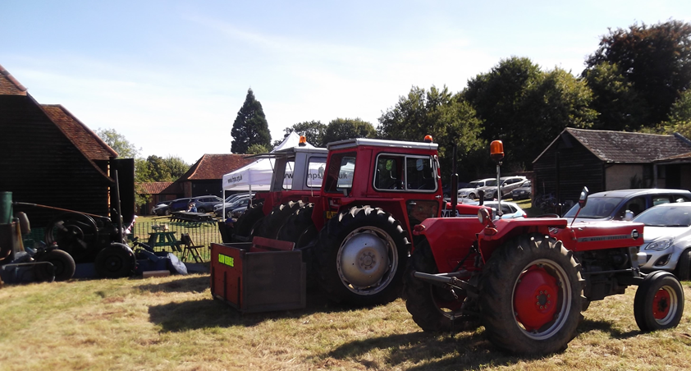The Farm Machinery Preservation Society was the group out on the field with five of their historic tractors.

Photo left – Tony Crosby

Four short talks were available inside the Barn highlighting just some of the local industries, plus the work of North Essex Heritage.

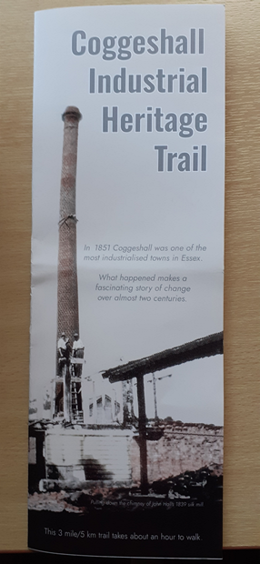An especially commissioned *Coggeshall Industrial Heritage Trail* was prepared by Trevor Disley of Coggeshall Museum and was available free to visitors to take away as a self-guided trail to follow during the day, or at a later date. Copies are still available if you want one, either from Coggeshall Museum or from ourselves (I will bring some to the Symposium).

Also open for the day were Coggeshall Museum; Abbey Mill (courtesy of Richard and Petra Ward); the Blacksmiths Shop operated by Dick Nunn; and the Saunders Collection, an exhibition on the site of the Barn of woodcarving tools used by local master carver Bryan Saunders until his death in 1975.

EIAG had a stand providing our own information and publications. The display on the history of Essex industries at the stand was a newly, especially designed display by Peter Jones, one of our members, for which congratulations and many thanks to Peter (see his photo of the display below).

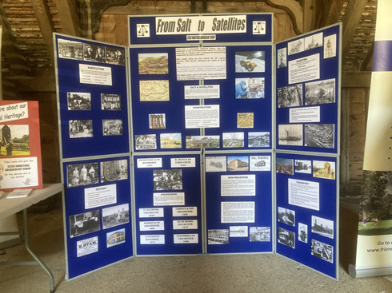

The two main concerns about the day were that having the talks in a corner of the Barn with all the buzz of the visitors elsewhere in the building made hearing the speakers, who did not have access to a PA system, difficult and hence spoiled the experience for some; and also parking on site was a problem during the busier periods. Otherwise we were pleased with the event – numbers of visitors was up on 2022; working with the National Trust took some of the organisational burden from our Committee members, but attendance by some of the larger heritage organisations with historic sites was lower than usual.

Feedback as recorded by Heritage Open Days included:

* Well organised by The National Trust and EIAG and was certainly a good number of visitors throughout the day
* A special event / opening which was organised to coincide with H O D in preference to the organiser's usual meet in October in order to attract more visitors and (hopefully) enjoy warmer weather.  All the exhibitors were friendly and happy to engage with visitors. The talks were interesting and a number of barn volunteers were available to answer "barn" and "local" questions. The abbey mill was open as was St Nicholas Church (the abbey gatehouse church) and a number of people walked to both.
* As a regular exhibitor at EIAG fairs it was one of the best I've been involved with. The venue was beautiful and the fair attracted more people than previous events due to it being also a Heritage Open Day event at a NT property. It was good to meet and talk to people who otherwise may not have come - and also to network with other exhibitors.
* The heritage event at Coggeshall was varied and interesting with classic farm machinery, weaving and spinning displays and a tour by the owners of Abbey Mill, not normally open. We enjoyed our visit and a picnic by the car. The crafters were enthusiastic and welcoming, happy to spend time discussing their craft. Later Essex Police set up a stand offering advice and security gifts. We had a good day out and saw a kingfisher down by the bridge.
* Really opened my eyes to the heritage of Coggeshall. Very much enjoyed it.

From one of the exhibitors (first timers) – ‘Just a short note to say how much we enjoyed yesterday - a great event and very well organised. We found it particularly useful for networking with other likeminded organisations!’

Your Committee will use their first meeting of 2025 to consider all the above feedback and in the light of that and our own capacity, decide whether to hold another Fair in 2026, as has been the pattern, maybe again with a partner organisation(s) or to perhaps to organise other type of events, such as visits and/or talks.

**EIAG Annual Meeting**

As previously announced as this year’s ESAH Archaeology & Local History Symposium is on a post-medieval theme, including industrial topics, this year’s EIAG Annual Meeting will be held during the lunch hour of the Symposium in one of the rooms upstairs at the Roman Circus Visitor Centre. The programme and booking details for the Symposium are below:

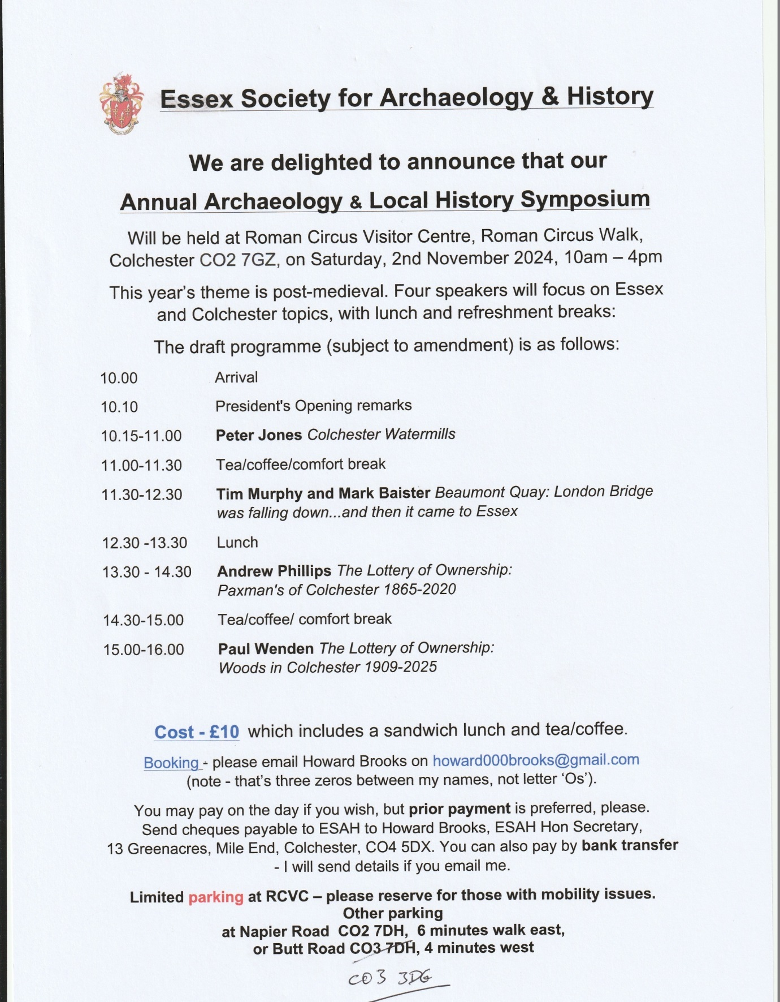

Usually the **EIAG Annual Meeting** consists of a short time of business - looking back over the year’s activities and looking forward to what is planned for the coming year - followed by a lecture on an industrial topic given by a local expert. As the Symposium has four such lectures the Annual Meeting will be mainly about the Group’s future activities for 2025 onwards. As already reported above, the Industrial Heritage Fair was deemed a success and there is demand for it to continue. Running the Fair jointly with the National Trust (NT) and as part of Heritage Open Days (HOD) meant that your Committee was greatly assisted by NT particularly in both planning the Fair and running it on the day. The capacity of your Committee to organise another Fair is both limited and diminishing, so at the Annual Meeting we would like to hear from members ideas for holding another Fair in 2026 such as venues and organisations we could work with again. Also are there other activities you would like to see on the programme such as visits to particular former industrial sites and museums, or topics and speakers for talks either online and/or at particular venues.

Please do attend what promises to be a fascinating Symposium on 2nd November and particularly the EIAG Annual Meeting. An active EIAG Committee is essential for the sustainability of the Group well into the future, to bring in new ideas for activities, and to take on roles both to support current members with their responsibilities and also to take up new roles which are being identified. Please consider joining the Committee – we meet four times a year in Chelmsford for a couple of hours and communicate between meetings as necessary by email. Do talk to current Committee members at the Annual Meeting if you have an interest in joining the Committee.

**John Booker – *Essex and the Industrial Revolution***

As mentioned in the last edition of this Newsletter, this year marks the 50th anniversary of the publication by the Essex Record Office (ERO) of John Booker’s seminal work ‘*Essex and the Industrial Revolution*’. We are now actively planning with staff at the ERO to hold a commemorative half-day event of lectures in April 2025. The date has been set as:

**Saturday 26th April 2025 from 10:30 – 1:00**

**at the Essex Record Office, Chelmsford**

So save that date! The programme is now being planned and we will keep you up-to-date with all the details through this Newsletter as they are confirmed.

**Stansted Mountfitchet Windmill**

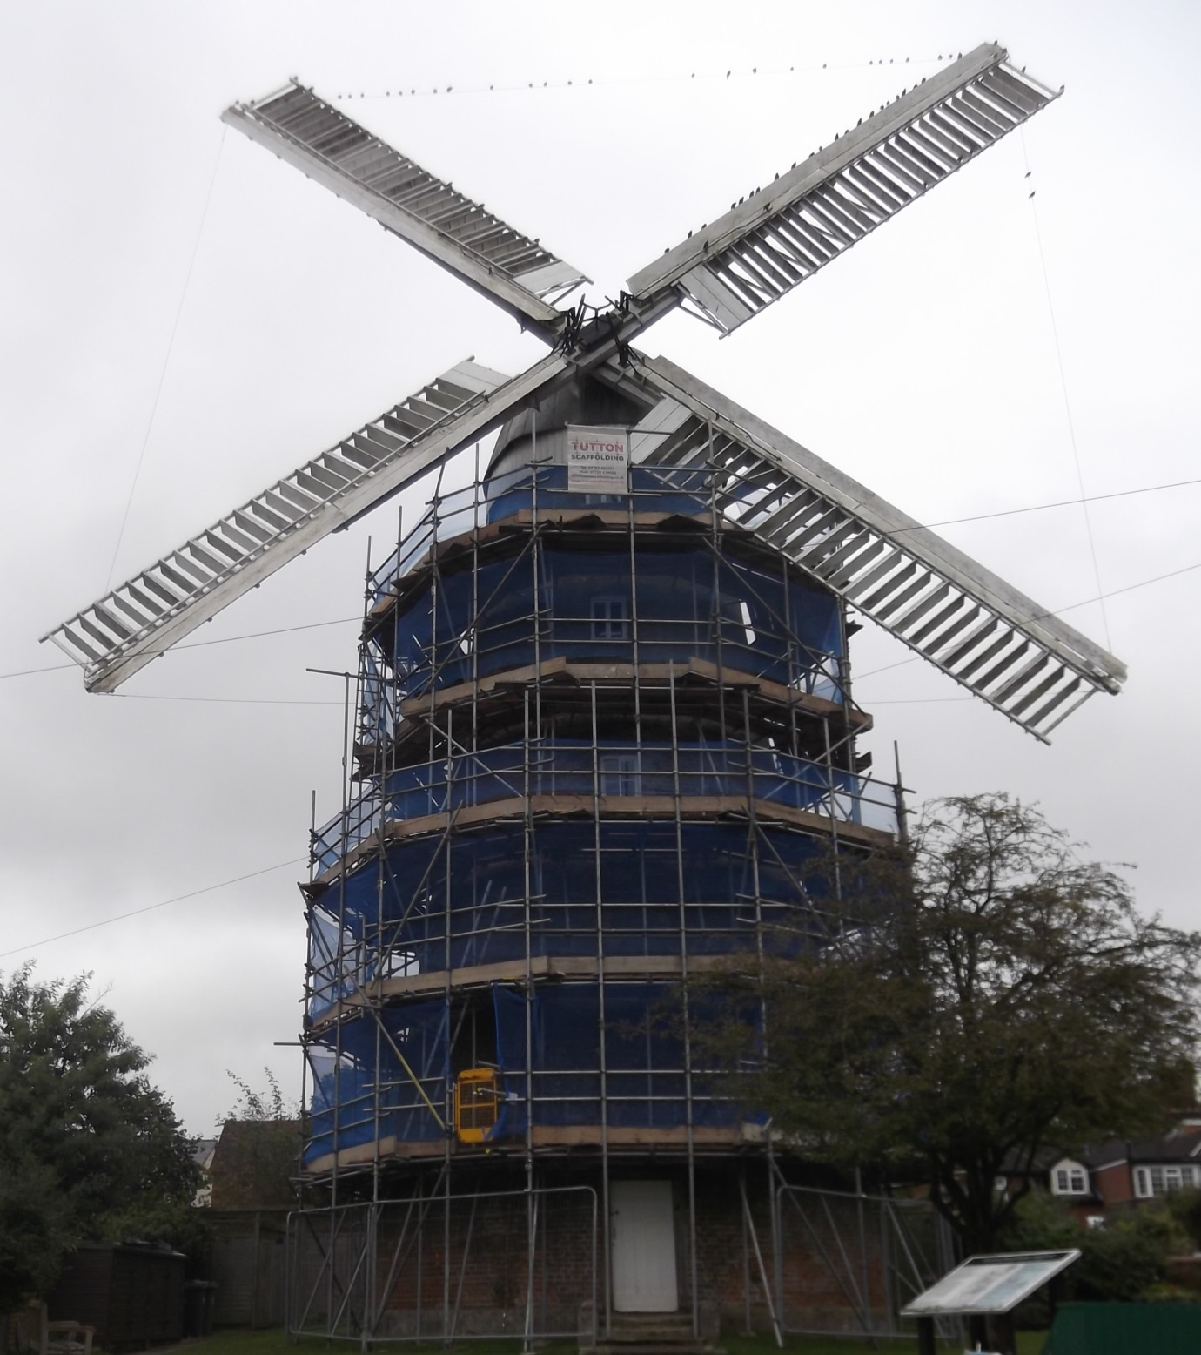

Following many months of fund-raising and grant applications, work is now able to begin on re-pointing and replacing bricks on the tower of this 237 year old windmill. As can be seen from the photo, it is now shrouded in scaffolding in preparation for this repair work to be undertaken. Grant funding is being provided by the Essex Heritage Trust, SPAB Mills Group and Stansted Airport. Fund-raising events at the mill provide further money, plus a very generous amount from the Parish Council. It is hoped that the work will be complete ready for the mill’s Santa fund-raiser in December.

Text & photo – Tony Crosby